Personal, Social & Emotional Development | Physical Development | Communication & Language | Literacy | Mathematics | Understanding the World | Expressive Arts & Design
Make or draw something for a friend – think about what they would like and why. | Learn to use a new tool with the help of your parent, this could be something in the kitchen, garden or something used for arts, crafts or writing. | Can you retell one of our traditional tale stories? E.g. Goldilocks and 3 Bears | Keep a brief diary of your time off – draw a picture and write one simple sentence a day. | Practise counting everyday objects around to house – up to 20 or further for a challenge! | Find out about the lifecycles of some minibeasts – can you find any outside? If you do why don’t you take a photo! | Can you sing a different nursery rhyme or song a day?
Try something completely new – a new food, a new drink or a new experience. | Practise holding a pencil correctly and forming all the letters of the alphabet. | Can you share your favourite toy with someone at home and tell them why you like playing with it? | Make some labels for things around your house. | Count how many things you can do in 30 seconds e.g. how many jumps can you do? How many times can you clap your hands? | What plants and flowers can you see outside? Try to draw a flower that you can see and label the different parts e.g. stem, petal, leaf | What objects could you use in your house as instruments?
Play a board game with your family, practising taking turns and following the rules – maybe you could make your own Snakes & Ladders board or even your own game! | Discuss with your parents what germs are and how we can stay healthy e.g. washing hands – you could also make a poster to share what you know!  Recite the days of the week & months of the year EVERY day | Find 3 objects around your home and describe what they are - using your 5 senses  (what do you see, smell, taste, hear & touch) | 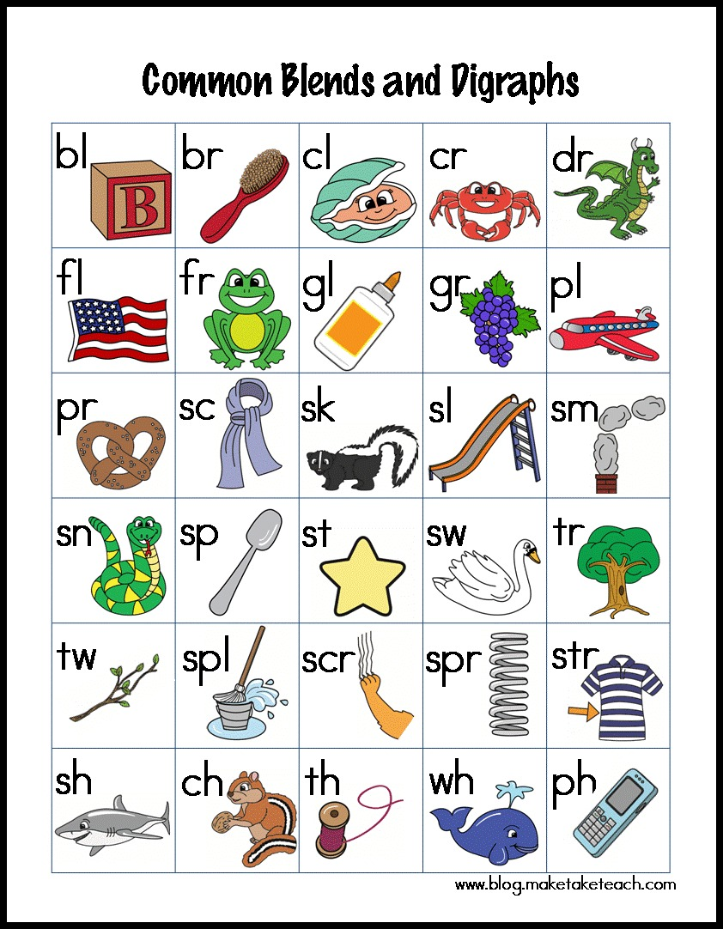 | Work on simple adding or taking away problems – using counters, buttons or other small objects (pasta) to help you. You could always draw circles to represent counters if you don’t have any. | Can you find the different types of technology used in your house? What is it used for? E.g. microwave, washing machine | Can you make a dance pattern using 5 different movements e.g. jump, clap, turn, roll, stamp?
 | Get yourself dressed everyday | Everyday tell someone in your family what day it is. | Practise writing the alphabet – upper and lower case a, b, c etc A,B,C | Explore shapes around your house – what 2D and 3D shapes can you find? | Help someone at home get a meal ready one day for all the family. | Can you design and create a character from our Traditional Tale stories?
 | Talk about your food you are eating what is healthy or unhealthy on your plate and why? | Play a memory game – what is under the blanket? Take an object away, can you remember what is left? | Try to read a book a day – then change the ending to the story. Can you come up with a more exciting end to your story? | Can you compare the size or weight of some different household objects? You could use your hands or feet to measure them or some household scales. | On your tablet, computer or phone use www.toparks.co.uk to complete an Early Years activity. | Can you make a model using different materials at home.
 | Catch a large ball and throw it to someone 5 times/ten times without dropping it. |  | Can your adult read you a story a day? | Can you make some pictures using shapes? Try a car, a space ship or a castle.

