Writing
Today, for writing, we are creating a story about what it would be like to be on tour with your band. What would it be like to live on a tour bus for months? What would it be like to visit all the different cities in the world? Did anything funny happen with your band? What was your favourite and least favourite part of being on tour?
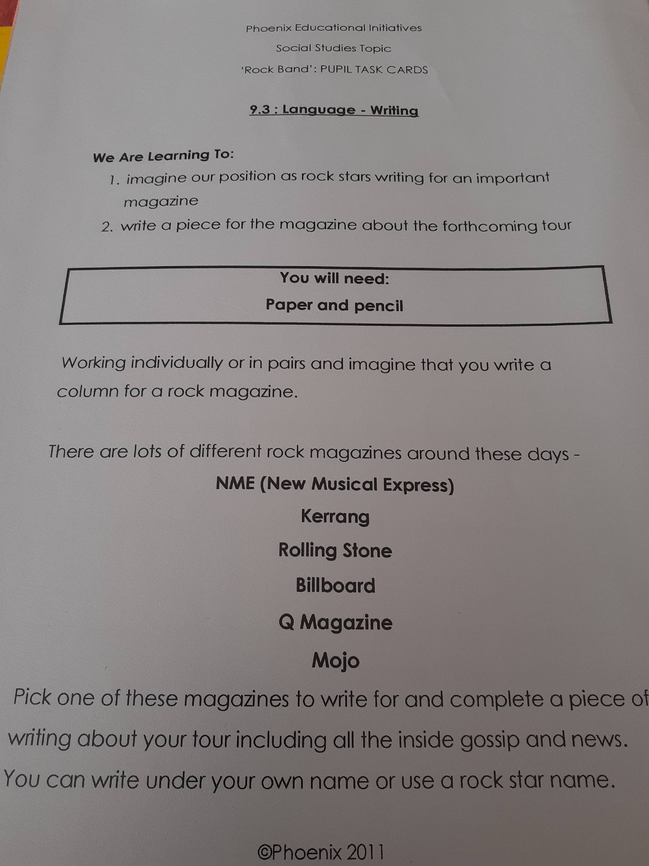I can’t wait to read about your experiences!

