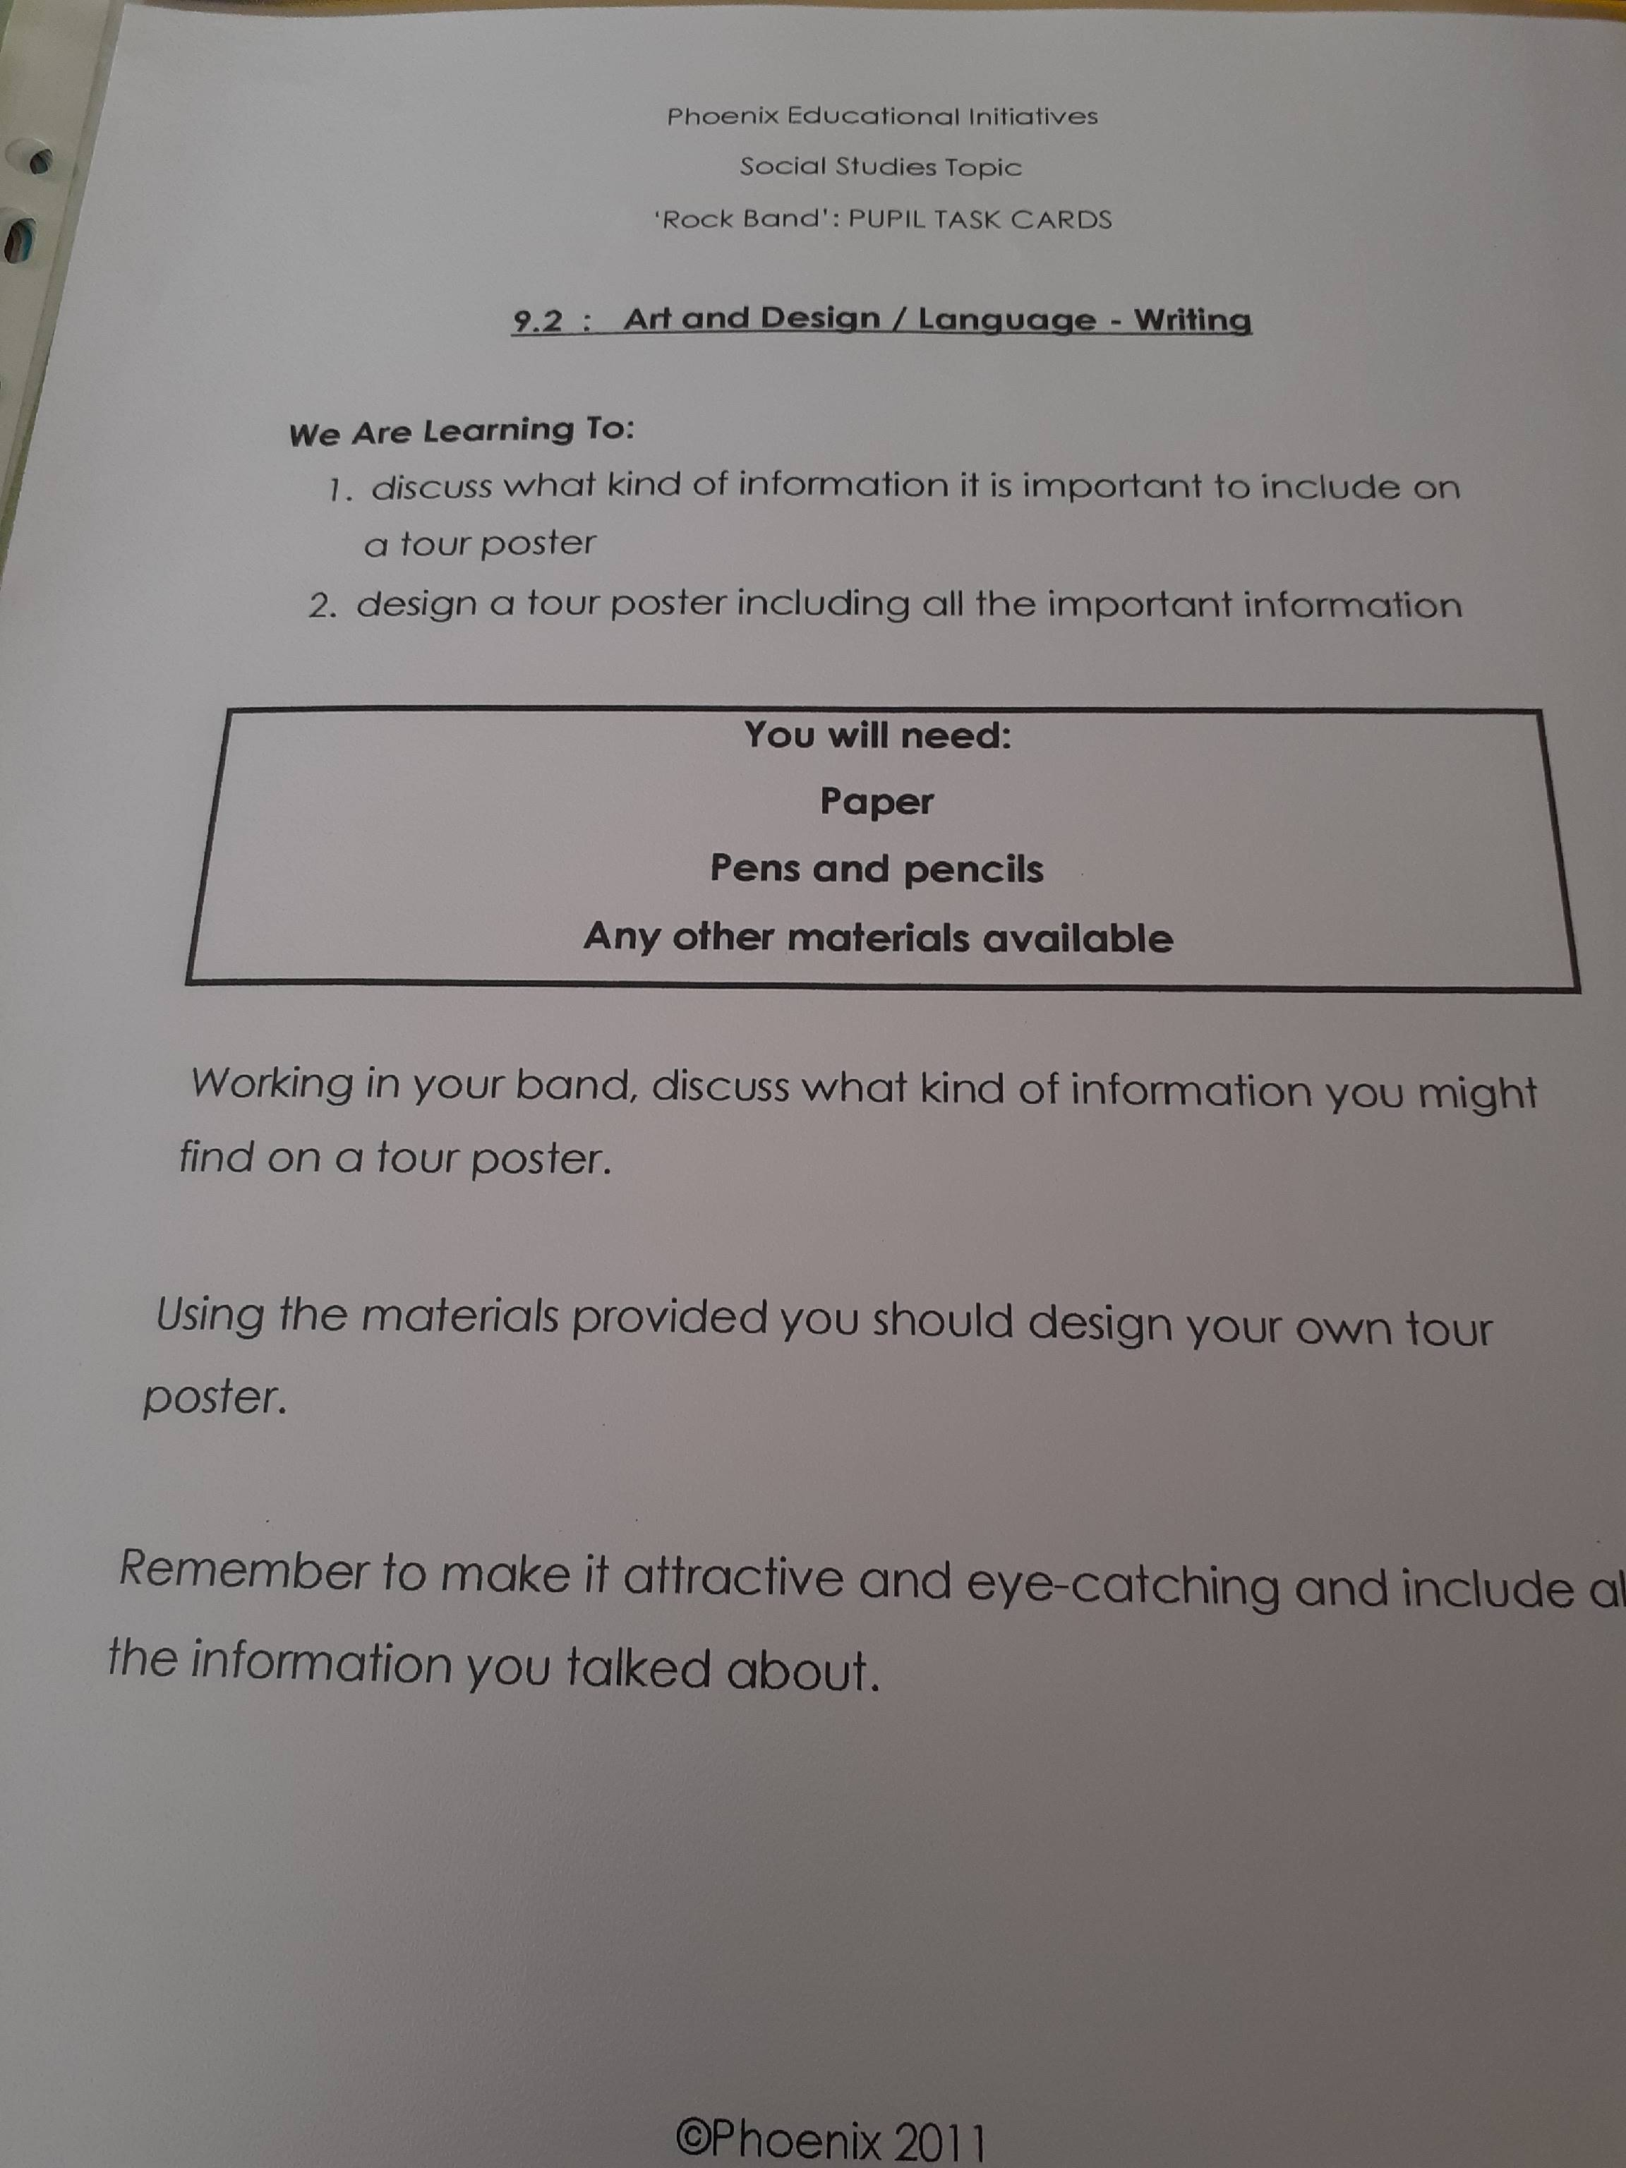Topic – Designing a Tour Poster

We have designed T-Shirts for our band’s tour. Now let’s create a poster to advertise the tour. Remember, the more effective your poster is, the more money your band will make so you want it to be as creative and exciting as possible.
Good luck!

