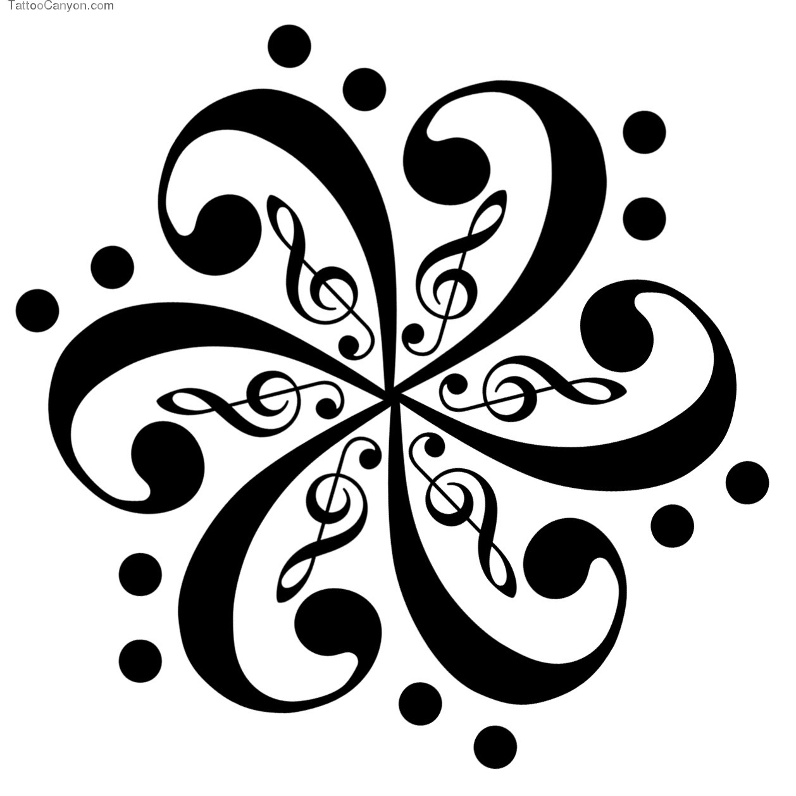
Primary 1 Music activities (if possible please print a copy of this grid for your child to complete.)
Choose an activity from the grid below. When you have completed the task use your colouring pencils to colour in the squares.
1.  Sing a songs and nursery rhymes. How many can you think of? | 2.  Dance to a piece of your choice. | 3.  Listen to sounds in your garden or from your window. What do you hear? Can you make a list? | 4.  Sing in the bath as loud as you can.
5.  Teach someone in your family a song. | 6.  How many different body percussion sounds can you use to show the steady beat in a song? | 7.  Join in with Fishy Music Assembly on a Monday. | 8.  Listen to the music at the start of your favourite T.V. programme. Tell someone in your family how it sounds. Loud/soft, fast/slow, happy/sad or lively/calm.
9.  Sing a song from your favourite film or T.V. programme. | 10.  Can you make a musical instrument from things you find in your house? Boxes, plastic milk bottles, wooden utensils.  Can you make different sounds from them? | 11.  Can you use the instruments you made in box 10 to accompany a song of your choice? | 12.  Watch a musical film. How many songs does the film have?

