Topic
So much designing in this topic, it’s fantastic! Today you are creating tour posters. It has to be so good that people want to spend money to come to your band’s concert!
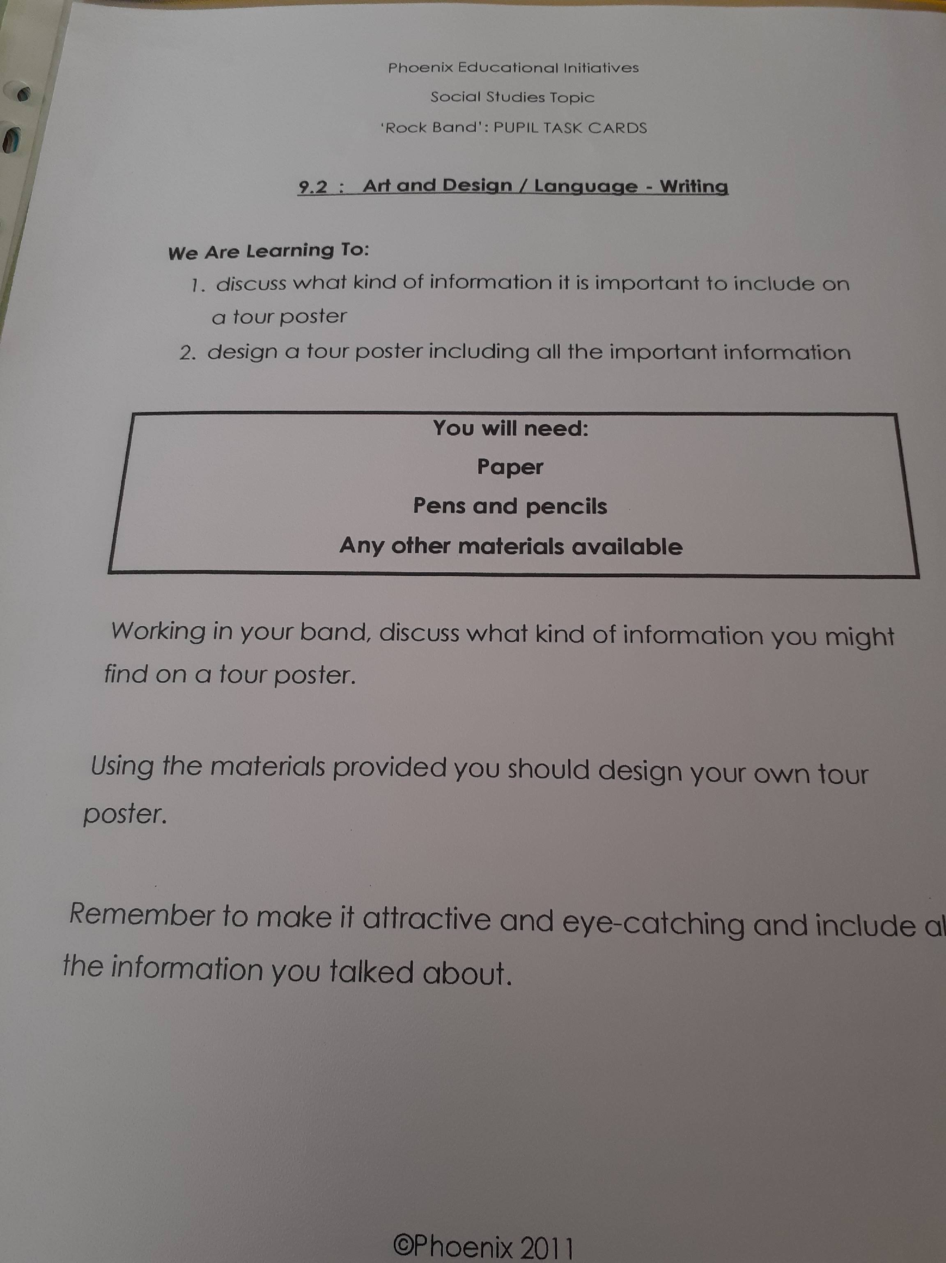Get creative and make people want to spend money!!

