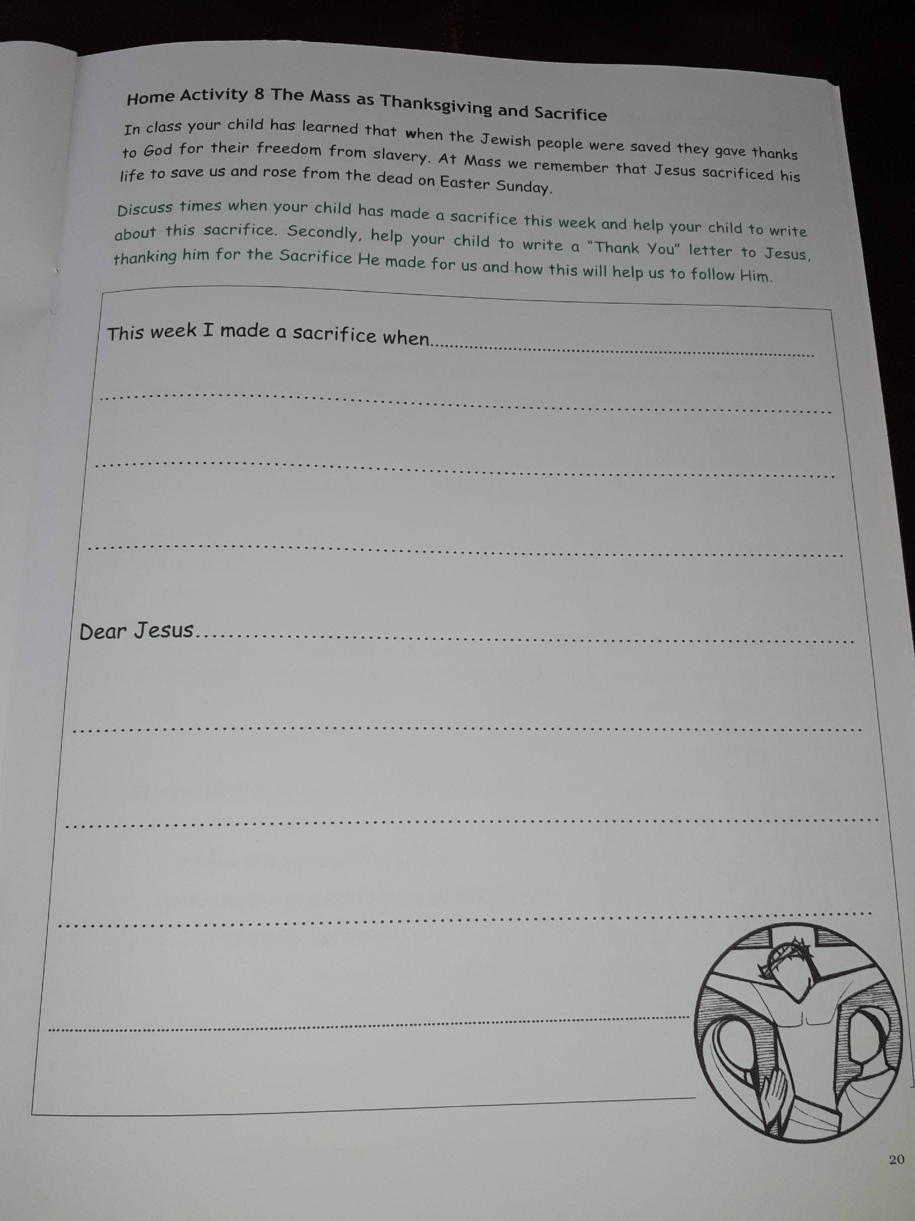RE – Making Sacrifices
Please complete this in your jotter. If you are preparing for First Holy Communion, you will find this task in your Communion book.
Please think hard and give a detailed example of when you made a sacrifice and create a detailed thank you letter to Jesus for all his blessings and sacrifices for us.

