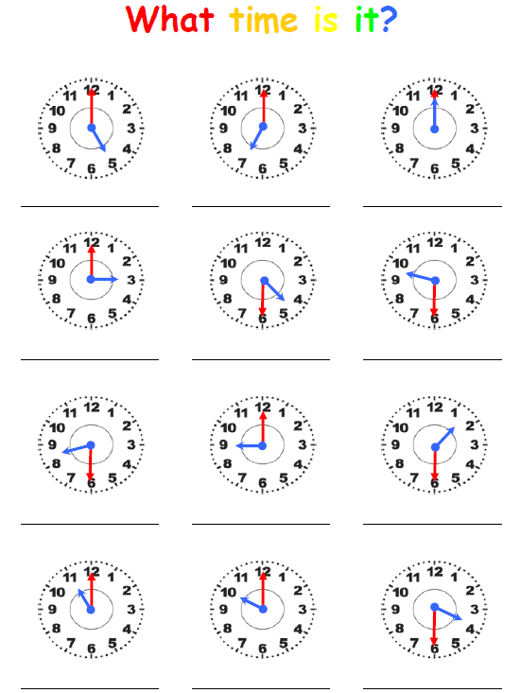
,

3
2
1

6
5
4

7
8
9

11
12
10

L.I.- to convert analogue time to digital time
Task 1 – write down the time on each of the clocks in words, for example, ‘Quarter to 5’
Task 2 – write down the time of each of the clock in digital form, for example, ‘4:45’

