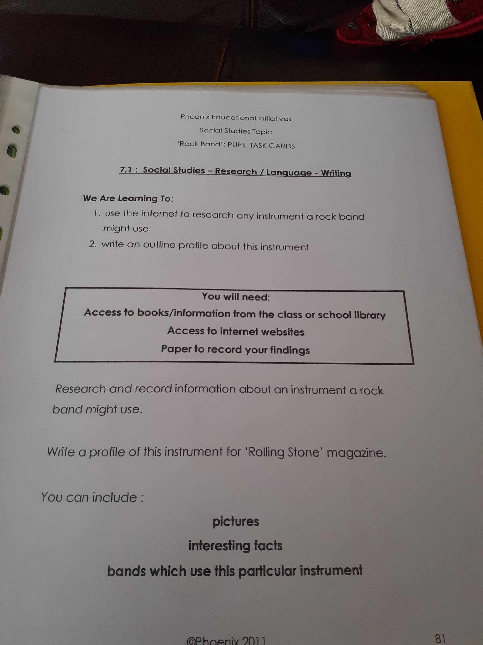Topic - Instruments
Today, I would like you to research The Beatles, McFly or The Corrs. These are all bands that use different types of instruments. You can pick to research one band or all of them, it’s your choice to challenge yourself!
Write about the people in the band and what instruments they play. I would also like you to write a bit about the background of the band.
For each band, I am looking for a list of instruments they use and 5 facts that you can find out about them. Good luck!

