Topic
We are continuing with Rock Band until the topic is finished and we move on to a different topic. Today, it’s all about famous guitarists and designing your own guitar. You can do this either by drawing it or making it.
I would like you to research either Eric Clapton or Jimmy Hendrix, both really famous for playing the guitar. I would like you to write down at least 5 things you find out. If you get to 10, that will be amazing!
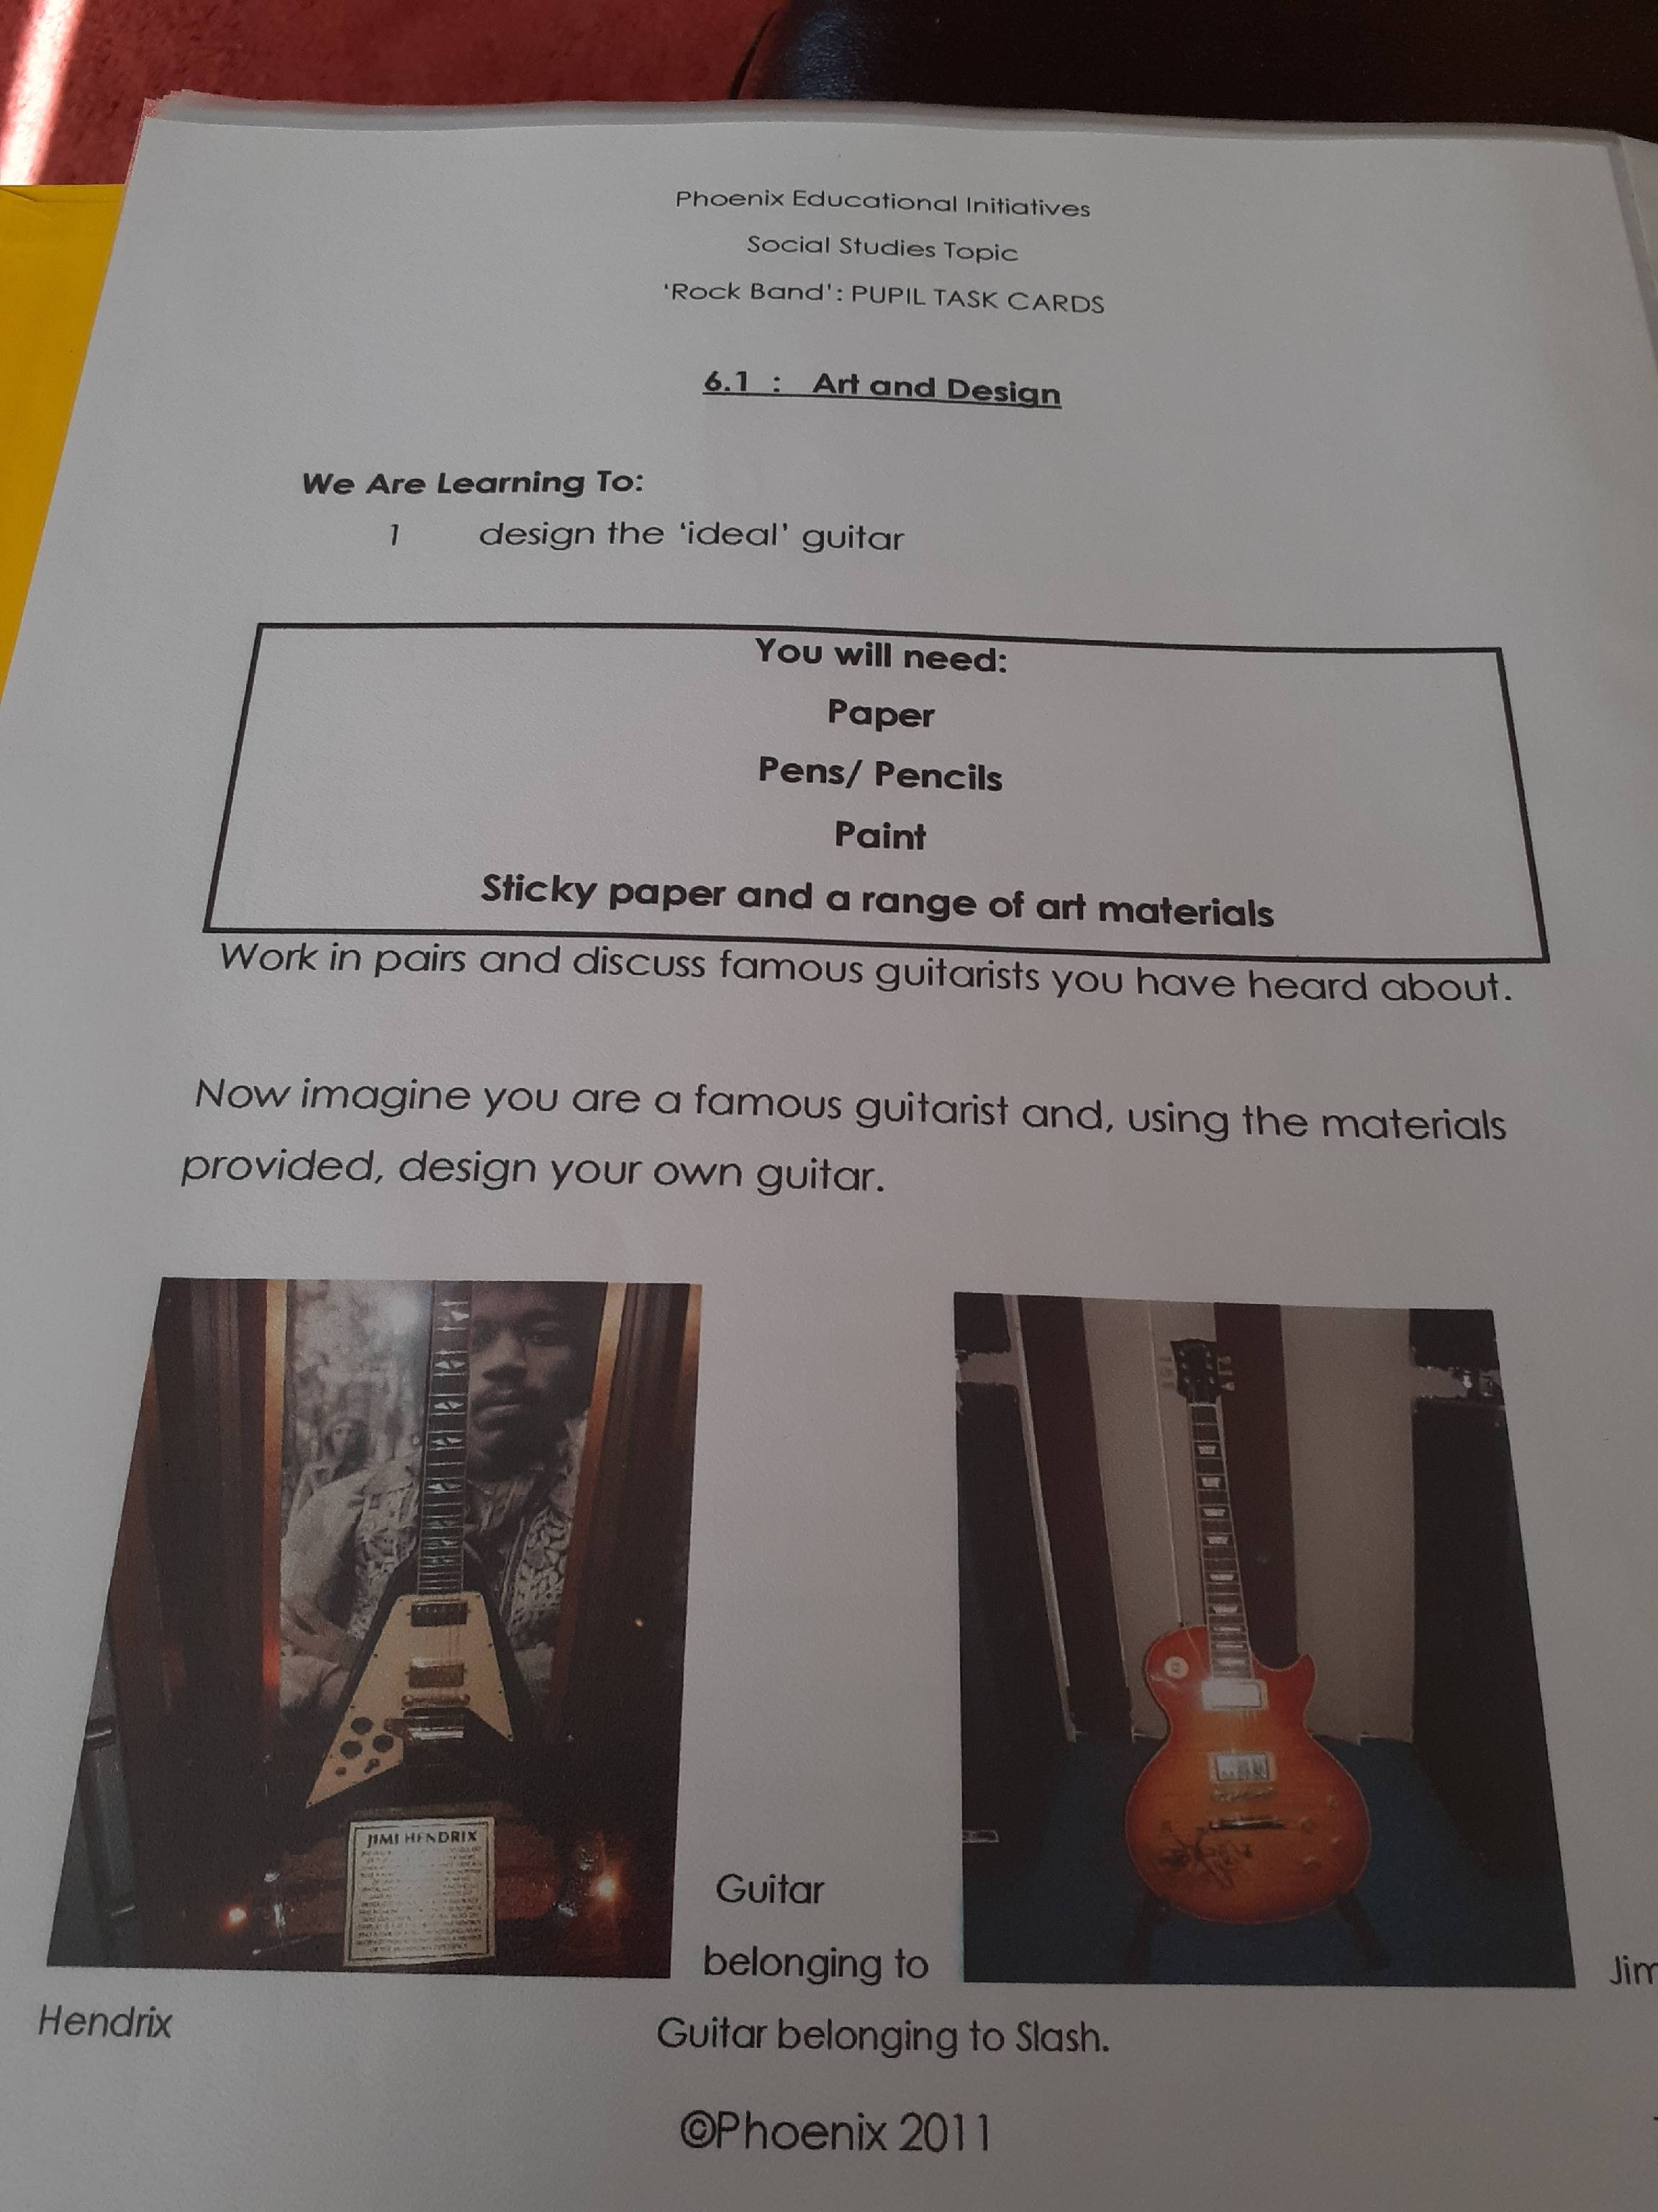Then I would like you to design a guitar! Be as creative as possible with colour and shape.

