RE – Jesus is Always With Us

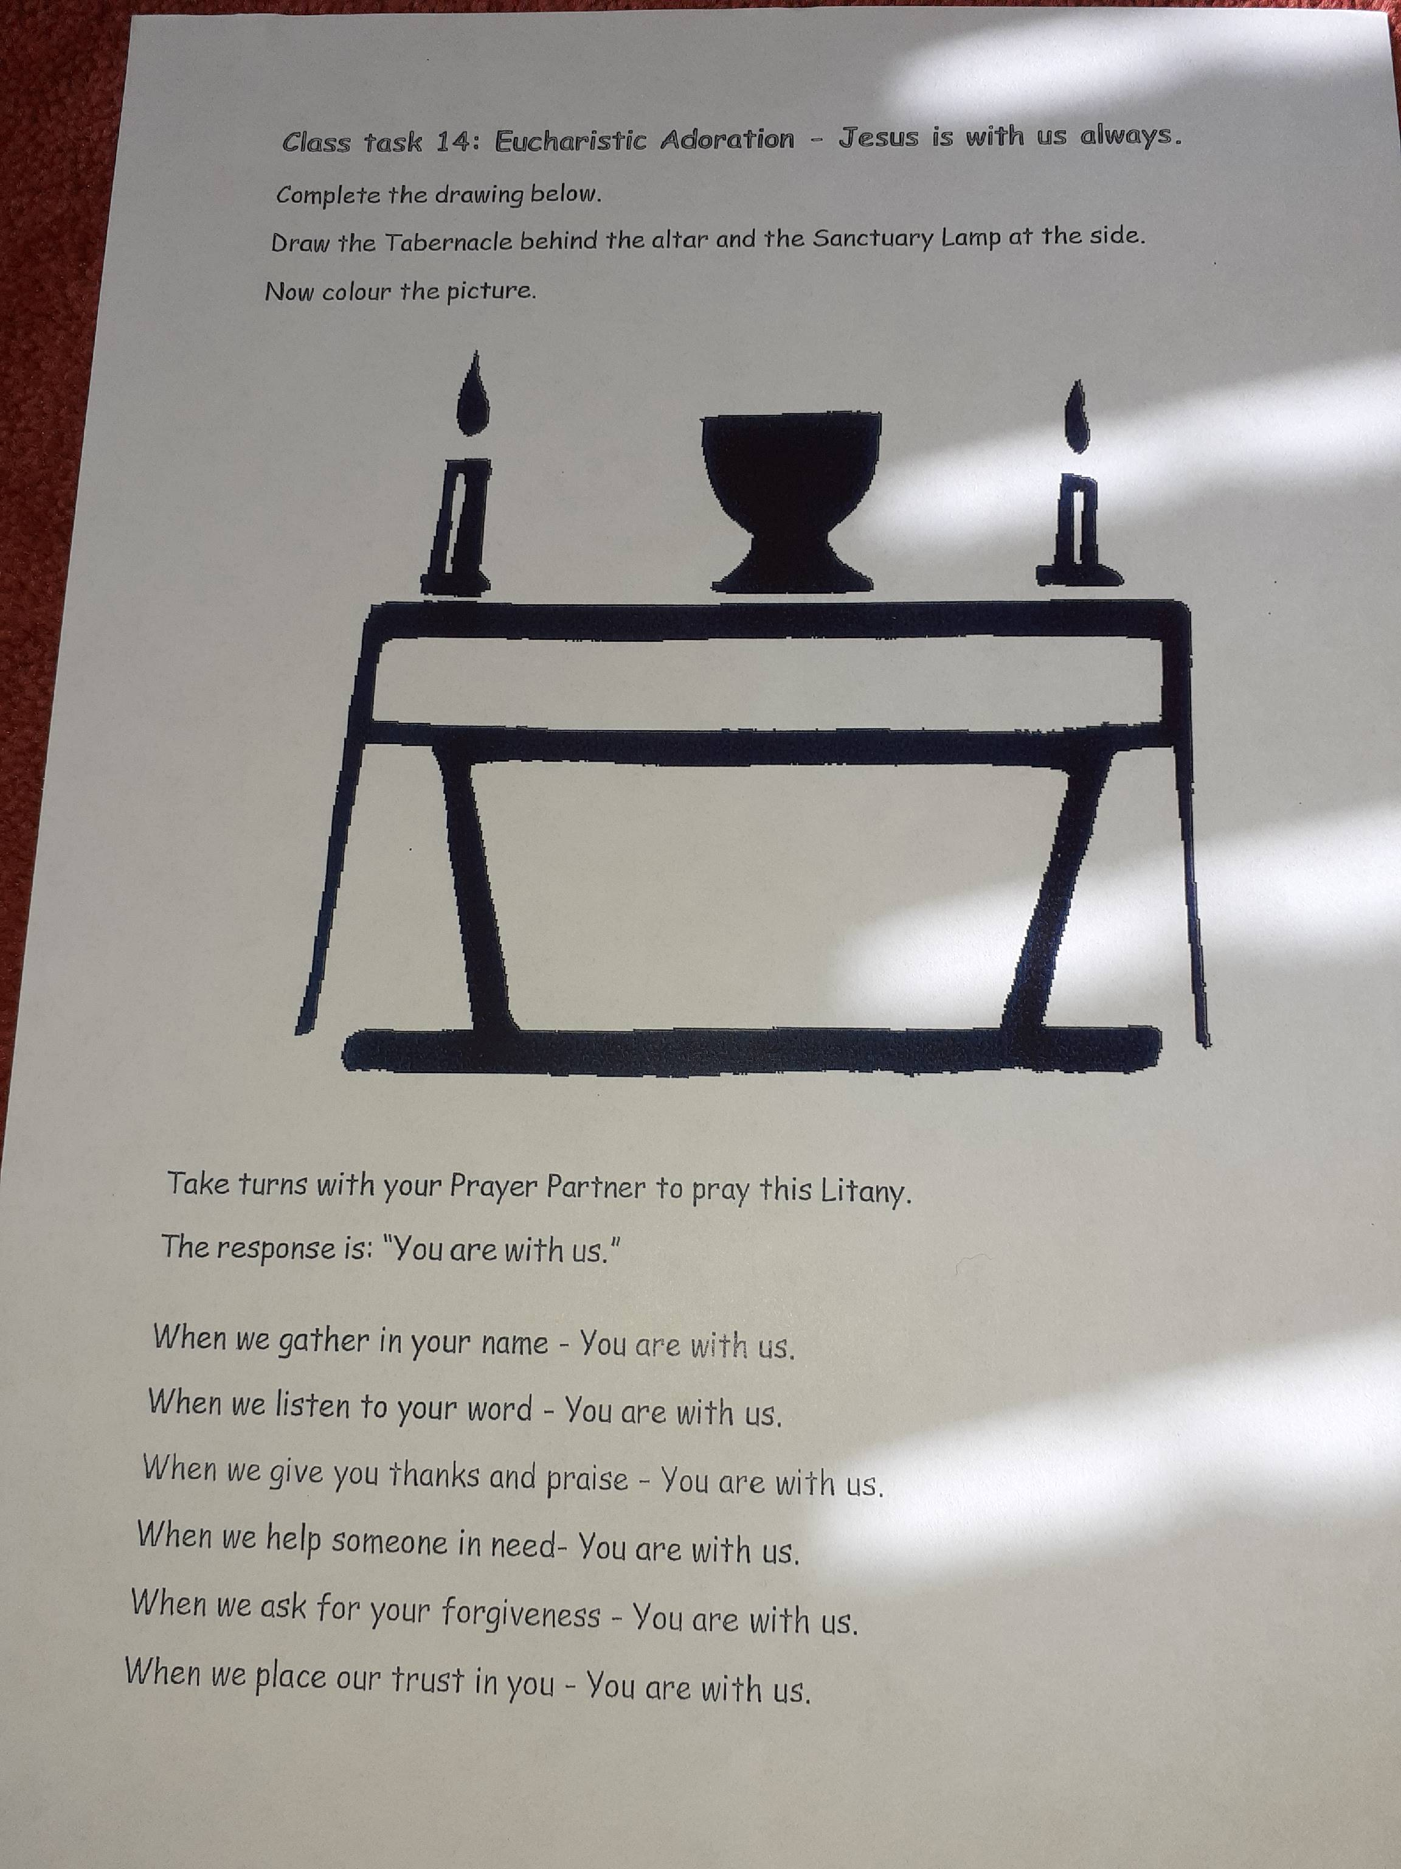Now our celebration of Easter is over, we concentrate again on receiving First Holy Communion. I am looking forward to seeing your drawings. Do these in your jotter.

