Oxford Owl is a website which provides free e-books which can be read at home. You need to create an account but there is no charge.
- Google ‘Oxford Owl’ and click on the website.
- Click ‘join us’ - circled.
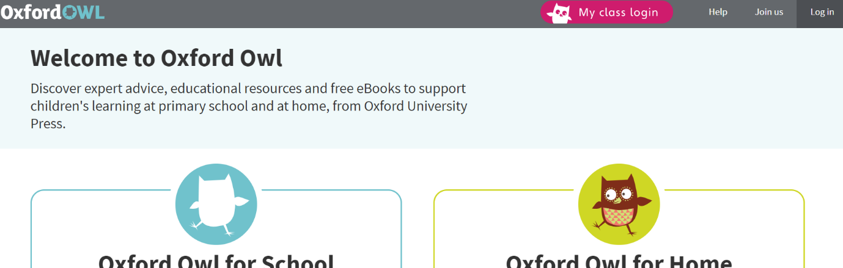

- Follow the steps to create your free account.
- Once logged in, click on ‘enter site’ in the ‘Oxford Owl for Home’ box.
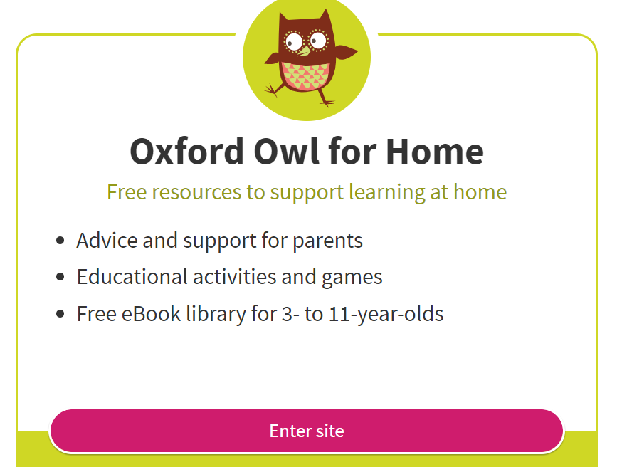

- Click on the little magnifying glass button

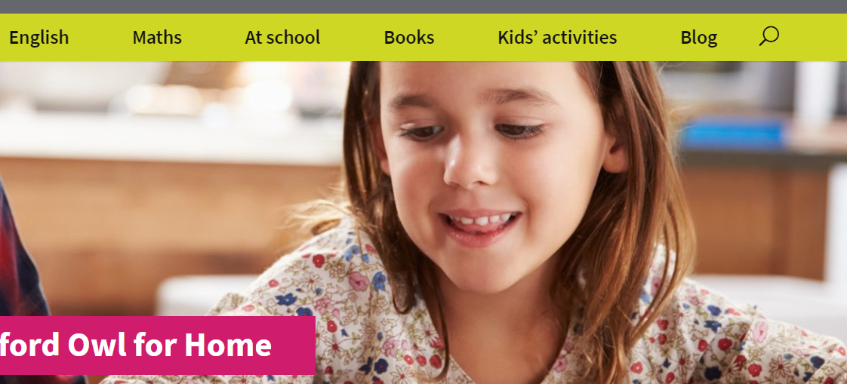

- Type in the name of the book and press enter. Click on the book.
- Click on the book again.
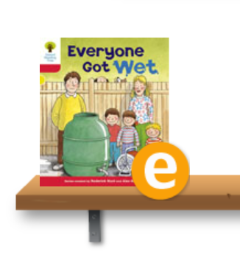

- The book should appear. If you press ‘audio’ the book will be read aloud – or you can read it yourself.
This is a new book which the children have not been able to prepare for by practising any of the words, so please be sure to take it slowly and let the children experiment with new, tricky words they have never seen before. They have also never seen these characters before so it may take time for them to be able to recognise who everyone is. Encourage your child to sound out words wherever possible, e.g. ‘got’ and ‘wet’. Please remember discuss the plot with your child and ask questions so that they understand what is happening in the story. There are comprehension activities above the book which your child can also have a go at.

