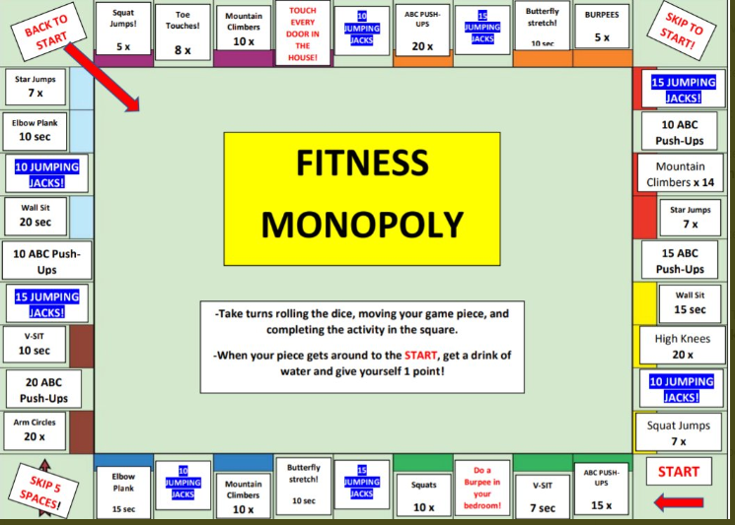

For PE today, play Fitness Monopoly. If you don’t have a dice, just pick 4 or 5 of the boxes that you want to do. It’s great fun and you can involve the whole family.