Step 1 – click on Books

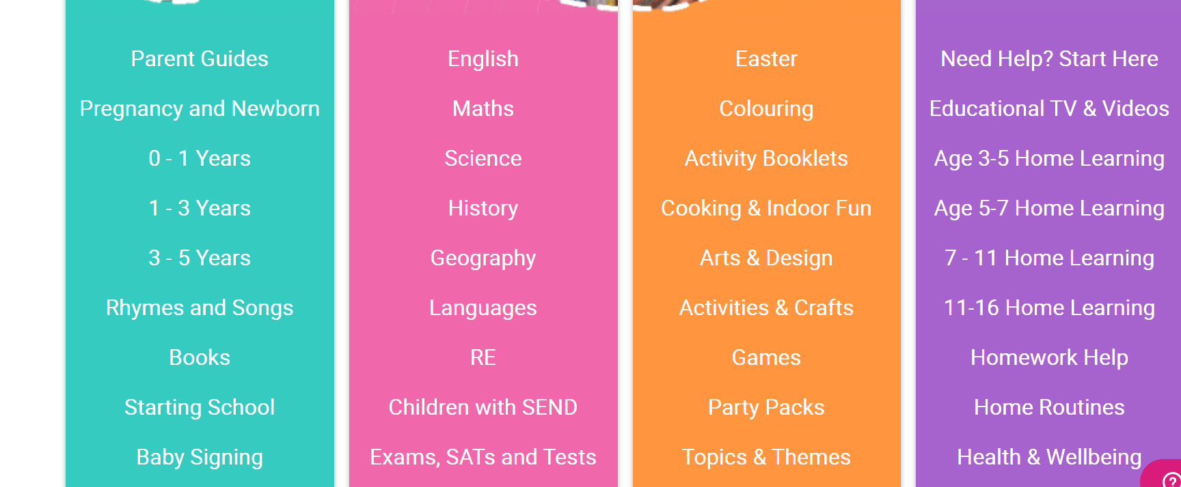

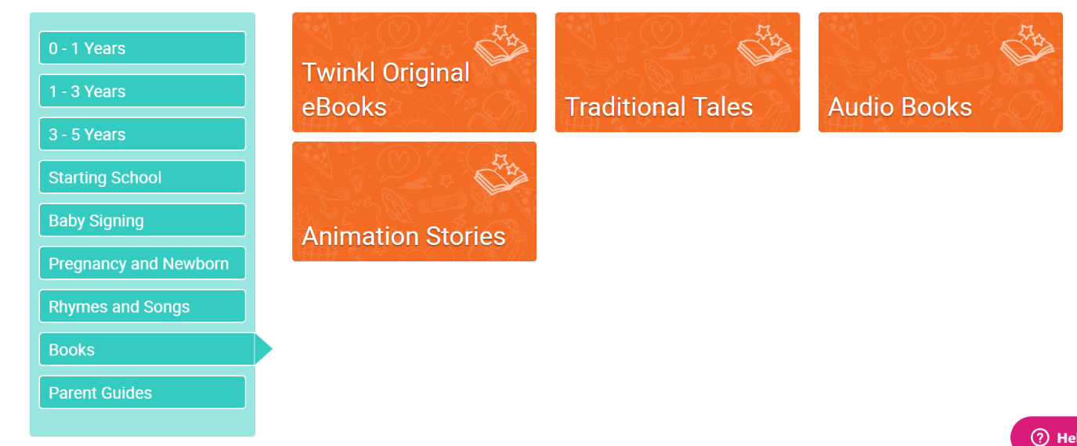

Step 3 – select a book to download! Enjoy!

Step 2 – Click on Twinkl Original eBooks