P3 Continuing with the Hidden Giants Project
We might not be able to meet up with the Hidden Giants (Paul & Matthew) for some time now but that doesn’t mean we can’t continue to find out more about carrots ourselves!!
Here’s a mini topic for us all to try. I think you’ll enjoy it!
Here are the instructions on how to grow a carrot top at home. This is a fabulous introduction to ‘growing’ for children as it provides them with a basic form of responsibility to look after and help the carrot top grow. So much can be observed over the days as it sprouts and grows up tall. Why not keep a little diary/photo diary of the changes you see?

HOW TO RE-GROW CARROT INDOORS ** parental supervision required for cutting the carrot**

Re-growing carrots indoors is a simple activity that you can do with your family.
I loved doing this when I was your age! Please ask an adult to cut the top off the carrots!
- To regrow carrots indoors try the carrot top method. Simply cut about an inch off the top of a raw carrot.

- Place the carrot or carrots on a plate or a saucer and fill it about halfway to the top of the carrot top.

- Remember to change the water frequently. After a few weeks, plant the carrot tops into pots full of soil.

- After transplanting the carrot tops to the pots, they should begin to thrive and grow faster.

- Remember to water the carrot tops when needed and take good care of them.
No carrots will regrow as this is not possible however you will be able to watch the plants grow and hopefully see a flower.
DO NOT EAT!!
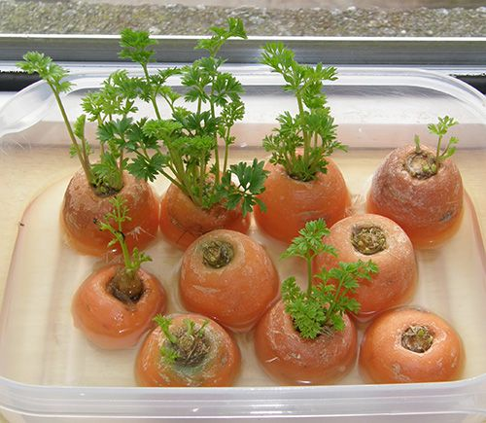
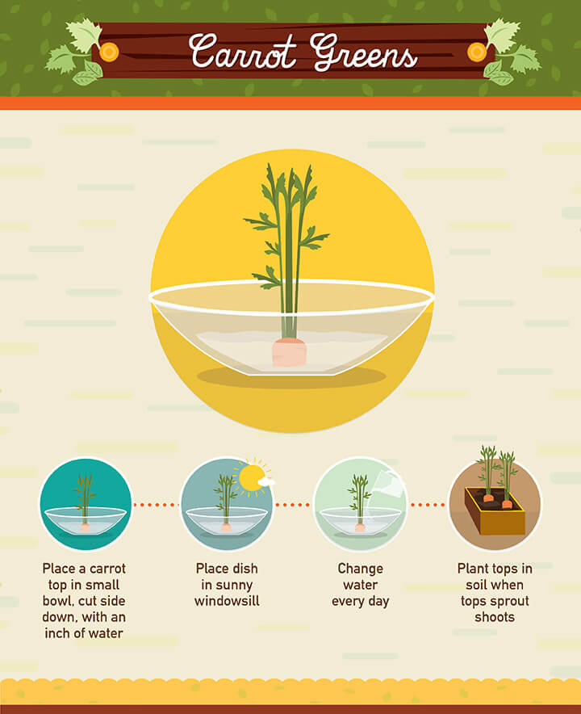
I’ve tried this at home with carrot tops, turnip tops, parsnip tops and sweet potatoes. All are sprouting EXCEPT the sweet potato! Try this with an adult and let me know how it goes! Remember leave the cutting to an adult!!

