31/3/20 Tuesday with Mrs McAlpine
This is a guide timetable. Remember we are being super flexible to suit your families so tasks can be done in ANY order
9am –Morning prayers. How are we all today? Check through our ‘feelings check in’ Did you know that Saturday the 28th was Earth Hour? Let’s discuss.
9.30am Live meeting to explain today’s learning
First task - Literacy – continue our work on ‘Openers’ (see below) 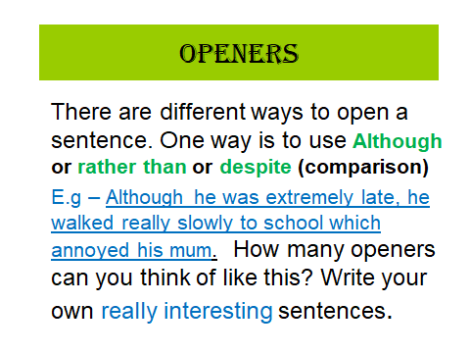
Log on to EPIC for some reading time – look in your mail boxes for new books I’ve assigned. Don’t worry if you have trouble getting logged on as lots of students will be trying to access online too. We will give it a try and hopefully we have success like last Tuesday. We are being flexible so you can try at different points in the day.
Break at 10.30 – 10.45am
BBC Newsround after break as we usually do, then maths that I’ve assigned on glow
Maths After your Education City worksheet on equivalent fractions then please complete the 6 times table worksheet. I’m happy for you to go online using your passwords to either Sumdog or Education City and access games there after some written maths work (the two worksheets I assigned)
RE Task

Work through the stations of the cross powerpoint, then write a prayer for those who find themselves in difficult situations like Jesus did when he was condemned to death (the first station)
Think about the second station (Jesus carries his cross). Complete the attached worksheet called ‘I am grateful’

Health & Wellbeing (HWB) Click through the Energy powerpoint on the blog (it’s all about Food as our body’s source of energy)
Write down each question (your first one is on slide 5) Which food provides the least energy?
Click on to the next slide to reveal the answer. Carry on through the powerpoint to answer all 4 questions (in your jotter if you wish)
Reflection time – were you surprised by what activity used up the most and least amount of energy? What else did you notice? Tell an adult what you learned about Food as our source of Energy and any other new learning since you have been learning from home.
2.00pm – Miss Hewitt wants to check in with you all which is lovely.
2.45pm – Check out for the day with Mrs McAlpine
Some other fantastic videos and activities that you may wish to do this week or during the holidays
https://request.org.uk/restart/2017/02/23/make-an-easter-garden/
https://request.org.uk/restart/2017/05/30/question-pod-3/
https://request.org.uk/restart/2020/03/24/easter-home-learning-pack/

