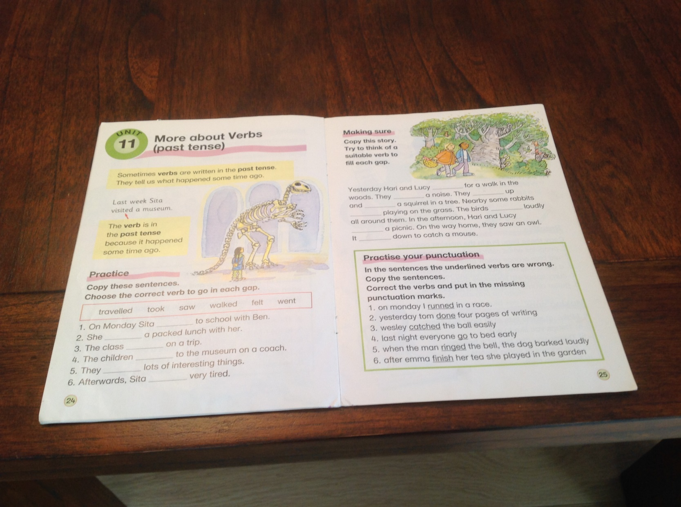
Grammar - Past Tense Verbs

