10 Leg Stretch (Both Legs)

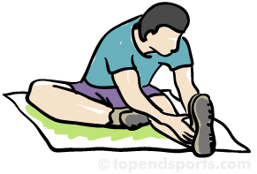

Choose a **CARDIO** exercise of your choice and do it 5 times

20seconds Butterfly

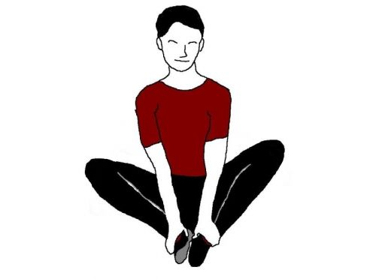

10 Lunges

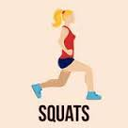

10 Frog Jumps

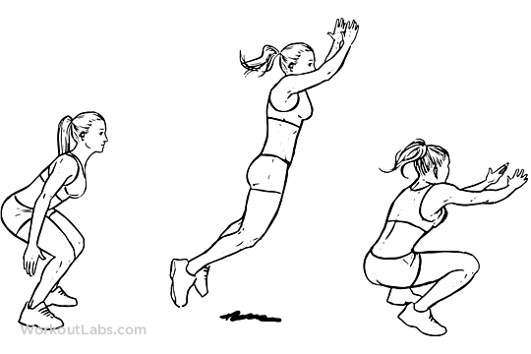

15 High Knees



10 Jumping Jacks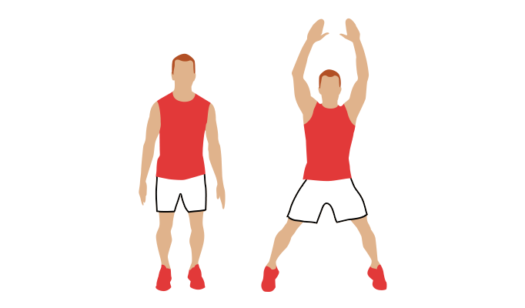

Start

S

20s Jog in Place

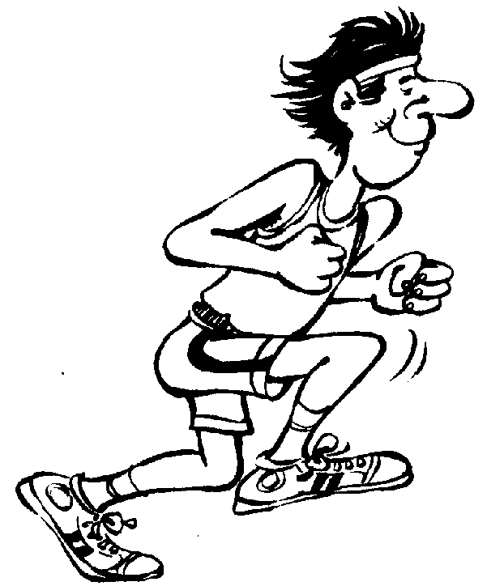

15 Sit Ups

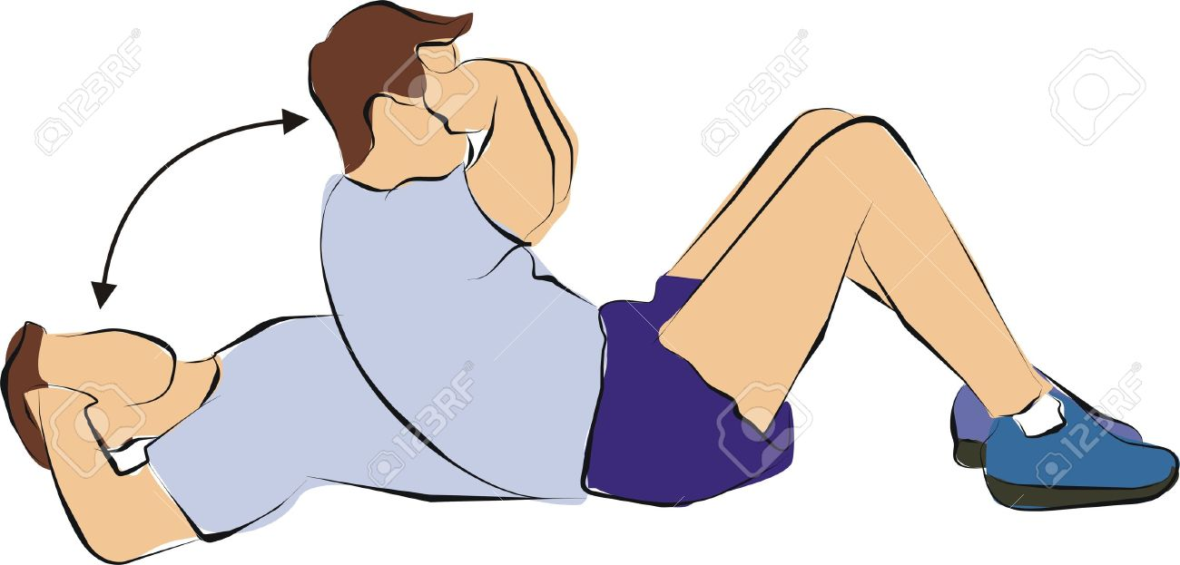

Fitness Monopoly Instructions

1. Each student gets their own colored marker
2. Decide who will go first
3. The first person will roll the dice and move that many spaces clockwise
4. Whichever exercise you land on, the whole group will perform it together
5. It is now the next persons turn

*If you land on a special spot (anything without an exercise and picture) do as it explains.



20 Ski Jumps

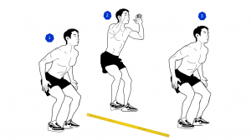

20s Plank

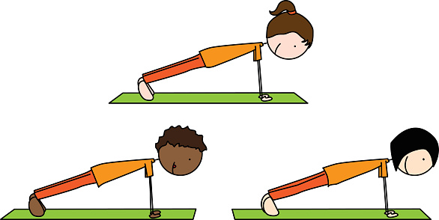

**­­­**

Fitness

Monopoly

25 Ski Jumps



10 Sit Ups



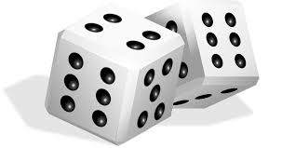

30s Jog in Place



20s Plank



20s Sit & Reach

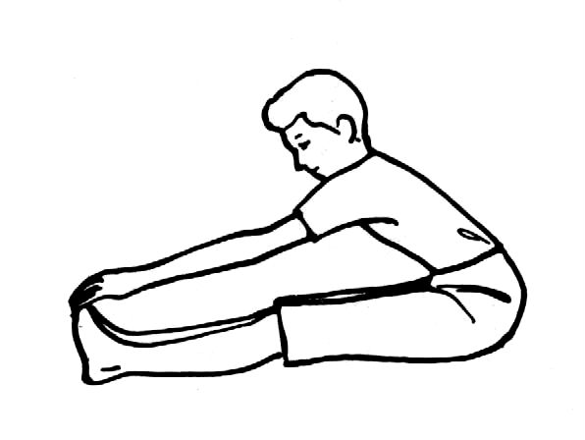

20s Touch Toes

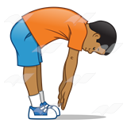

10s Arm Stretch (Both)



8 Frog Jumps



10 Squats

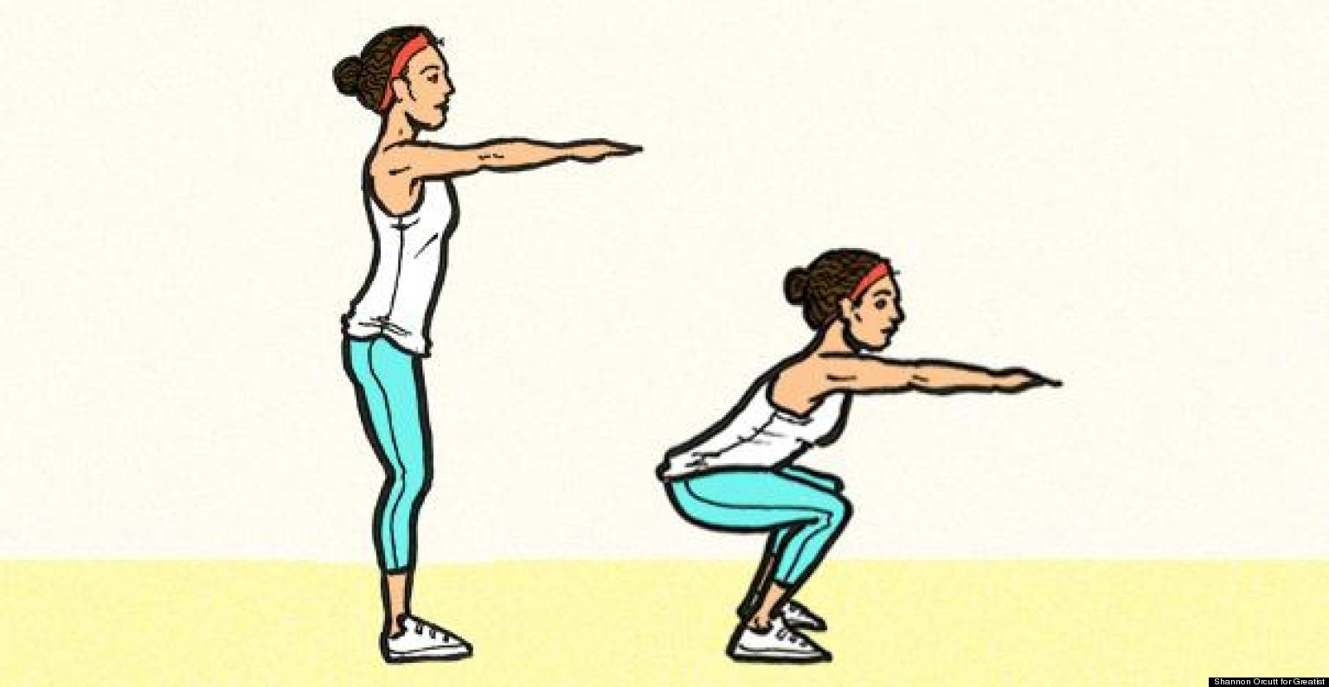

Choose a **Muscular Strength** exercise of your choice and do it 15s/15 times

10s Shoulder stretch (Both)

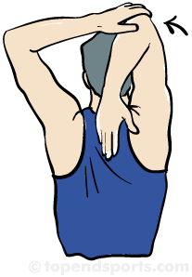

Choose a **Flexibility** exercise of your choice and do it 20s

20 High Knees



20 Jumping Jacks