9am –Morning prayers. How are we all today? Check through a ‘feelings check in’ (soft start)
9.15am Literacy – continue our work on ‘Openers’

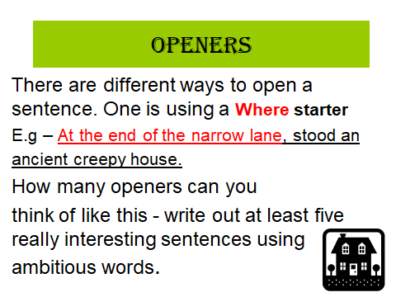

10am - Log on to EPIC for some reading time – look in your mail boxes for books I’ve added for you. Don’t worry if you have trouble getting logged on as lots of students will be trying to access online too. We will give it a try though! If you have trouble with this read a

Break at 10.30 – 10.45am

After you multiplication wheels and the Education City worksheet on the 6 times table, I’m happy for you to go online using your passwords to either Sumdog or Education City and access games that you know and can practise again. Only after some written maths work (the two worksheets I assigned)

RE Around 12pm to discuss, then task to be worked on after lunch
I recognise that we engage in prayer, fasting and almsgiving during Lent and I am increasing my understanding of these activities in association with my school parish and family.
RE Task

Choose a charity to research and think of possible ways you could engage in some activity to support its work. Donate some of your time to prayer for those in need. You could challenge yourself to write out a prayer. You can use the links below or perhaps find charities?

https://www.sciaf.org.uk/

https://cafod.org.uk/

Health & Wellbeing (HWB) Energy powerpoint (food is our body’s source of energy)
Write down each question on the powerpoint before clicking to the next slide (which reveals the answer)

