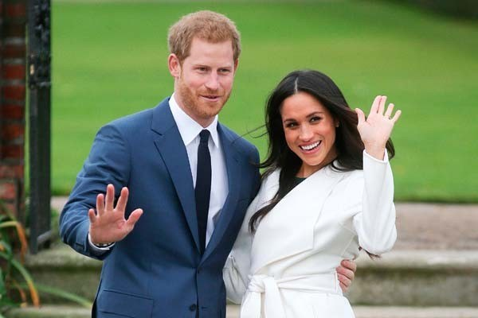
The Royal Wedding

Where are Prince Harry and Meghan Markle getting Married?
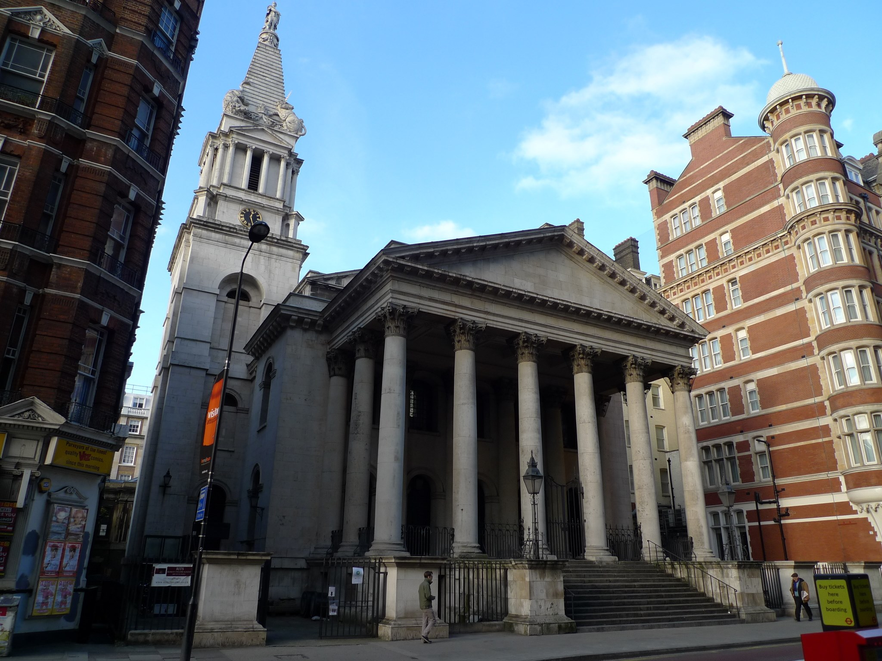
Prince Harry and Meghan Markle are getting married on Saturday the 19th of May at the venue of St Georges Chapel in Windsor Castle

Who is Prince Harry?
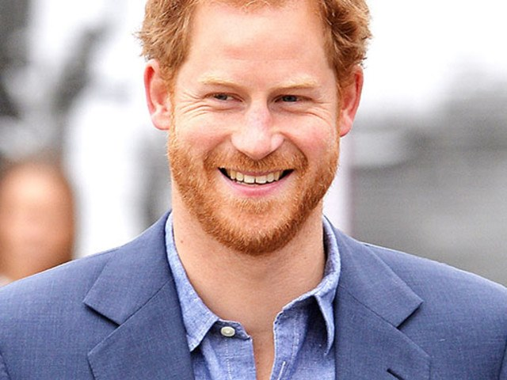
- Harry Charles Albert David was born in St Mary's Hospital, London on the 15th September 1984.
- He worked in the British Army from 2005-2015 and he had the Captain rank.
- His Mother was Lady Diana Spencer and his Father is Charles ,Prince of Wales.
- He lives in Windsor Castle.

Who is Meghan Markle?
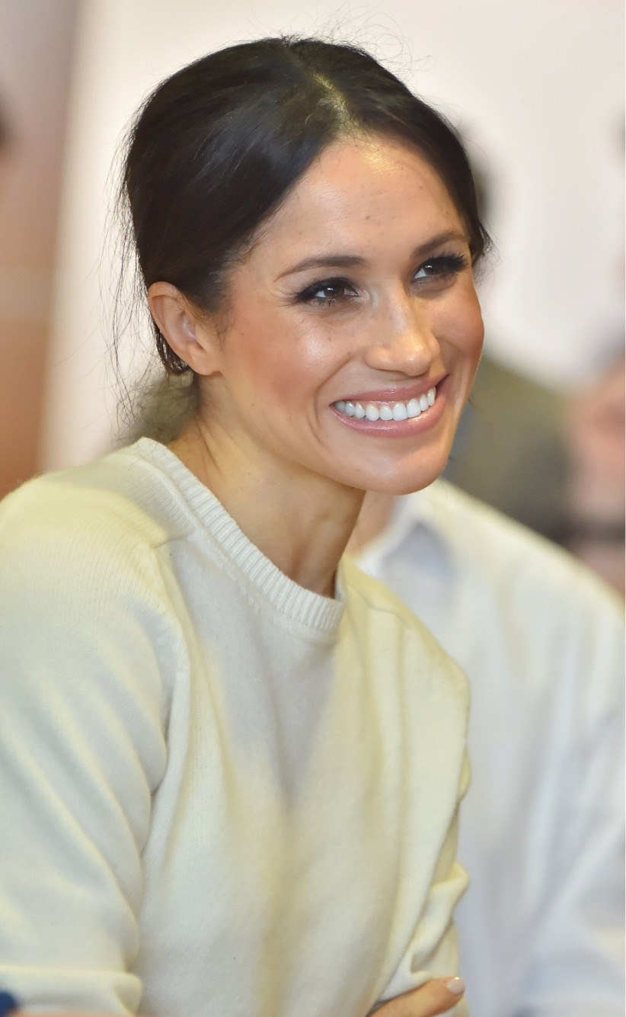
- Rachel Meghan Markle was born in Los Angeles, California, U.S on the 4th August 1981.
- She works as an actress from 2002-2017.
- Her Mother is Doria Ragland and her Father is Thomas Markle.
- She lives in Nottingham Cottage, Kensington Palace, London.

It doesn't come without costs!
The ridiculous cost of the Royal Wedding is one of the most expensive wedding in years costing over £500,000! Could you pay for that? Surprisingly, The Royal Family will pay for all the costs. Usually the government pays for this

Would you make it a Bank Holiday?
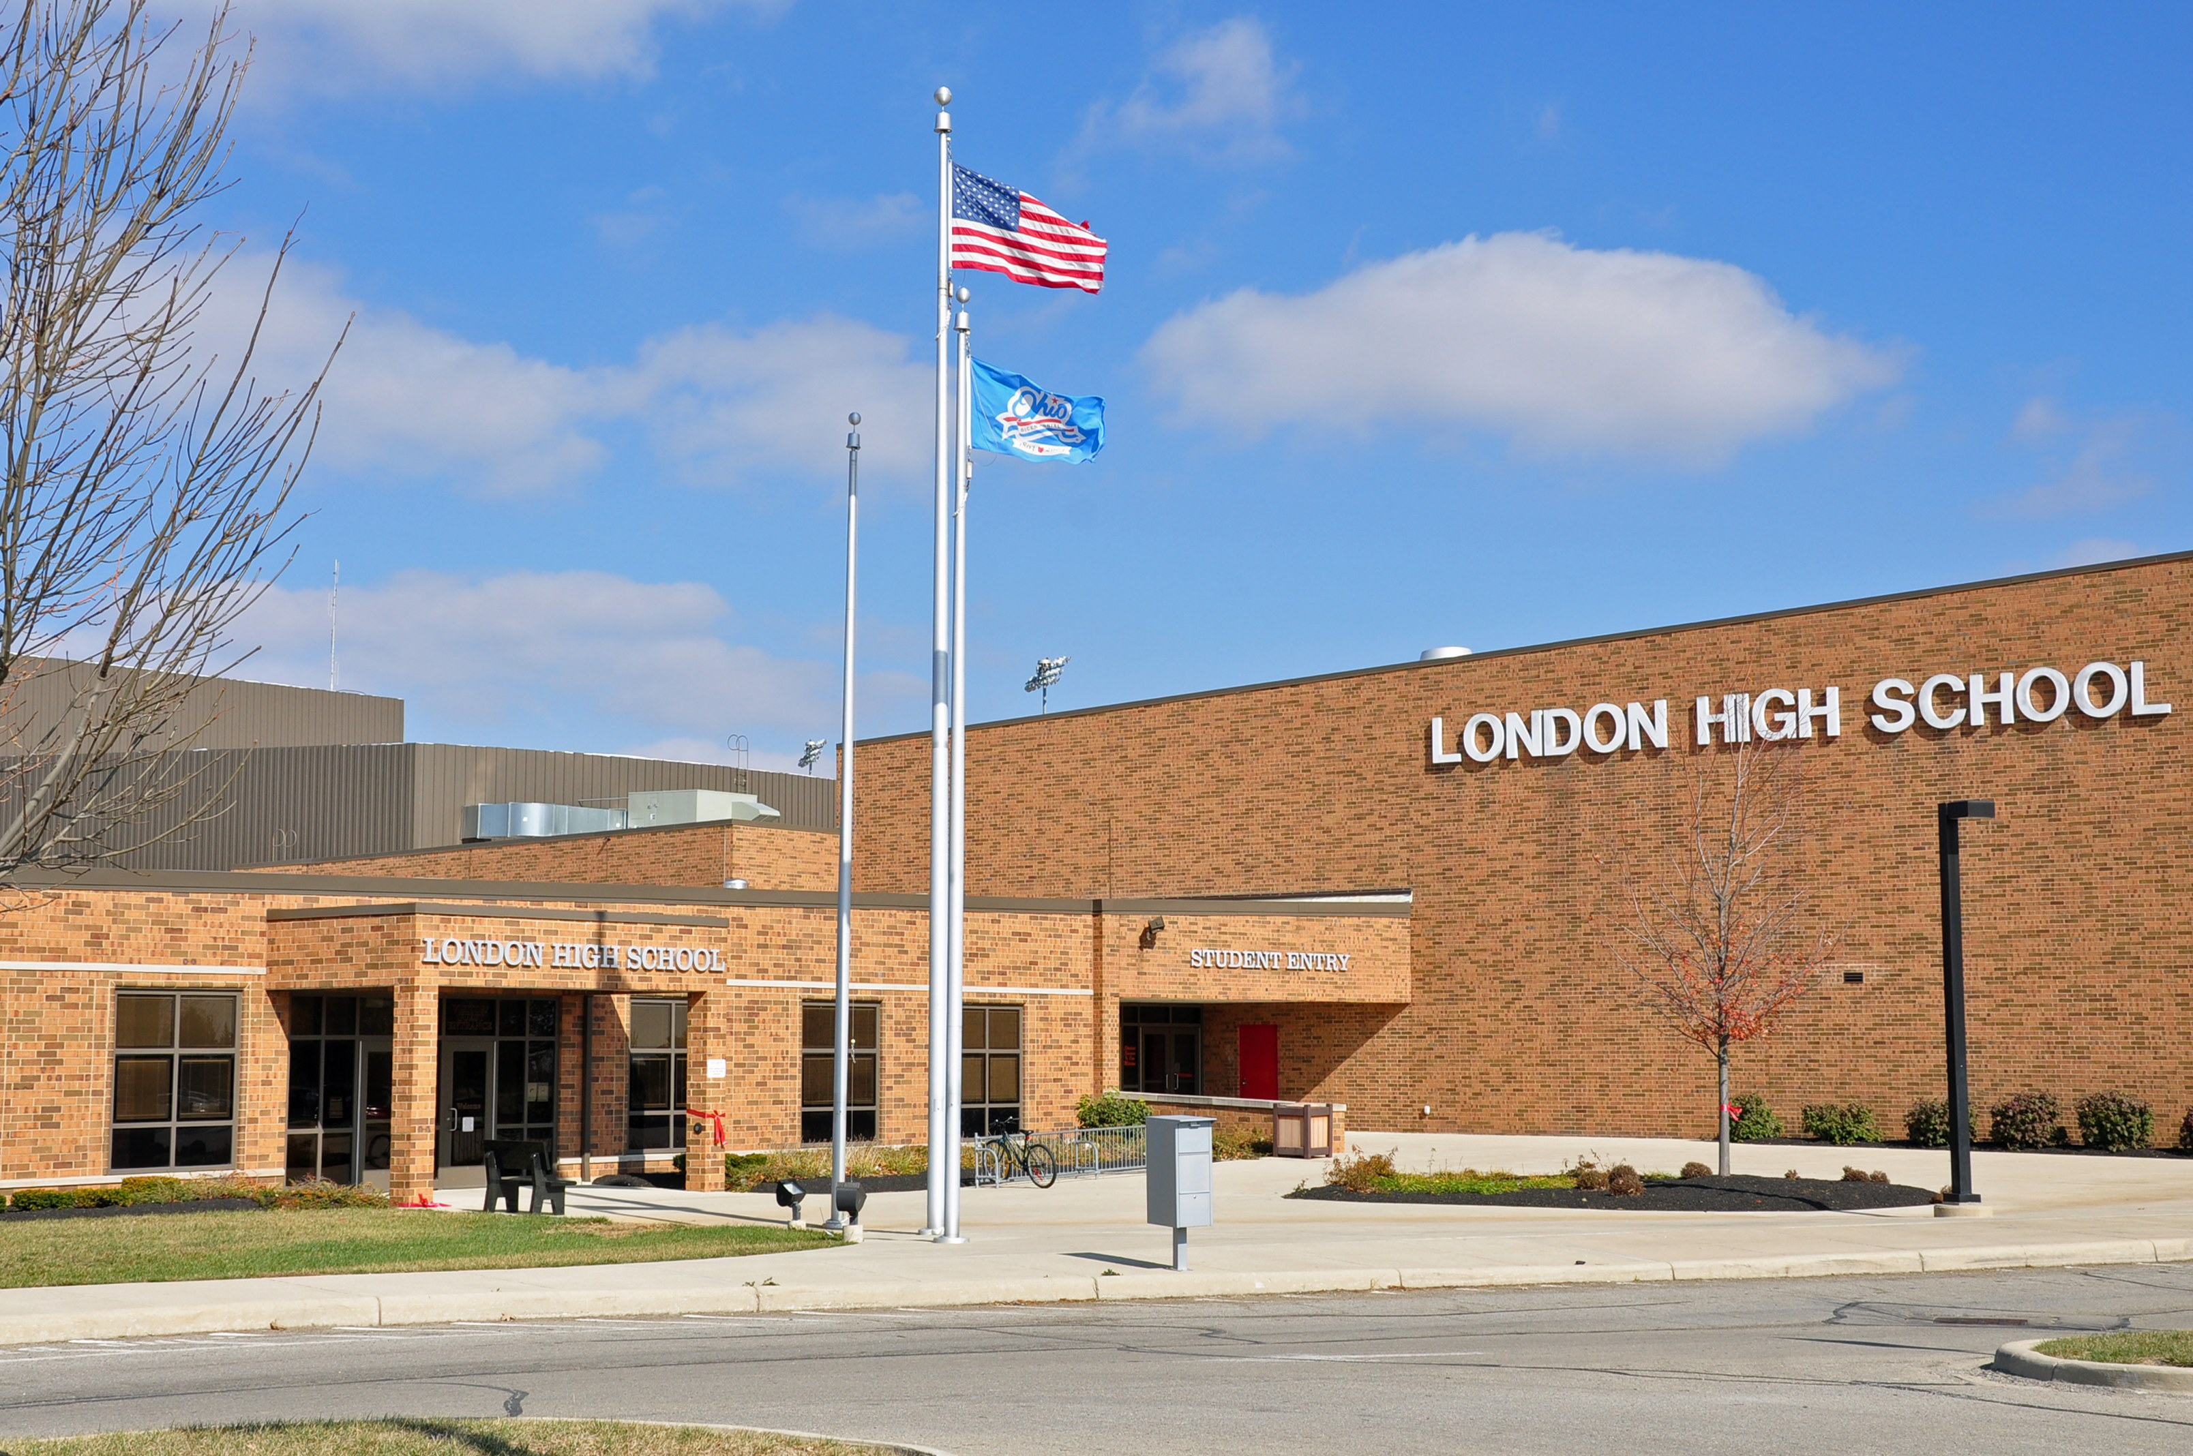
The Government decided not to make the 19th May a Bank Holiday for Harry and Meghan's wedding! Unfair! This is due to Saturday being a weekend and it's the same date as the FA Cup Final. AND it's also the same day as the Scottish Cup Final. Just imagine how good Harry and Meghan's day would be!

