PRIMARY 7

TASK – To build a Den for Harry the Hedgehog so that he stays dry, warm and safe.
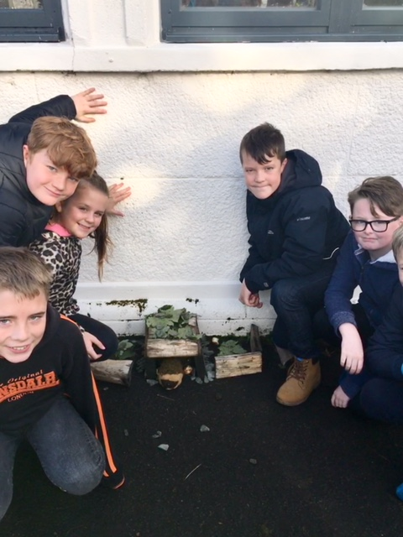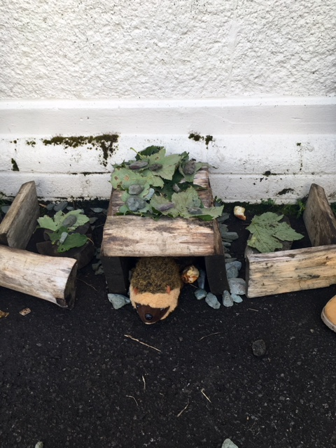
“It is helping us learn communication skills.”
“It helps us learn stuff that we could use in the future.”
“It is bringing us closer as a group.”
“It is making us think about what we need to make a good den.”

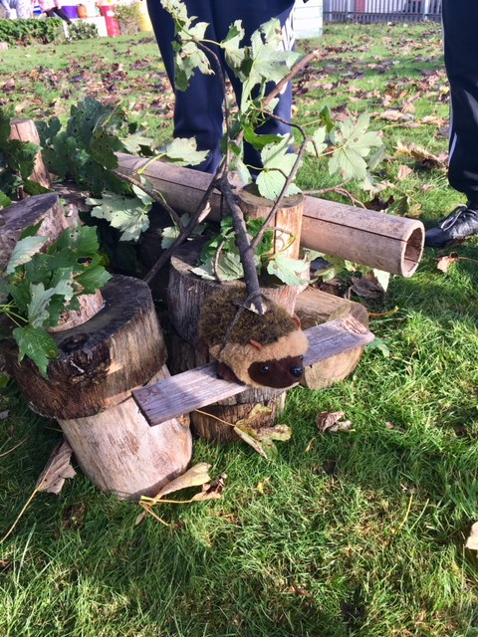
Harry the Hedgehog on his very own swing! #LOVING LIFE

