PRIMARY 6

TASK – To build a Den for either Harry or Mr Stink that keeps them dry, warm and safe.
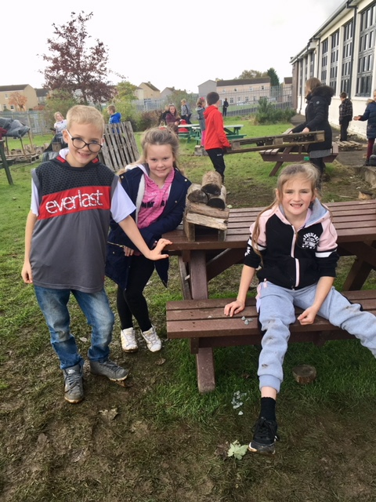
“We are using building techniques .”
“It is good for team work with your friends.”
“Harry needs to hibernate so we are making a shelter for him.”
n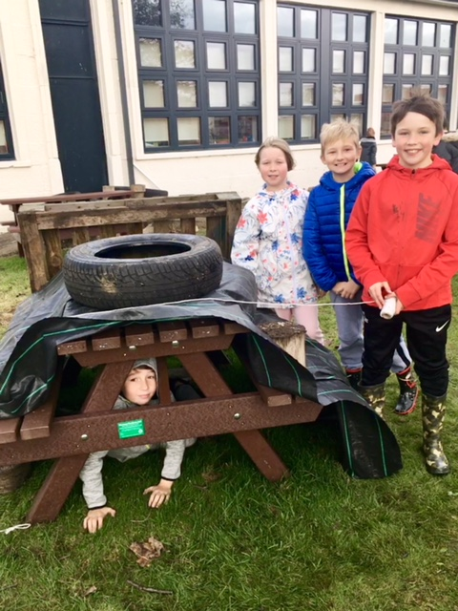
“We are building a home for Mr Stink as he doesn’t have a home.”

