PRIMARY 5

TASK – To get the ball to the end of the line using OVER and UNDER movements.
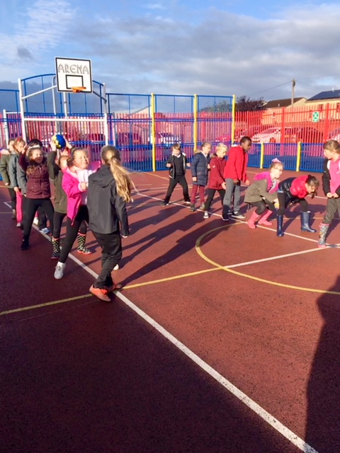

“we are learning Ball Skills and coordination.”
“We have to concentrate more.”
“We have to listen to the others in our team.”
“It is all about having fun!”

