PRIMARY 4

TASK – To learn about the points of the compass.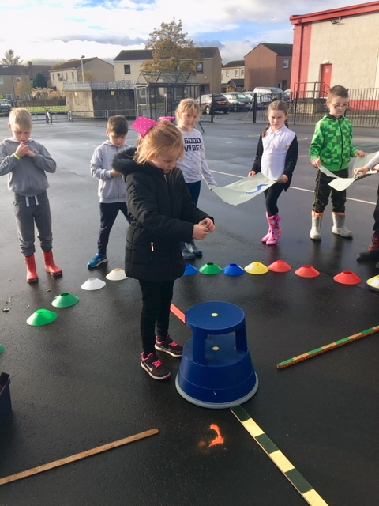
“We are finding out about North , South, East and West.”
“We’ve been doing this for maths in our class.”
“Outside we can make a ginormous compass!”
“It helps us with team work, friendships and respecting each other.”
