PRIMARY 3

TASK – To make a Harry the Hedgehog House.
“We are making a house and calling it; ‘The Harry House!’”.
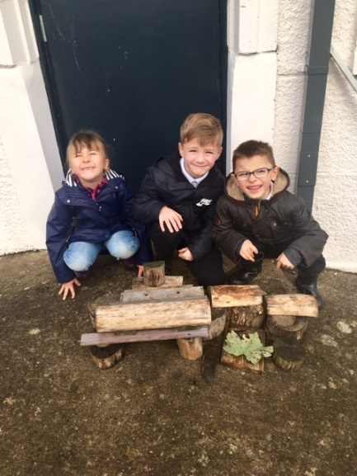
“We are learning to work together as well as building.”
“We like it as it’s fun – instead of working in the class all the time.”
“We are getting to learn about Team Work and how to help each other.”
