PRIMARY 2

TASK – To make a Dream Catcher for the B.F.G.
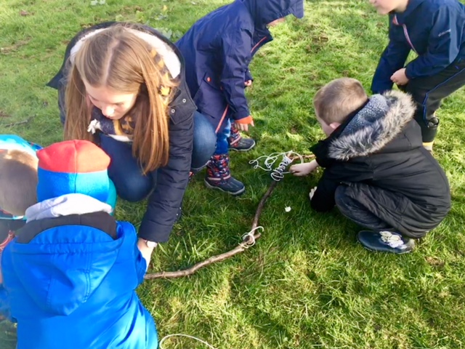

“We had to get sticks from the garden to make it.”
“We planned it in class first.”
“We had to tie them together with string to make it.”
“IT’S GREAT FUN!”

