PRIMARY 1

TASK – We can write our numbers 1 to 10.
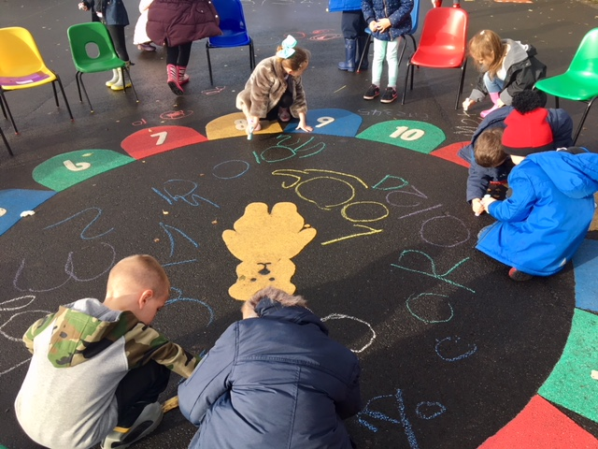
“We are writing our numbers.”
“We can make them really big!”
“We are having fun!”
