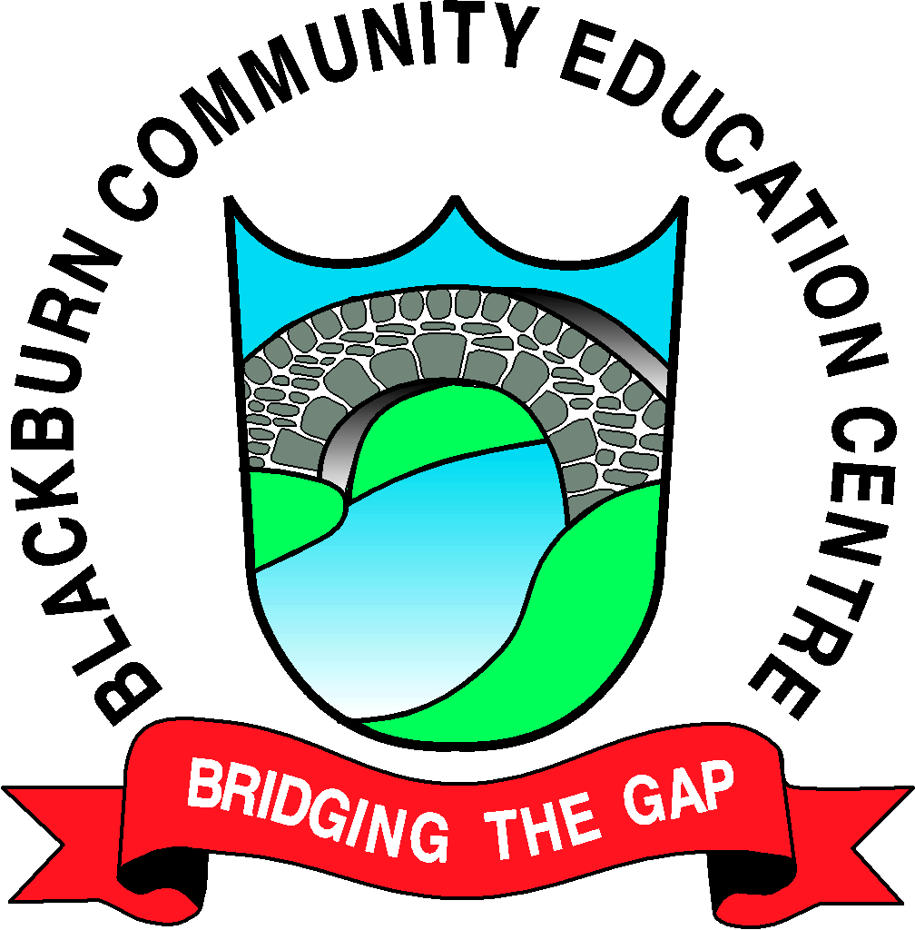

Friday 25th November

**5.30—7.00pm** Under 10’s event—Children MUST be accompanied by an adult

There will be a range of soft play / bouncy castle and disco to keep the wee ones entertained.

Snacks will also be provided.

**7.30—9.30pm** Under 18’s event

There will be terror slide, bungee run and rodeo bull and disco.

Snacks will also be provided at this event.

Saturday 26th November **Over 18’s only**

**2.00— 4.00pm**  Afternoon Tea

The chance to reminisce and share stories. Tickets include tea, sandwiches and cakes.

**7.30— 12.00** Disco

A chance to relive your youth at a centre disco—bring your own bottle event and a buffet will be provided.

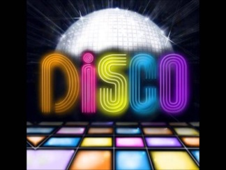

**\*\* PLEASE NOTE TICKETS ARE FREE BUT TO ENABLE CATERING TICKETS NEED TO BE COLLECTED FROM THE COMMUNITY CENTRE BY FRIDAY 18TH NOVEMBER.**

**FOR FURTHER INFO PLEASE CONTACT THE COMMUNITY CENTRE (01506 653014)**