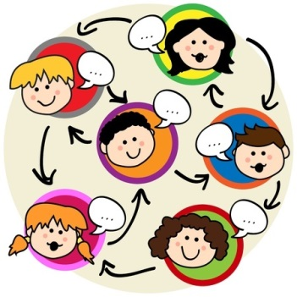
Pupil Voice Discussions – P2-7
Tuesday 6th September 2016
WHAT HELPS US TO LEARN AT SCHOOL?
What adults do?  - Repeat tasks so we understand  - Help with tricky work  - Have their own way of teaching  - Buy resources (Head Teacher)  - Go around tables individually  - Help us when we need it  - Gives us lots of ideas | Which resources?  - Rulers  - Books  - Pencils, pens etc…  - Net Books  - White board  - Laptops  - Muga  - IPad  - Teachers  - Reading books
In a classroom?  - Organised resources  - Quiet time  - Teachers  - Everything tidy  - Use the Smart Board  - Books to read  - A place for circle time | Other places in school?  - Playground for chalk drawings  - Garden to learn more about nature  - Playground for exercise  - Garden for athletics  - Hall for sport  - GP room for computer skills  - GP room for Art
Other ideas… Sleep, longer playtimes, games and chocolate!

