Winter Ready – Primary 1
December 2015

If the school is closed due to bad weather,
here are some ideas to help you carry on learning
at home.
- Key Words,
- Phonic recognition,
- Letter formation,
- I can write my name like this,
- Word building
- My favourite book
- Number formation
- Maths “Learn-it’s”
- Design a snowman

ORT stage 2 key words ________________

‘Sound it out’ words |  | got | cross | in
 |  | it | went
 |  |  |  | 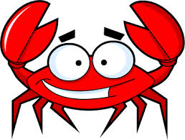
Sound out the  start |  | everyone
When ‘u’ sounds like ‘oo’ |  | put | pushed | pulled

When ‘a’ sounds like ‘awe’ |  | was | 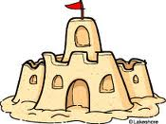  wanted
Magic ‘e’ words |  | made
When t and h make ‘th’ |  | they | the

Tricky ‘sight’  words |  | he | to | said
Don’t forget to point under every sound.
ORT Stage 3 Key Words __________________

‘Sound it out ‘  words |  | am | at | up
 |  | get | on | Wilf
 |  | Wilma
Sound out the start |  | jumped | barked
ee and oo words |  | tree | looked
When c and h make ‘ch’ |  | children
Magic ‘e’ words |  | gave
Tricky sight words |  | couldn’t | climbed | played
 |  | what | I

Don’t forget to point under every sound.

13.10.15 Phonics up to e,r,h ____________________________________________

Match the words
egg rat hat can dad cat
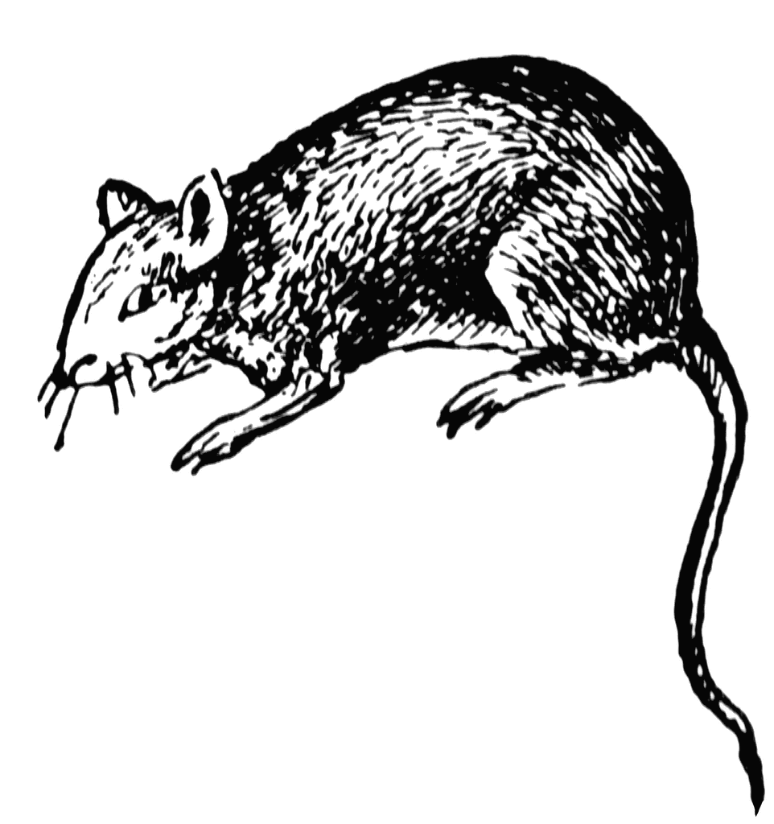
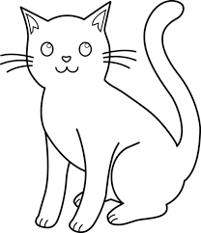

fan fin fun sun fit elf
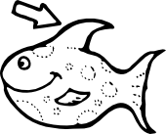
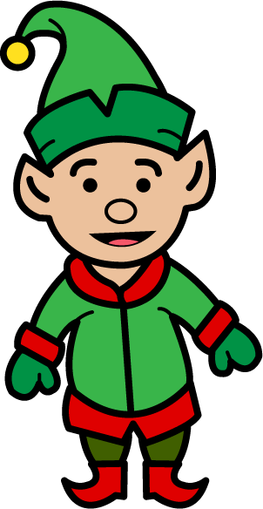
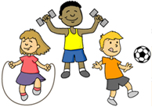

pot tap map mad sad sit
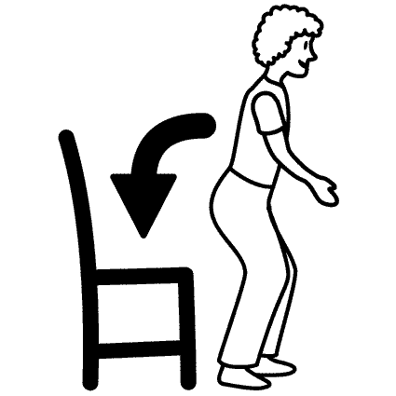
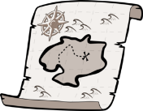

pin pan lid run ant mat

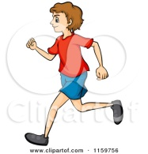
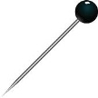

Write the words

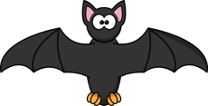

My Favourite Book
Draw a picture from your
favourite book.
Write the character’s names.
Copy a sentence.

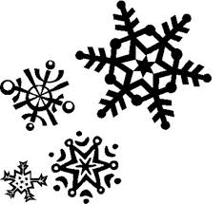
Design a Snowman
Draw a snowman.
Give him a hat and scarf.

Can you make a real snowman just like this one?

Primary 1 Learn Its KEEP ME AT HOME

1 + 1 = 2 2 + 2 = 4 3 + 3 = 6

4 + 4 = 8 5 + 5 = 10
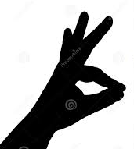
3 + 2 = 5
2 + 1 = 3
2 + 3 = 5
1 + 2 = 3

Homework task :
Can you learn these sums off-by-heart?
P.T.O. for parent’s notes.
Parent’s Notes:
Please help your child to learn these number-bonds off-by-heart.
- Start by looking at the pictures and saying the sums together.
- Then - read the sums again but
cover the answer with your finger.
- When your child is confident – try 3 + 3 = 6
the sums below without the pictures.

4) For any they are finding really tricky –
you could cut out the picture sum and stick it
somewhere (e.g. on the fridge?)

Check-up :
Help your child to test himself with these sums. . .
Please don’t write on this grid – it can be used over and over again.
- + 1 = ? | 2 + 2 = ? | 3 + 3 =
4 + 4 = ? | 5 + 5 = ? | 3 + 2 = ?
- + 1 = ? | 2 + 3 = ? | 1 + 2 = ?

Big Maths Beat That Learn It’s P2 Sheet 3 The bonds of 10

Name: _____________________ Date: ________

How quickly can you spot the “bonds of 10” sums ?
Write out 2 sums for each picture . . .

________ + _______ = 10 ______ + ______ = 10

________ + _______ = 10 ______ + ______ = 10

________ + _______ = 10 ______ + ______ = 10

________ + _______ = 10 ______ + ______ = 10

Bonds of 10 game

Play my favourite maths game . . .
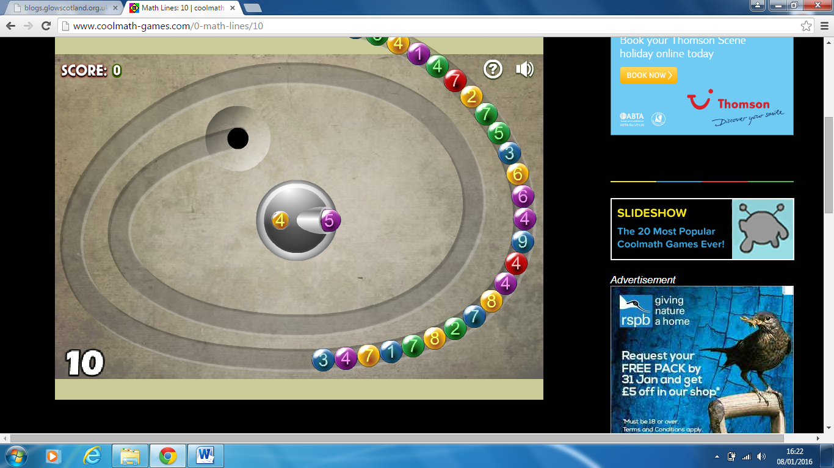
www. Coolmath-games.com
/ math lines

Challenge :- What level can you reach?

Extra Challenge:- You can change the total to work in a different
number bond.

