Nurture Group Summer 2015

It is hard to believe that this year is almost done and it is time for another newsletter to show you all what we have been up to.
SHIELD – Shaun, John-Paul, PJ, Hollie, Fiona, Lewis and Adam
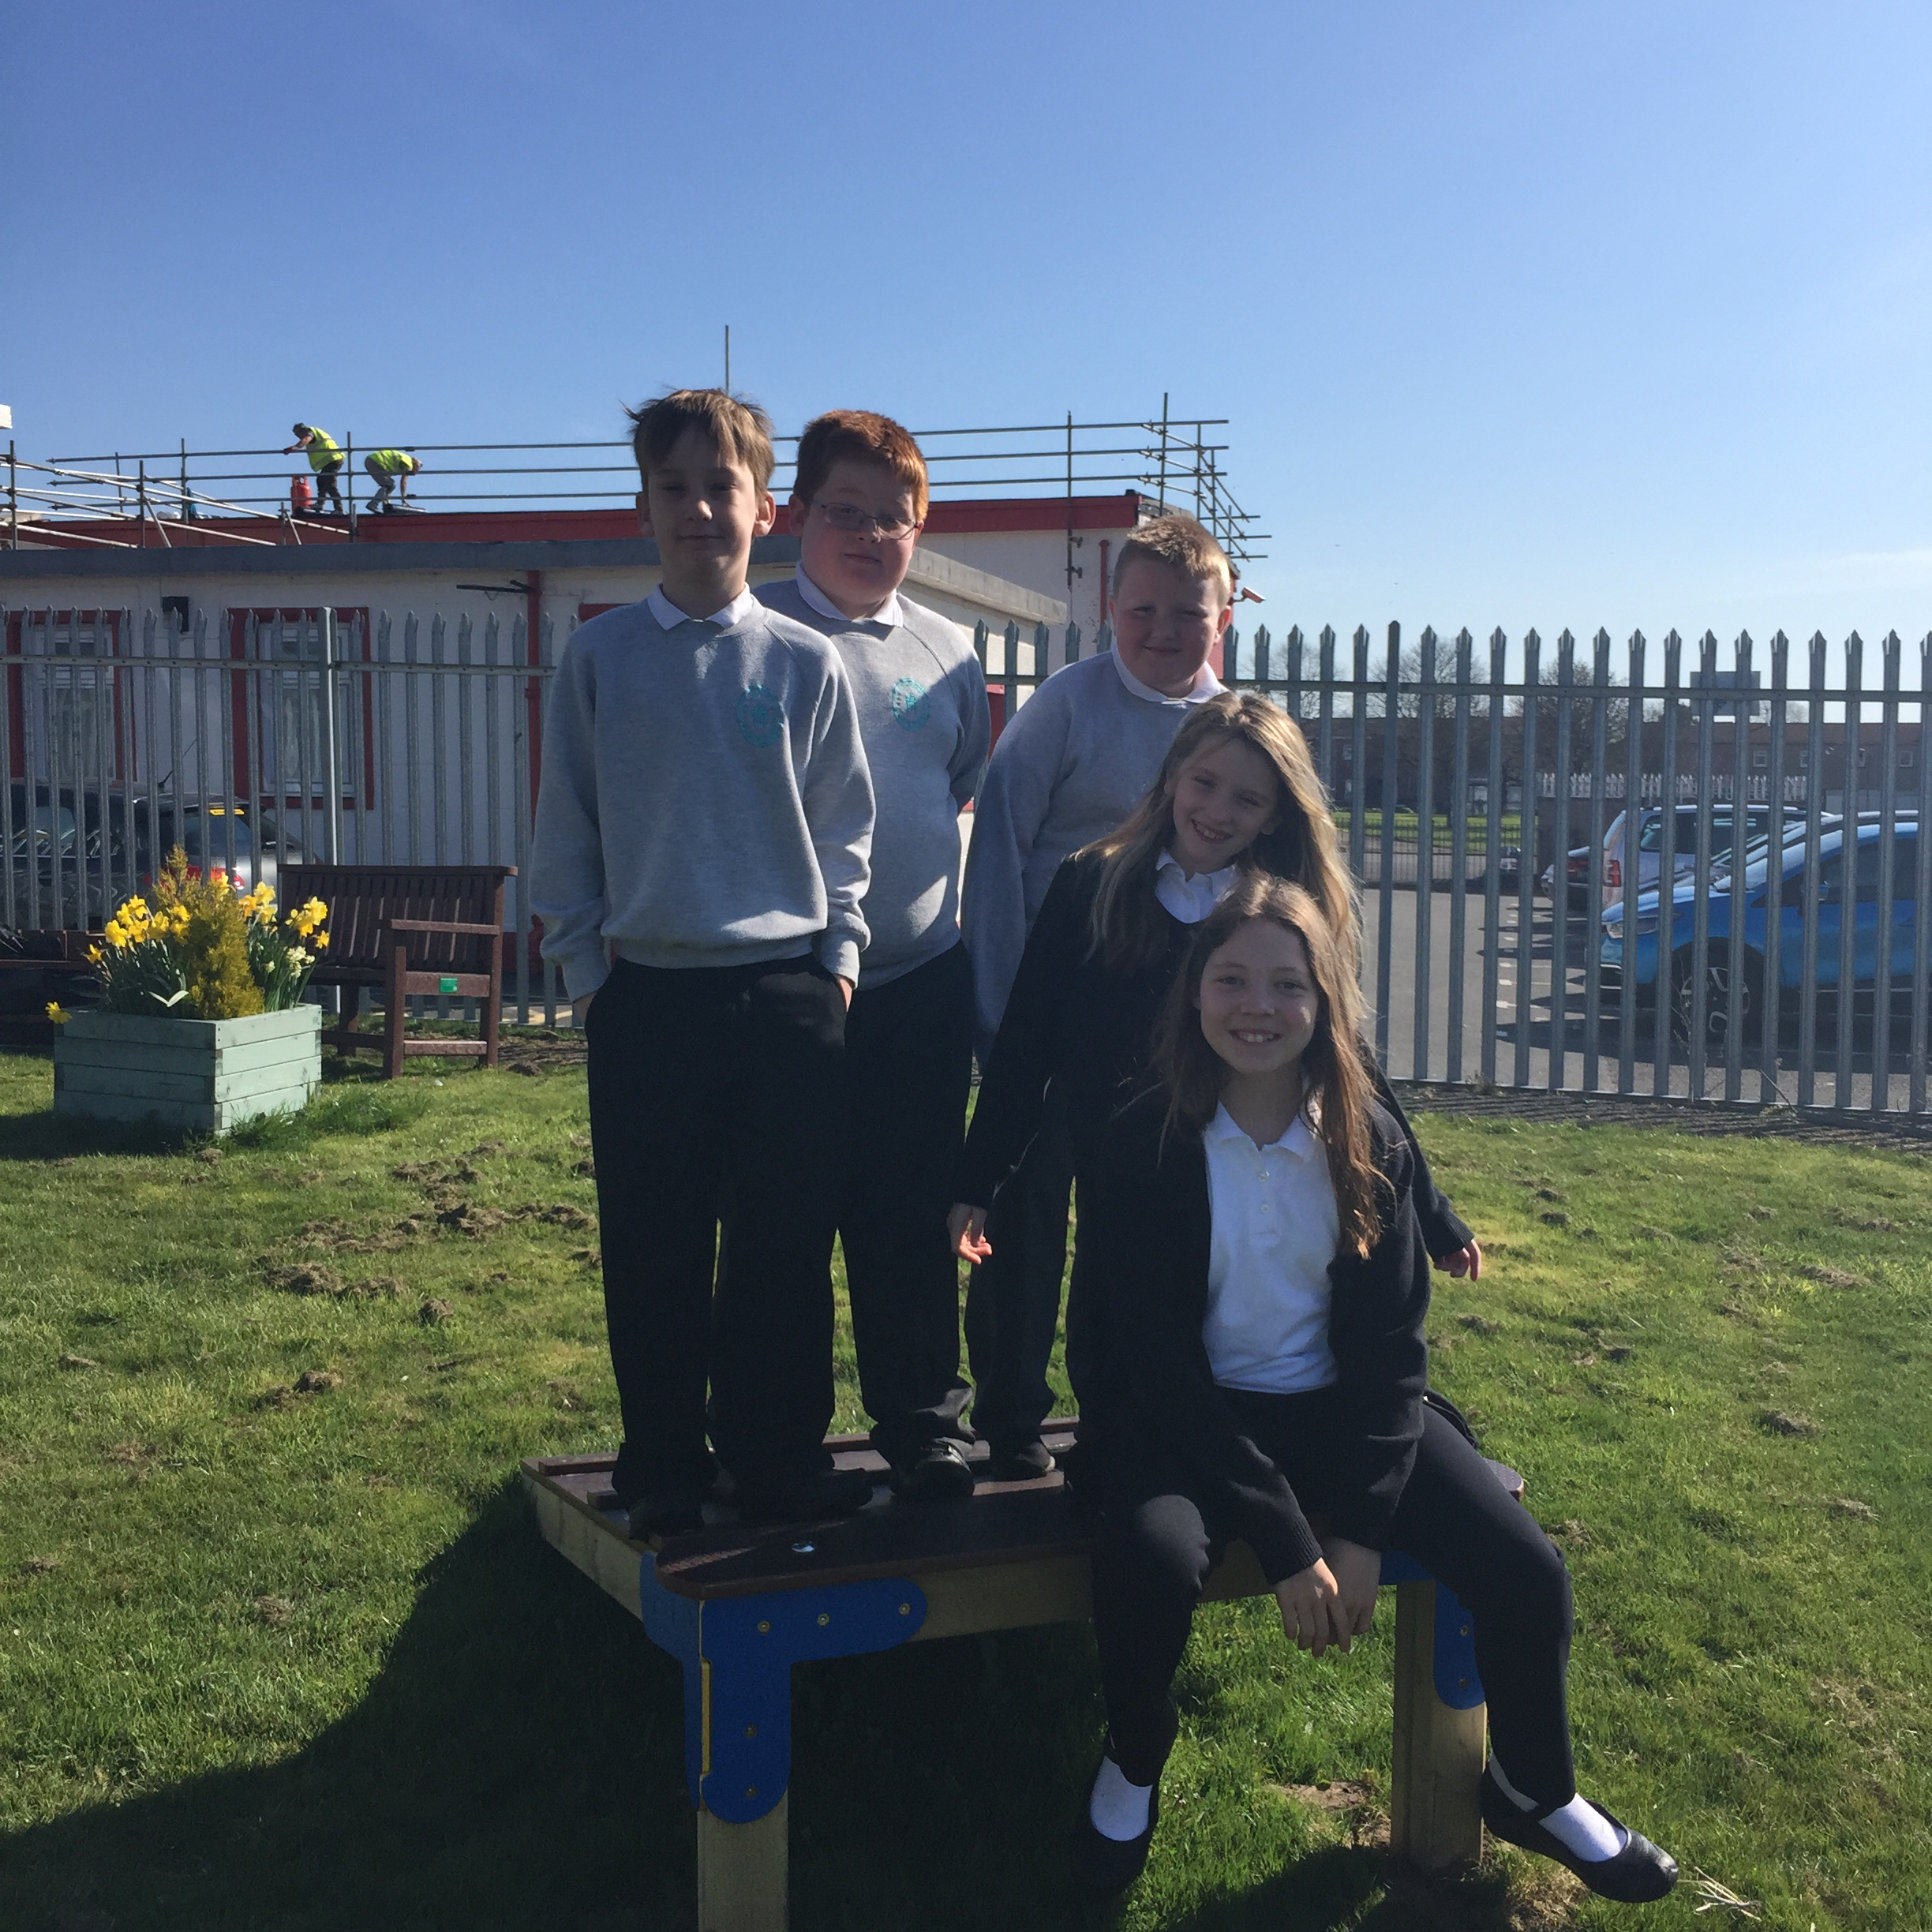
The Stars – Leah, Igor, Kevin, Cerys and Arran.
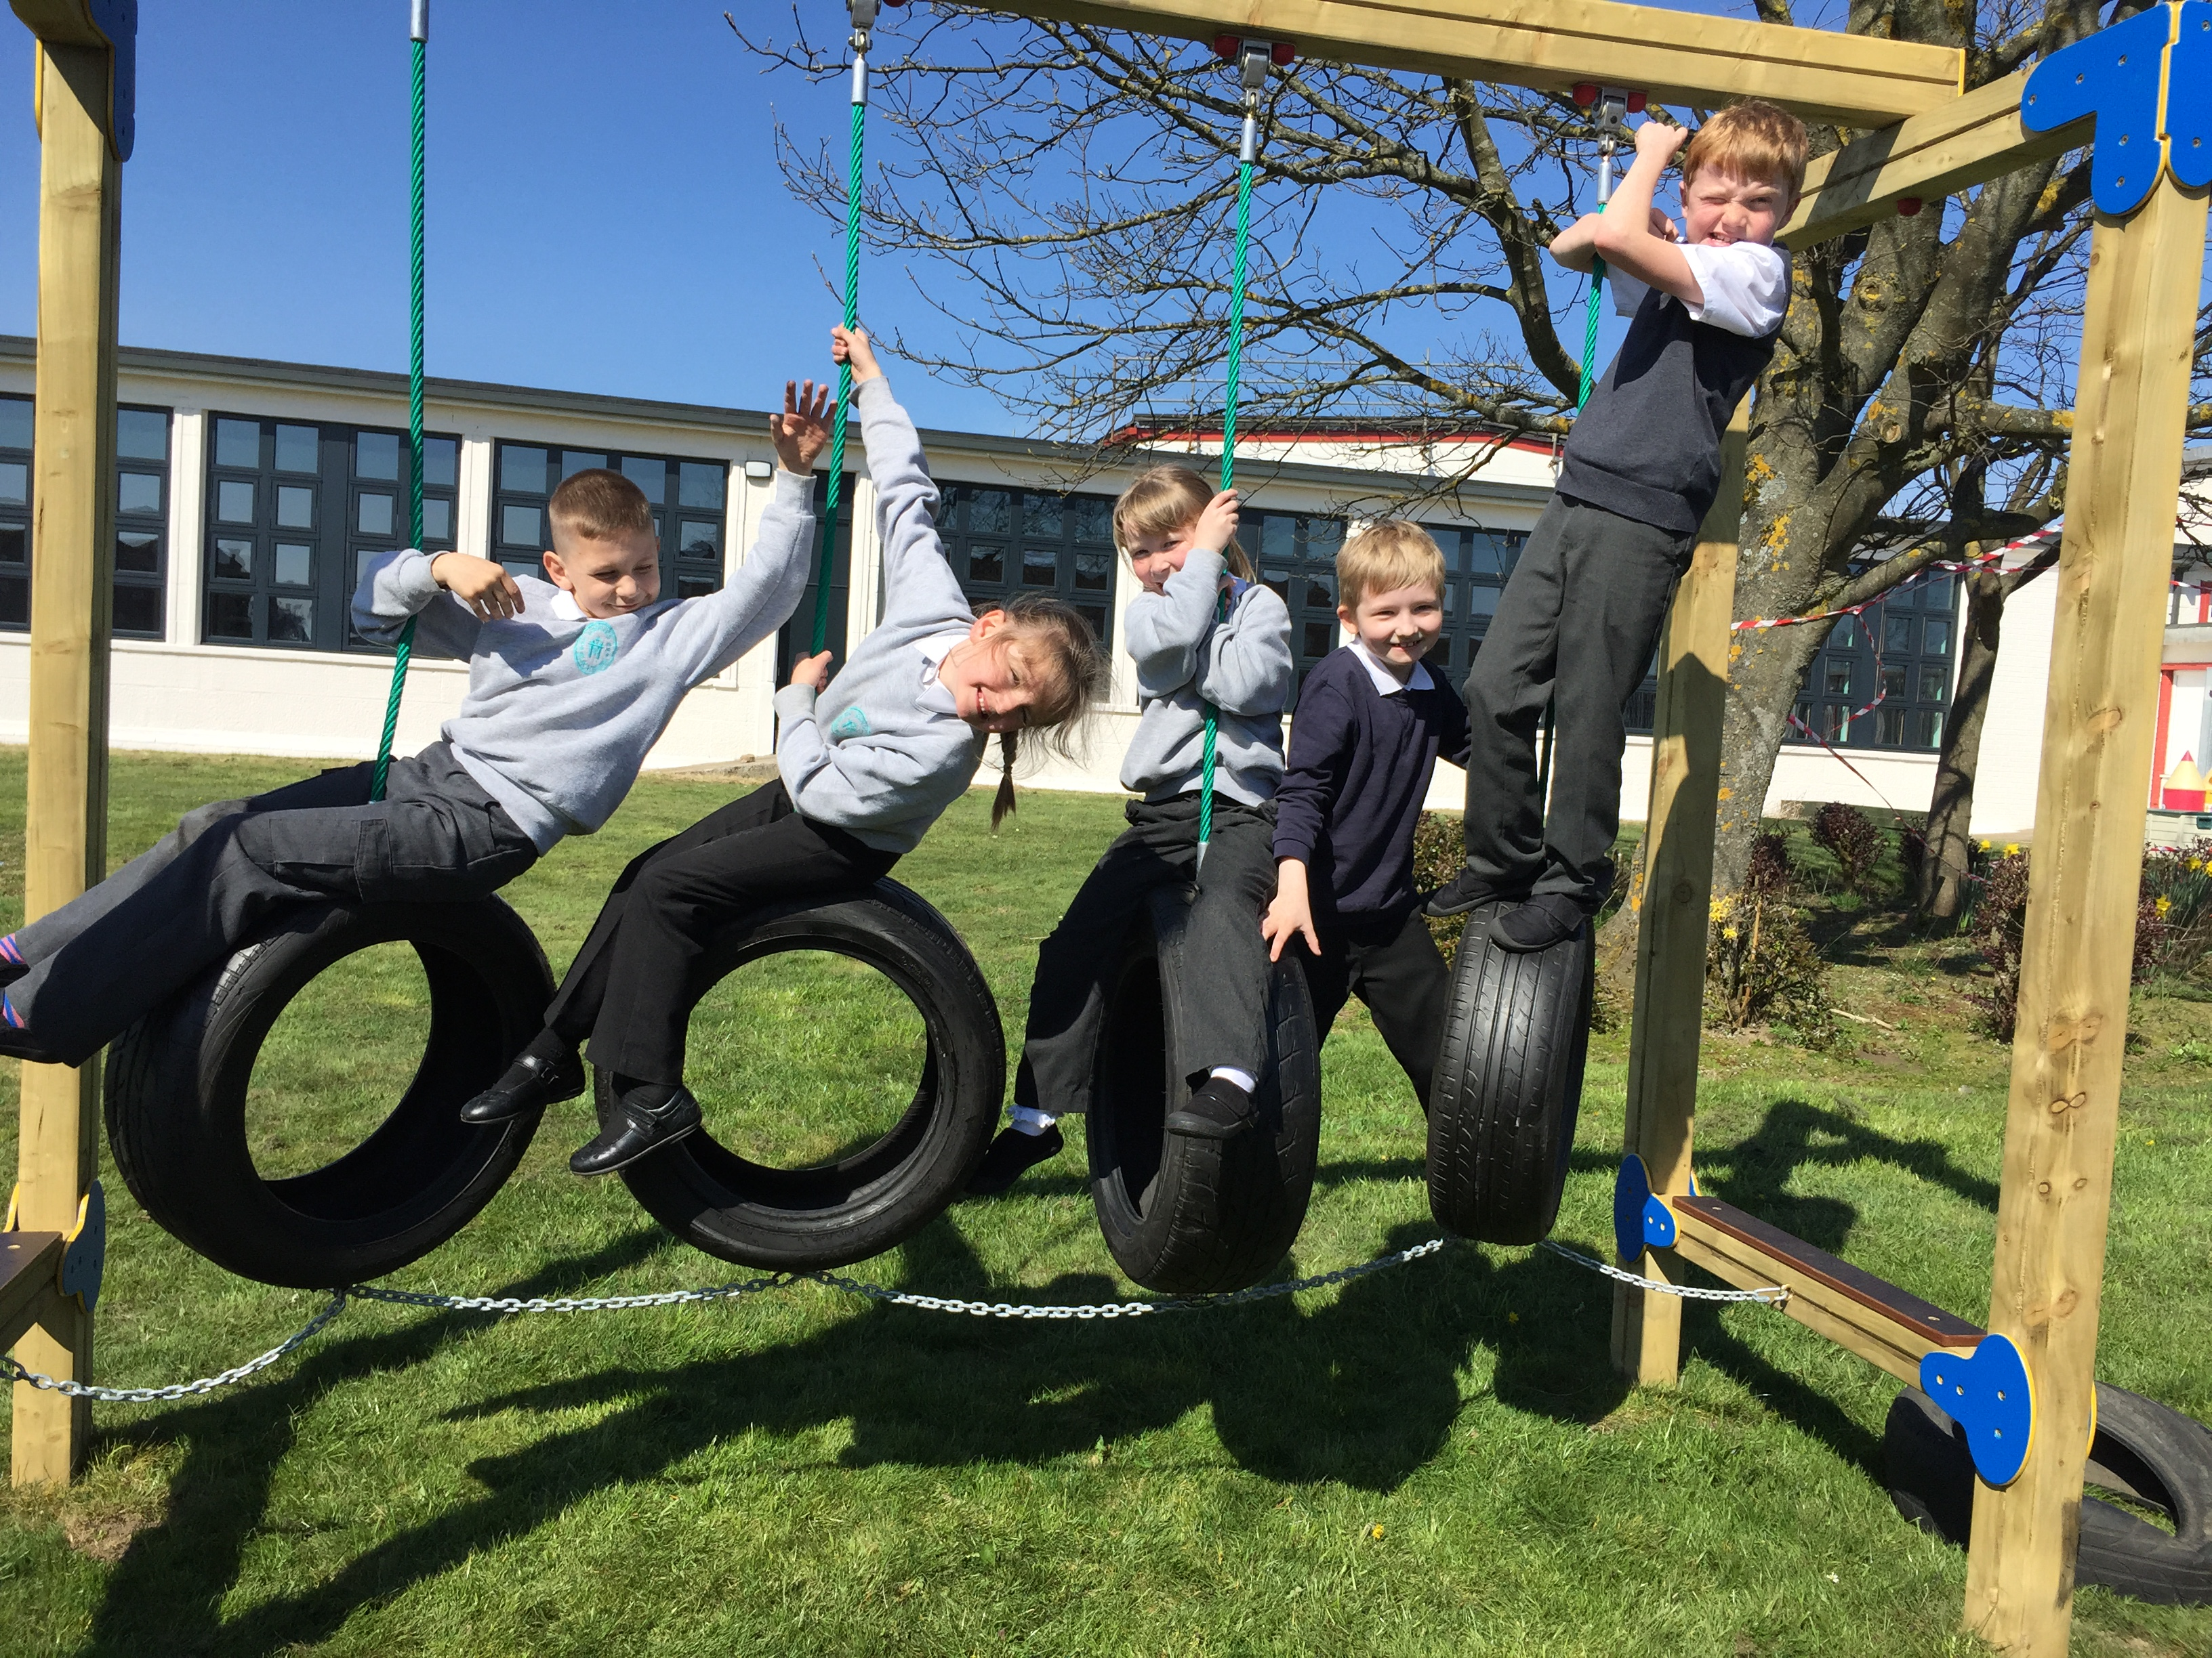
The big news this year has been that the SHIELD group were awarded the Access to Education fund they applied for and have been busy spending the money developing the school garden.
Most of the money went on a trim trail. The group were involved in every stage of buying this, meeting the salesmen, deciding which elements to buy and even checking the site for cables. We are thrilled with the result as are all of the classes.
PJ – It was fun and exciting helping the guy from Creative Play looking for cables.
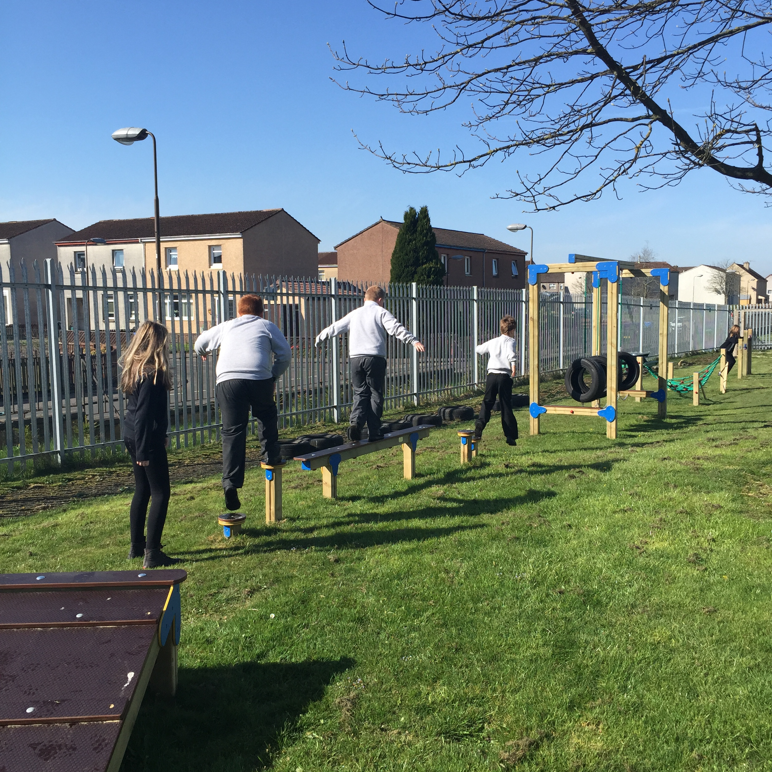
This was not the end of our work though and in May we have worked very hard to create an outdoor classroom space with logs and bark and a car track with stones and bricks.
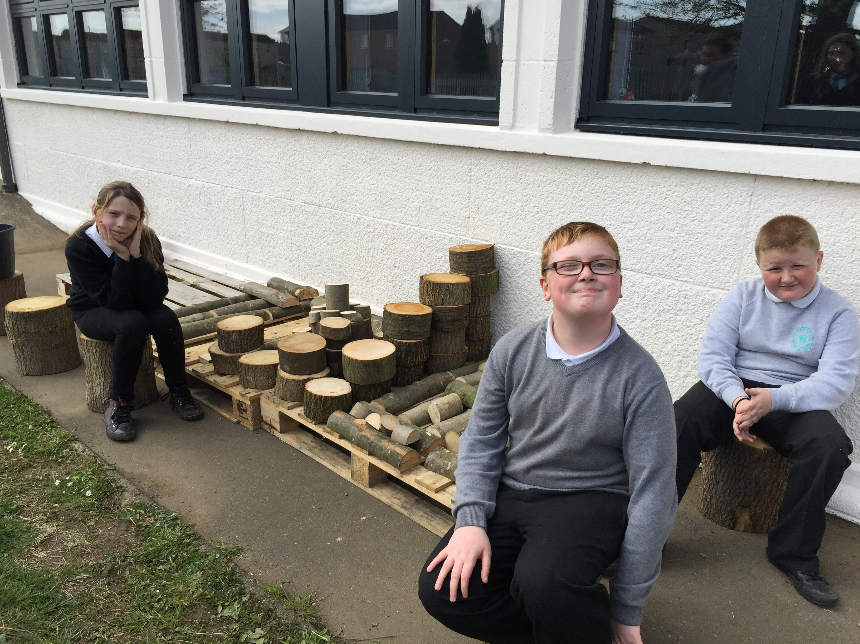
Fiona – The nurture group went outside to do work in the garden and then we got to play on the trim trail.
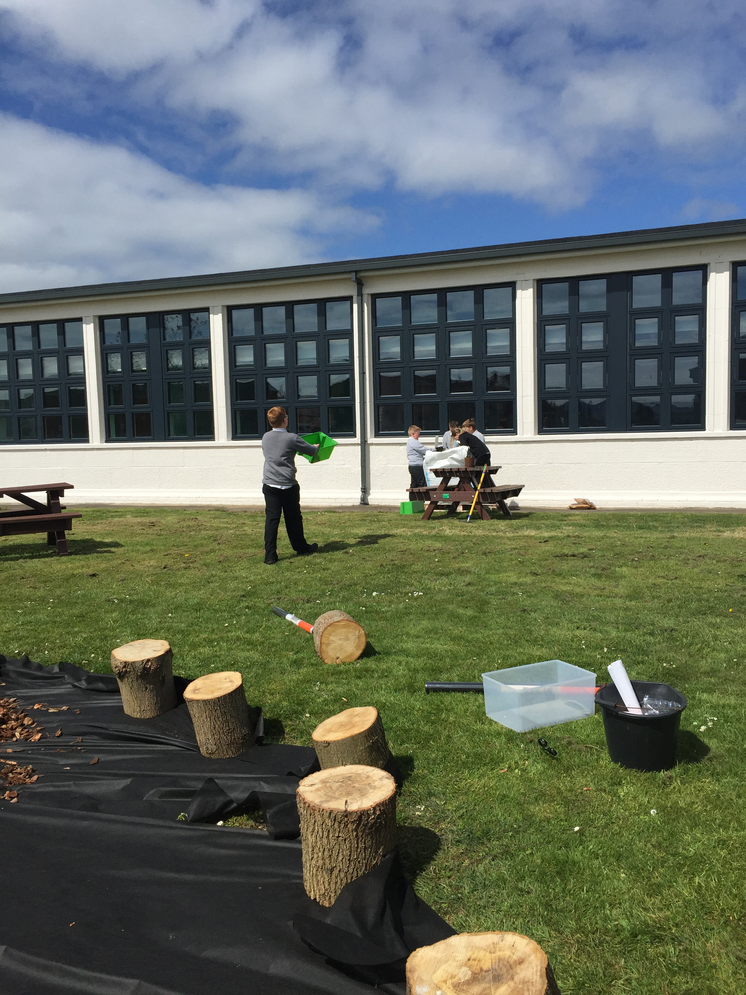

Lewis – I enjoyed making the seating area.
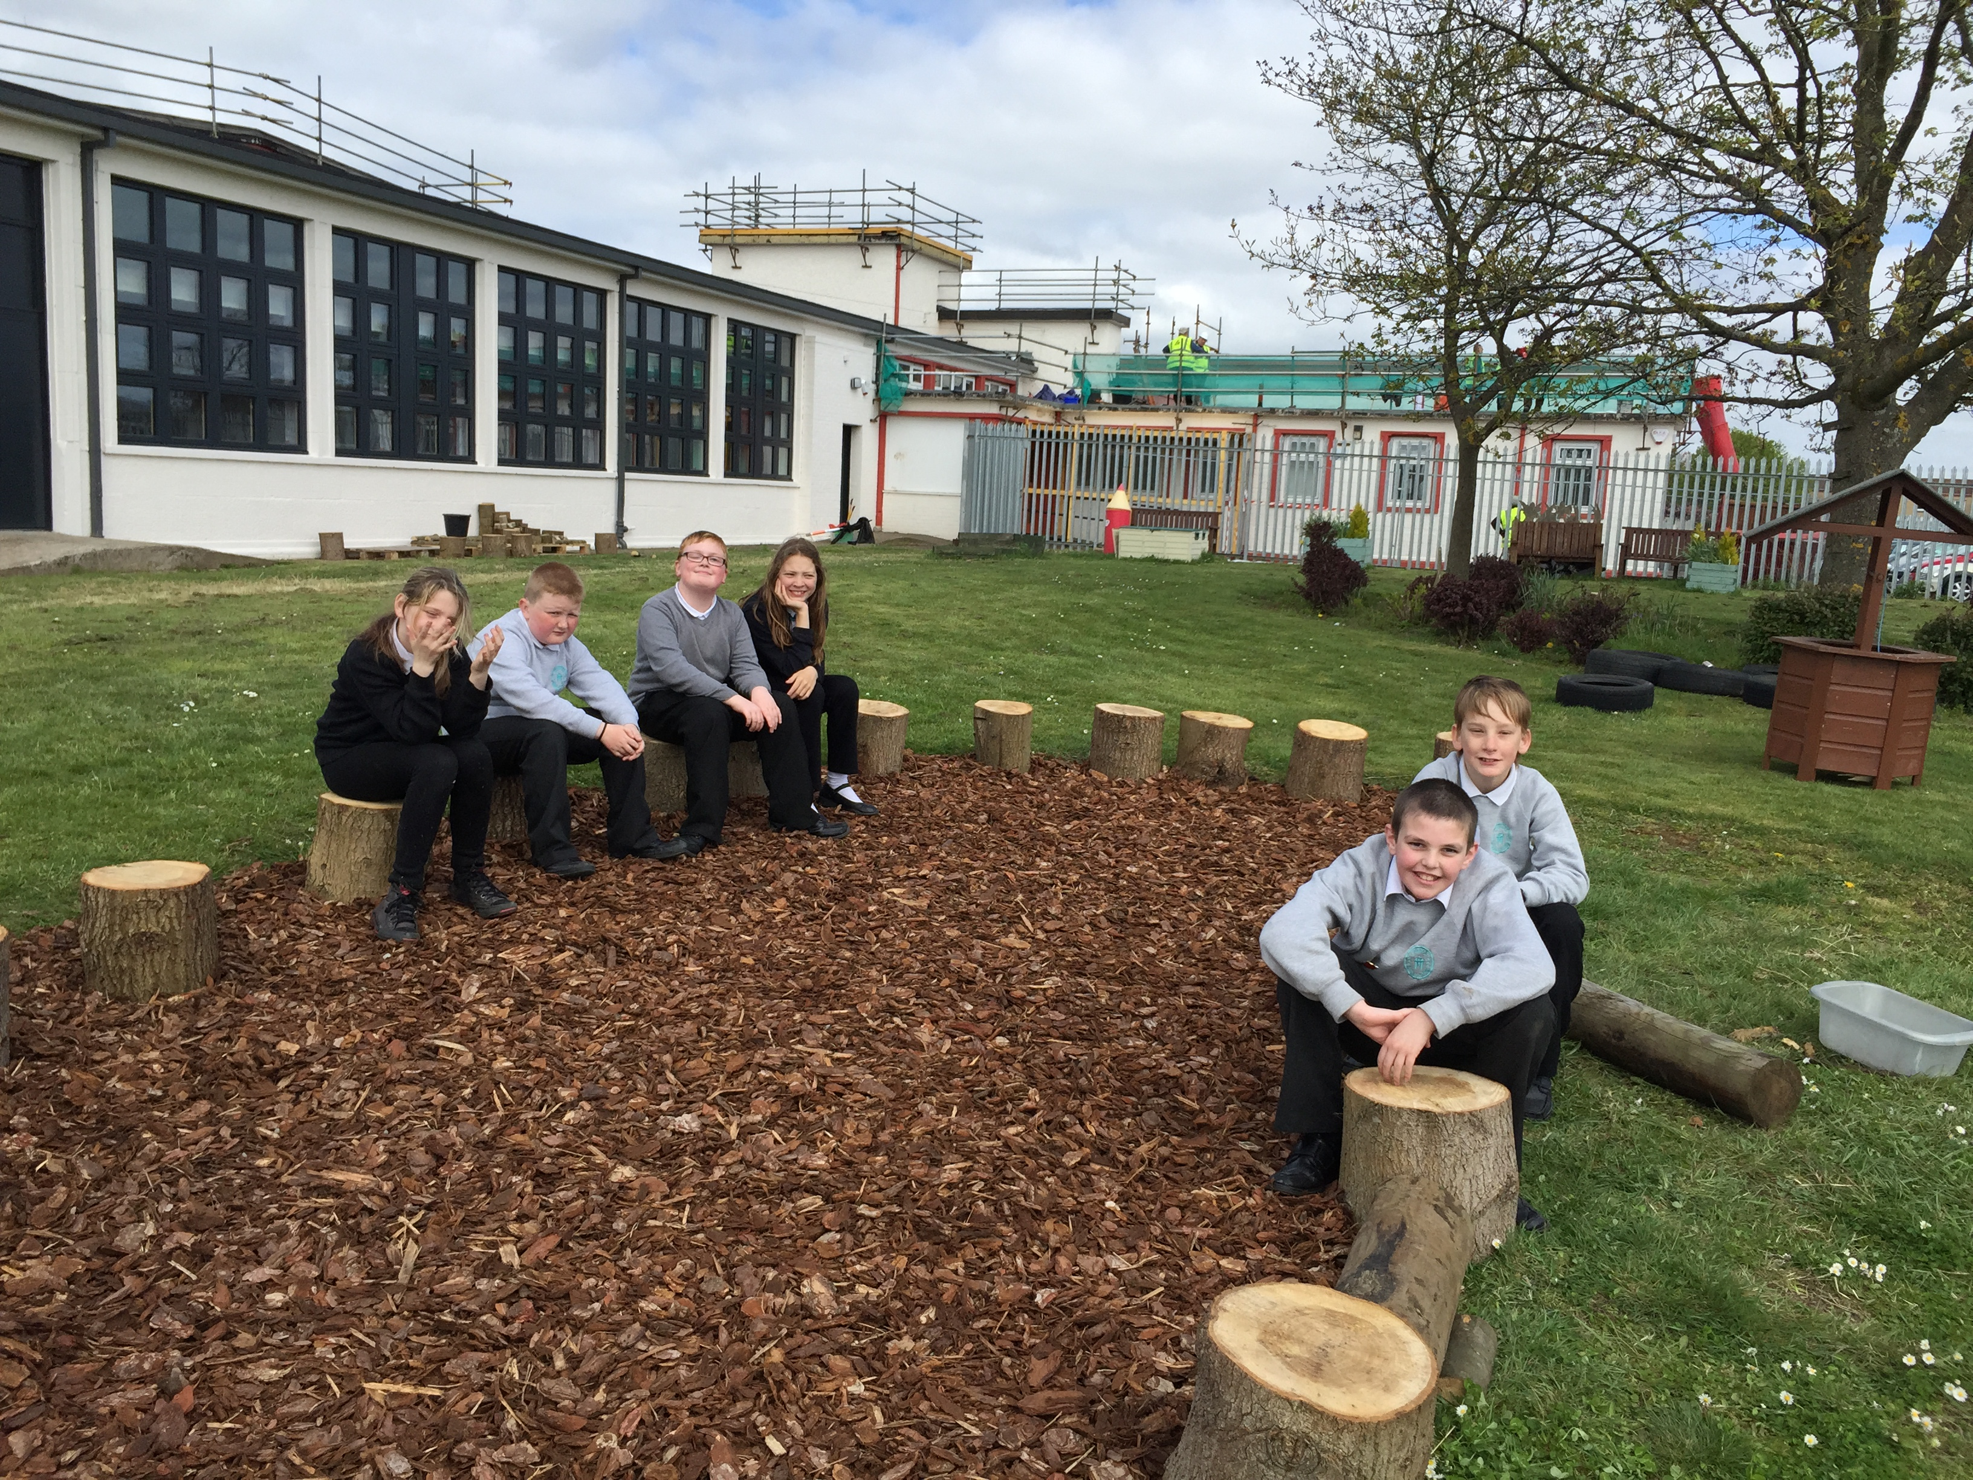
Adam – I loved building the outdoor class and helping the environment by picking up the litter.
We also created a small world space in one corner of the garden for the infants to use with cars or animals. We got really dirty the day we moved all of the gravel and hope that the parents don’t mind too much! We still have plans to create a hop scotch.
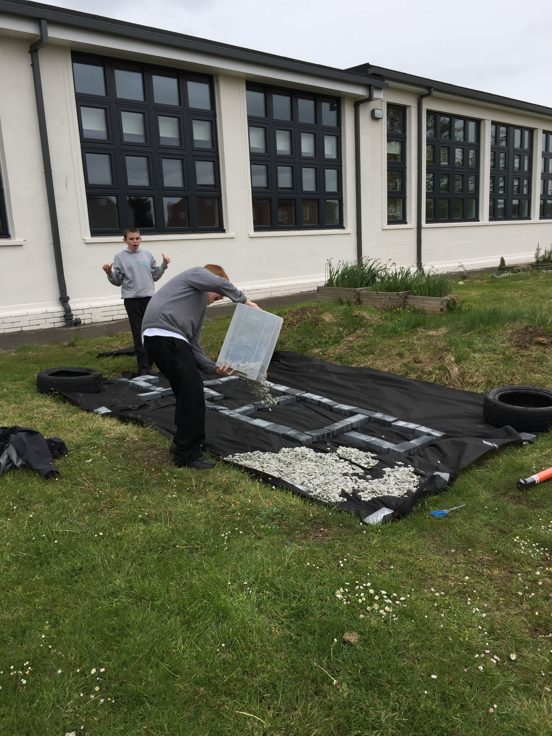
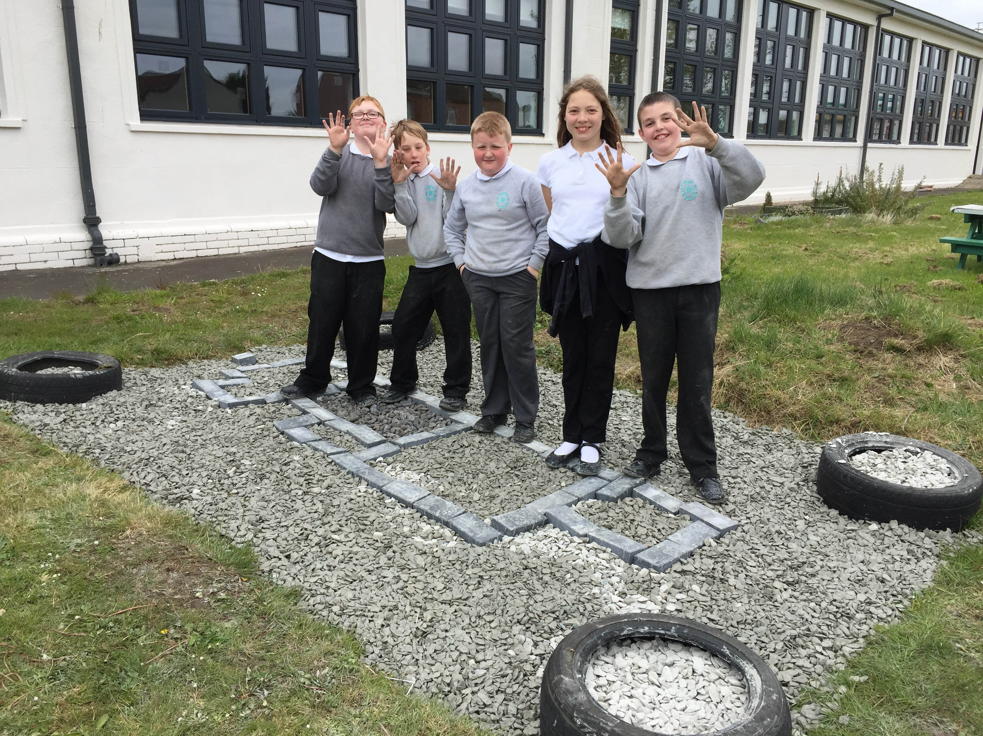
The group have also worked clearing the garden and with some planting. All of this work outside, along with the photography, planning and surveying last year were part of working towards the John Muir Award and I am thrilled to say the group have now achieved this and will be getting their certificates at the end of tem.
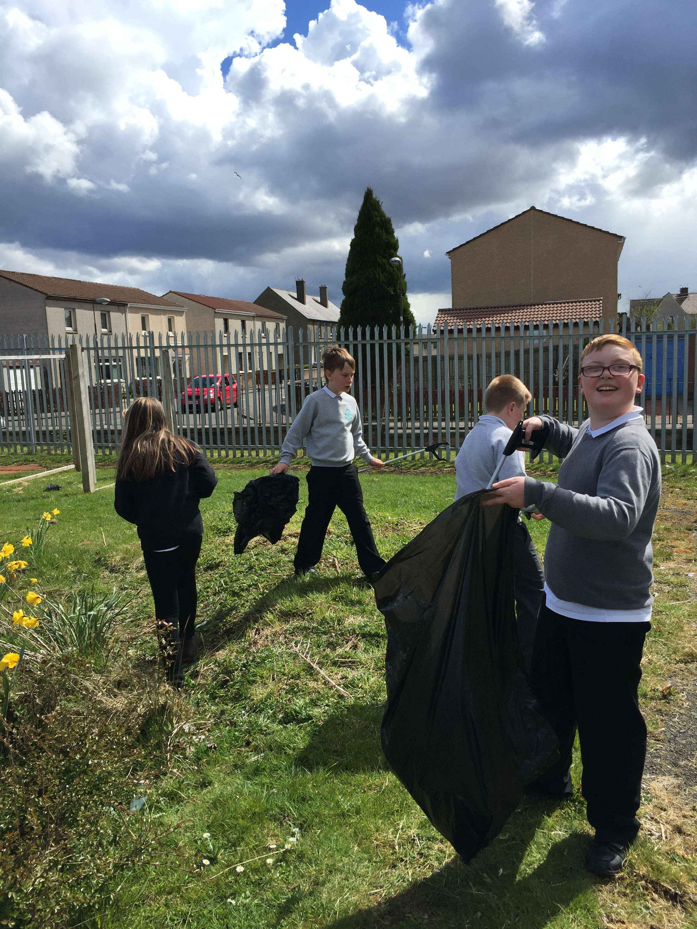
John-Paul – I liked tidying up the garden and helping with the gardening.
The Stars Group have also been busy this year. They have been working on attention and sitting at the table chatting for longer. The group will now happily sit for 30-40 minutes each week discussing questions like – Which is better TV or books? and ‘If you were the teacher and the class were noisy what would you do?’. These questions are designed to encourage the group to be confident, knowing that their opinion is important and so is everyone else’s even if it is different.
Art is always a favourite with both groups and recently our art has all had the theme of colour. We created a large piece of collaberative art with both groups which built over two weeks. As well as creating smaller pieces that are on display.
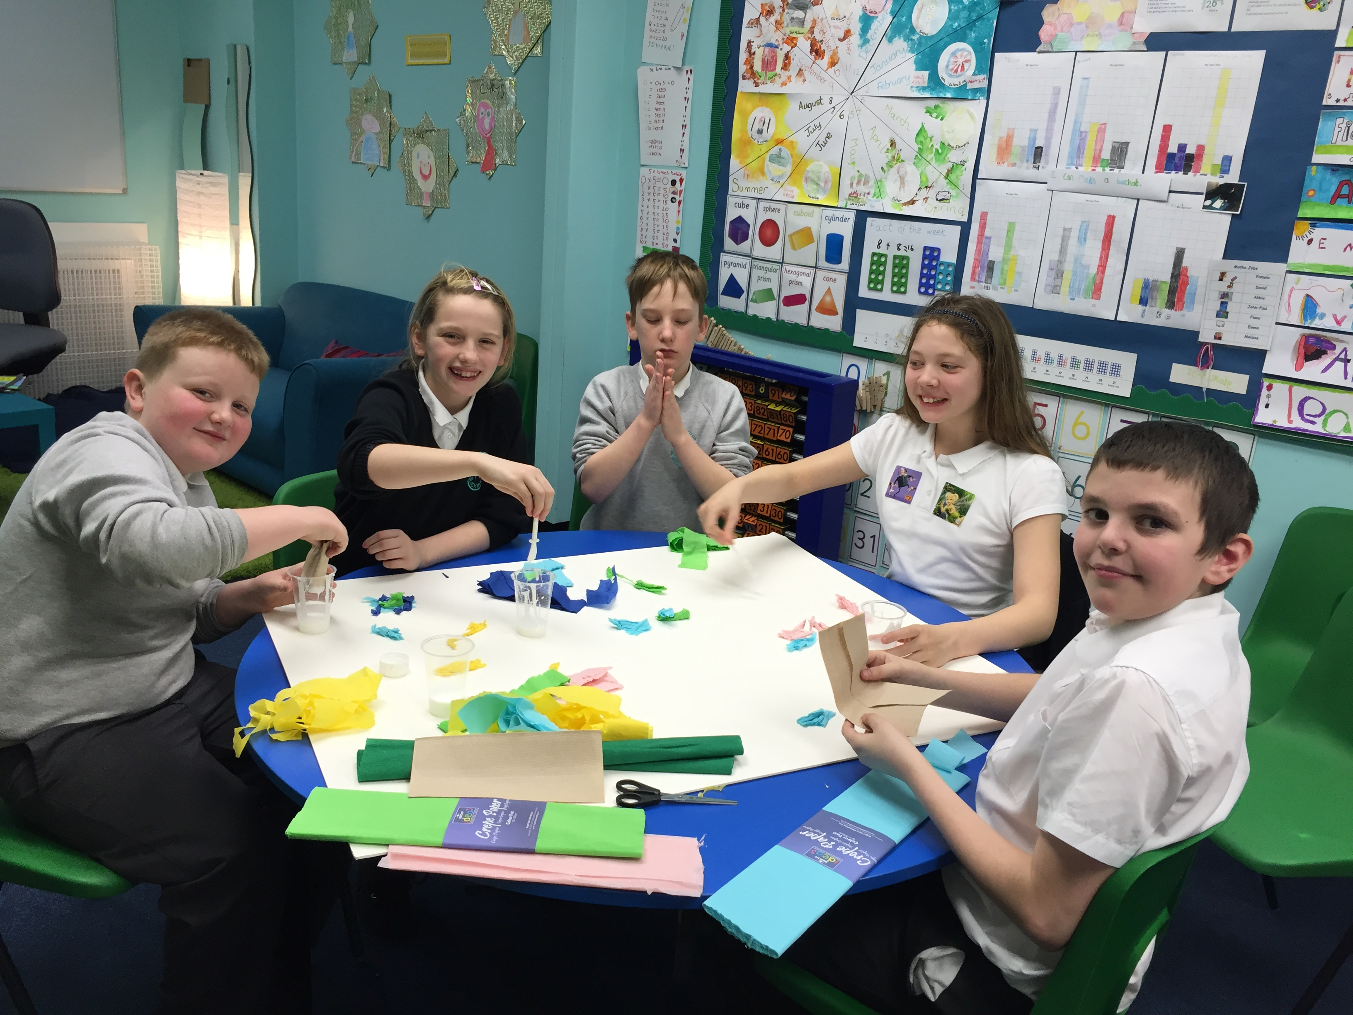
The older group started the collaberative art then the work was continued by the younger group.
Cerys - We have been working really hard together to make the art
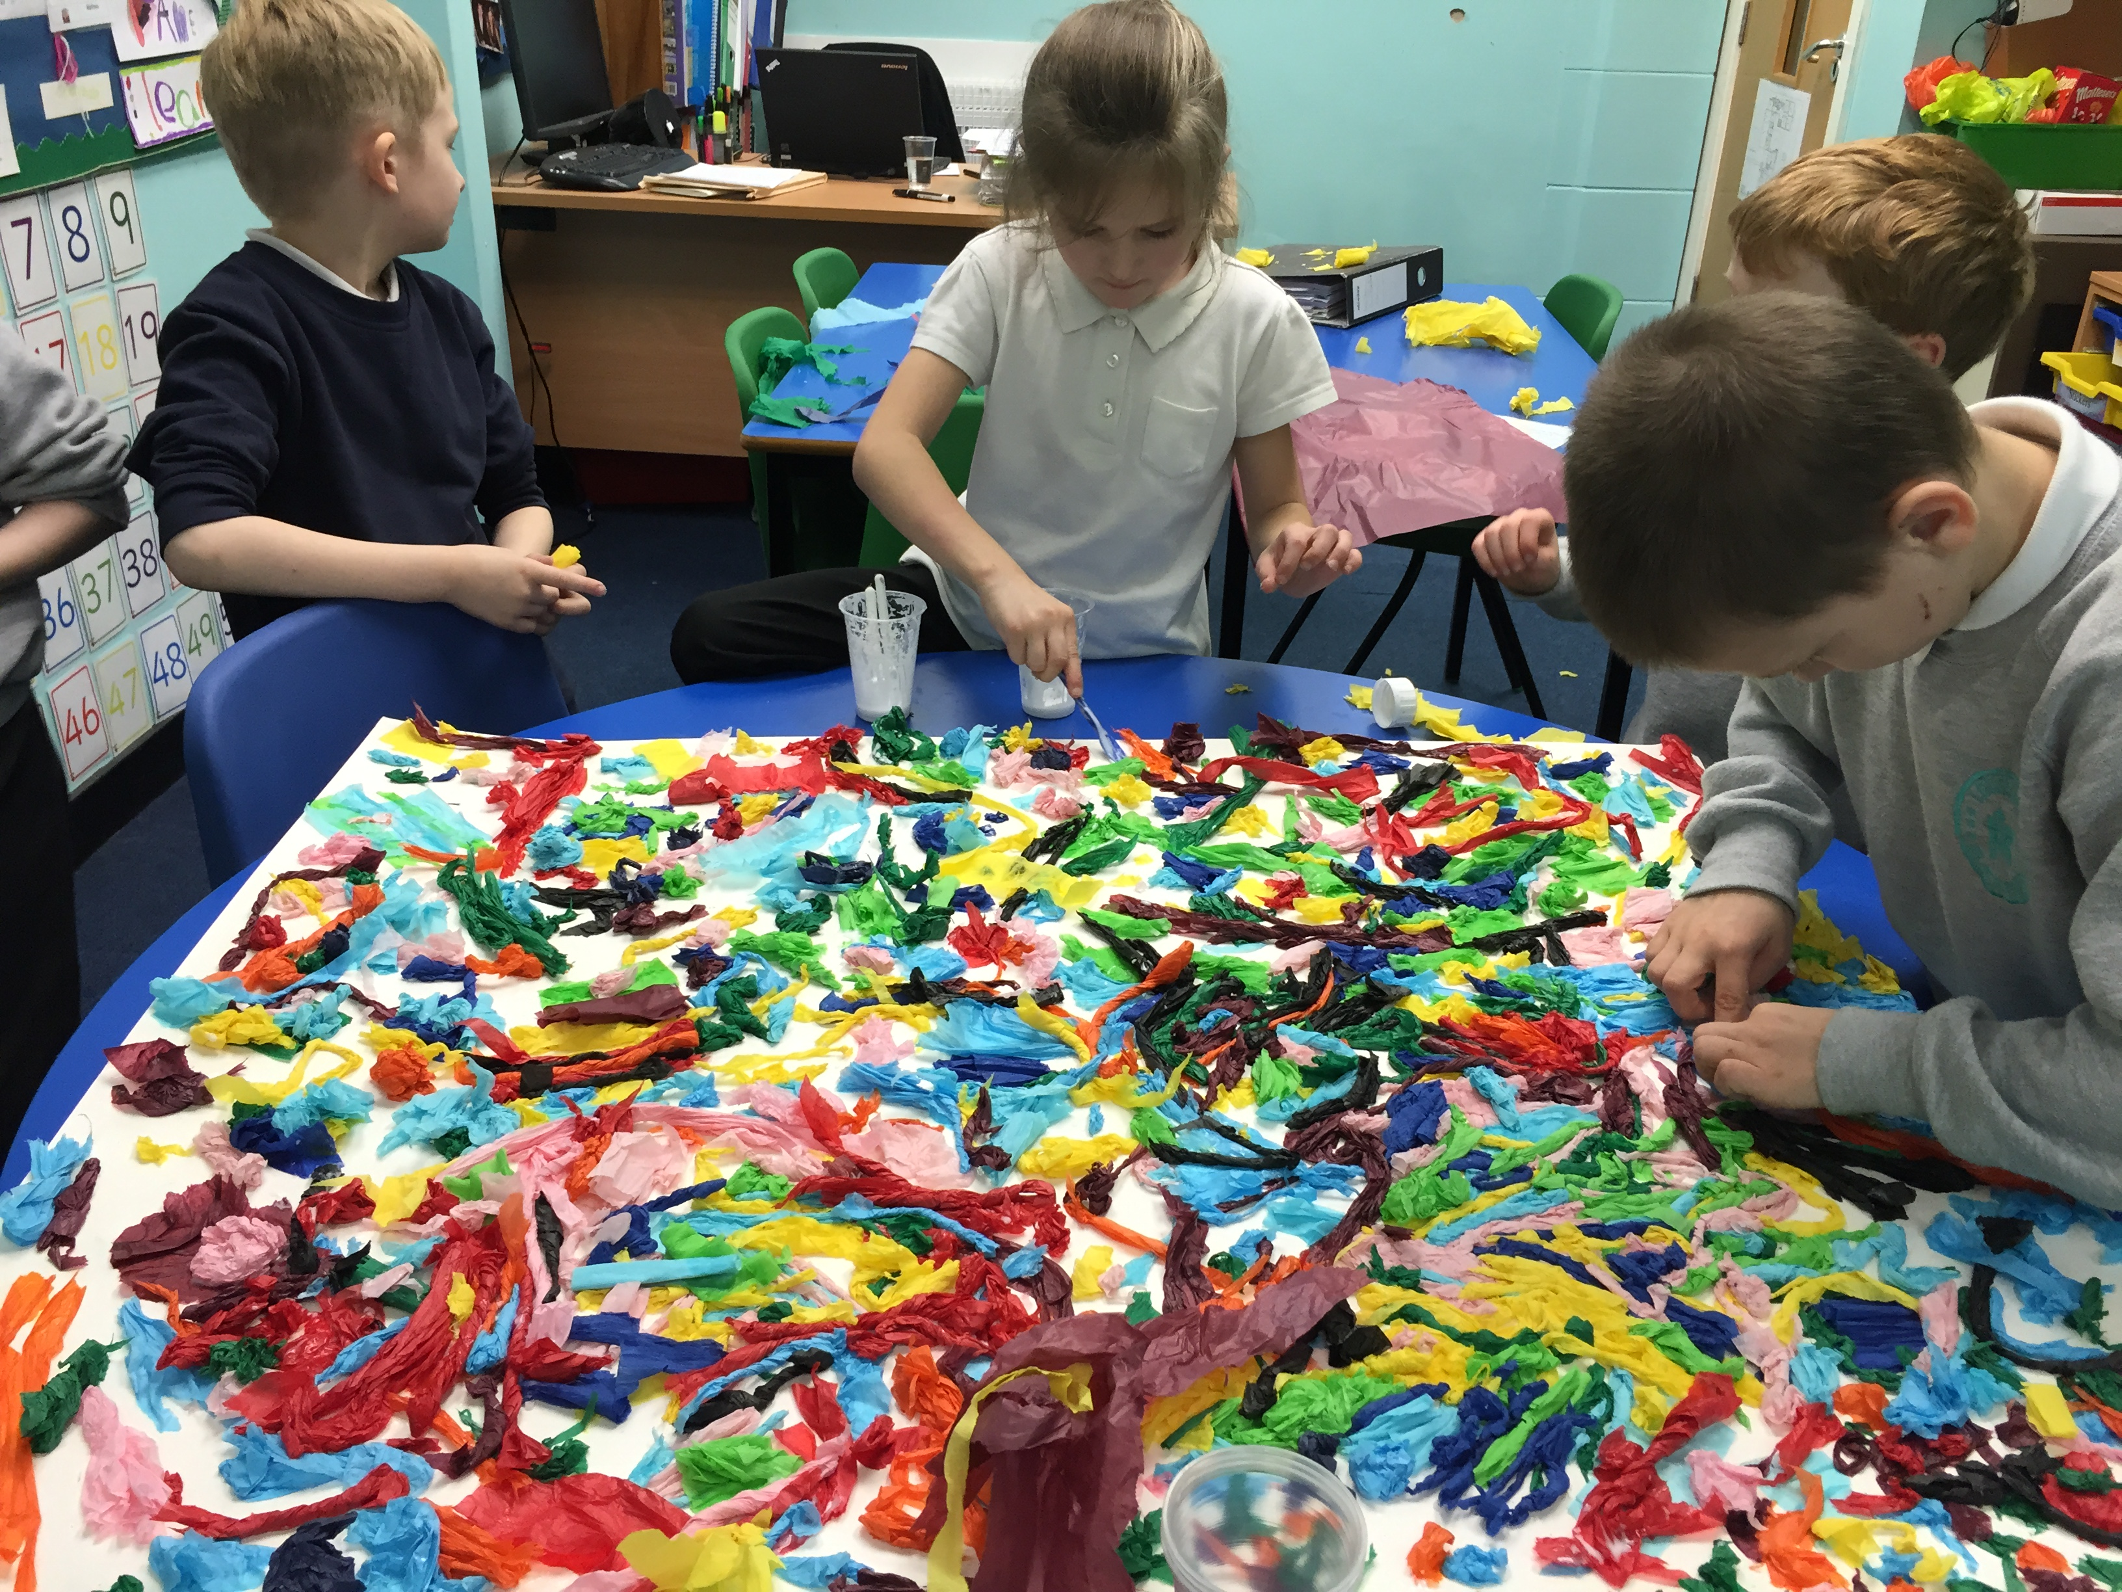
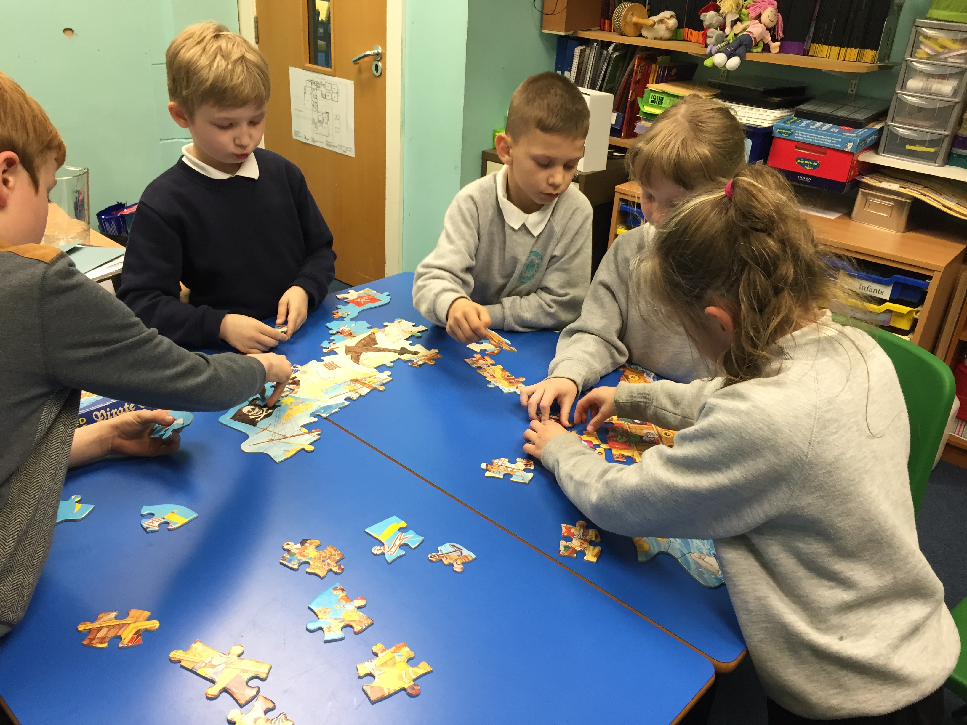
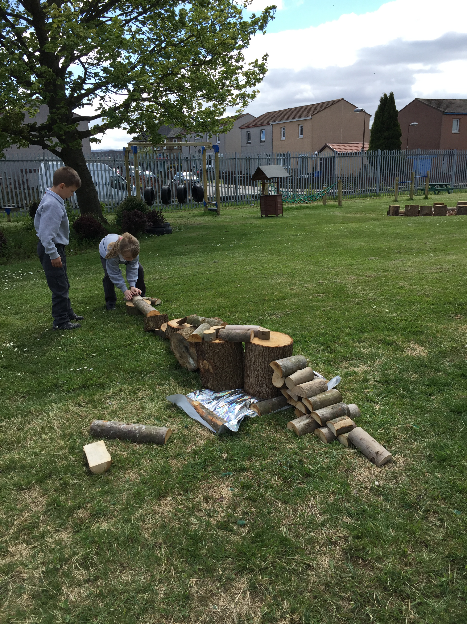
The Stars have been workiing together doing lots of tasks. These are to build the skills of co-operation and communication as well as confidence.
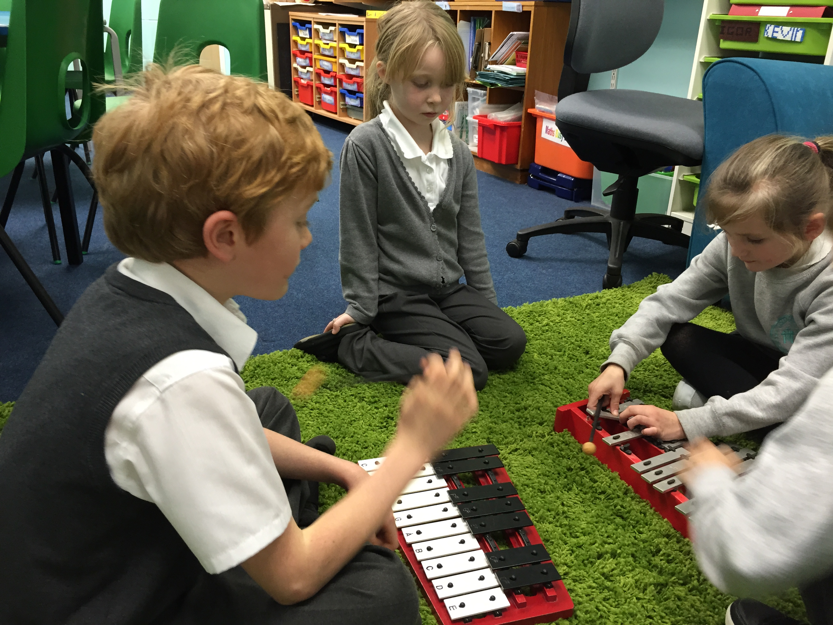
Leah - The music made me feel happy and it was wonderful.
Here the Stars were taking part in some music therapy, we have done this quite a few times this year as it teaches leadership, listening and confidence.
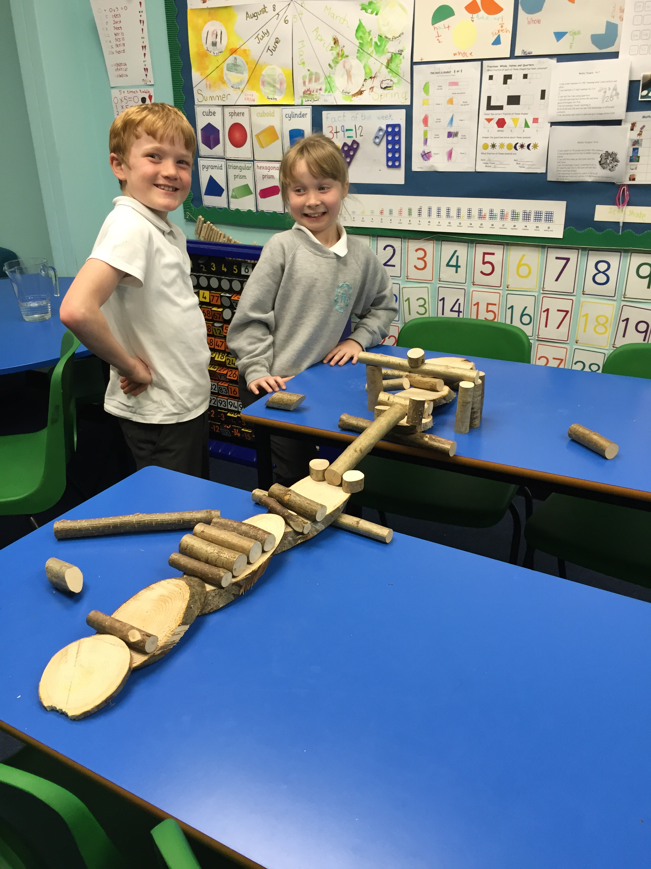
The group were given the task of building a bridge and worked well together to do this. I think you will agree that Leah and Arran made a magnificent job.
Arran - It was fun using team work to help us finish the bridge

Kevin - I made a bridge with Igor and it was good
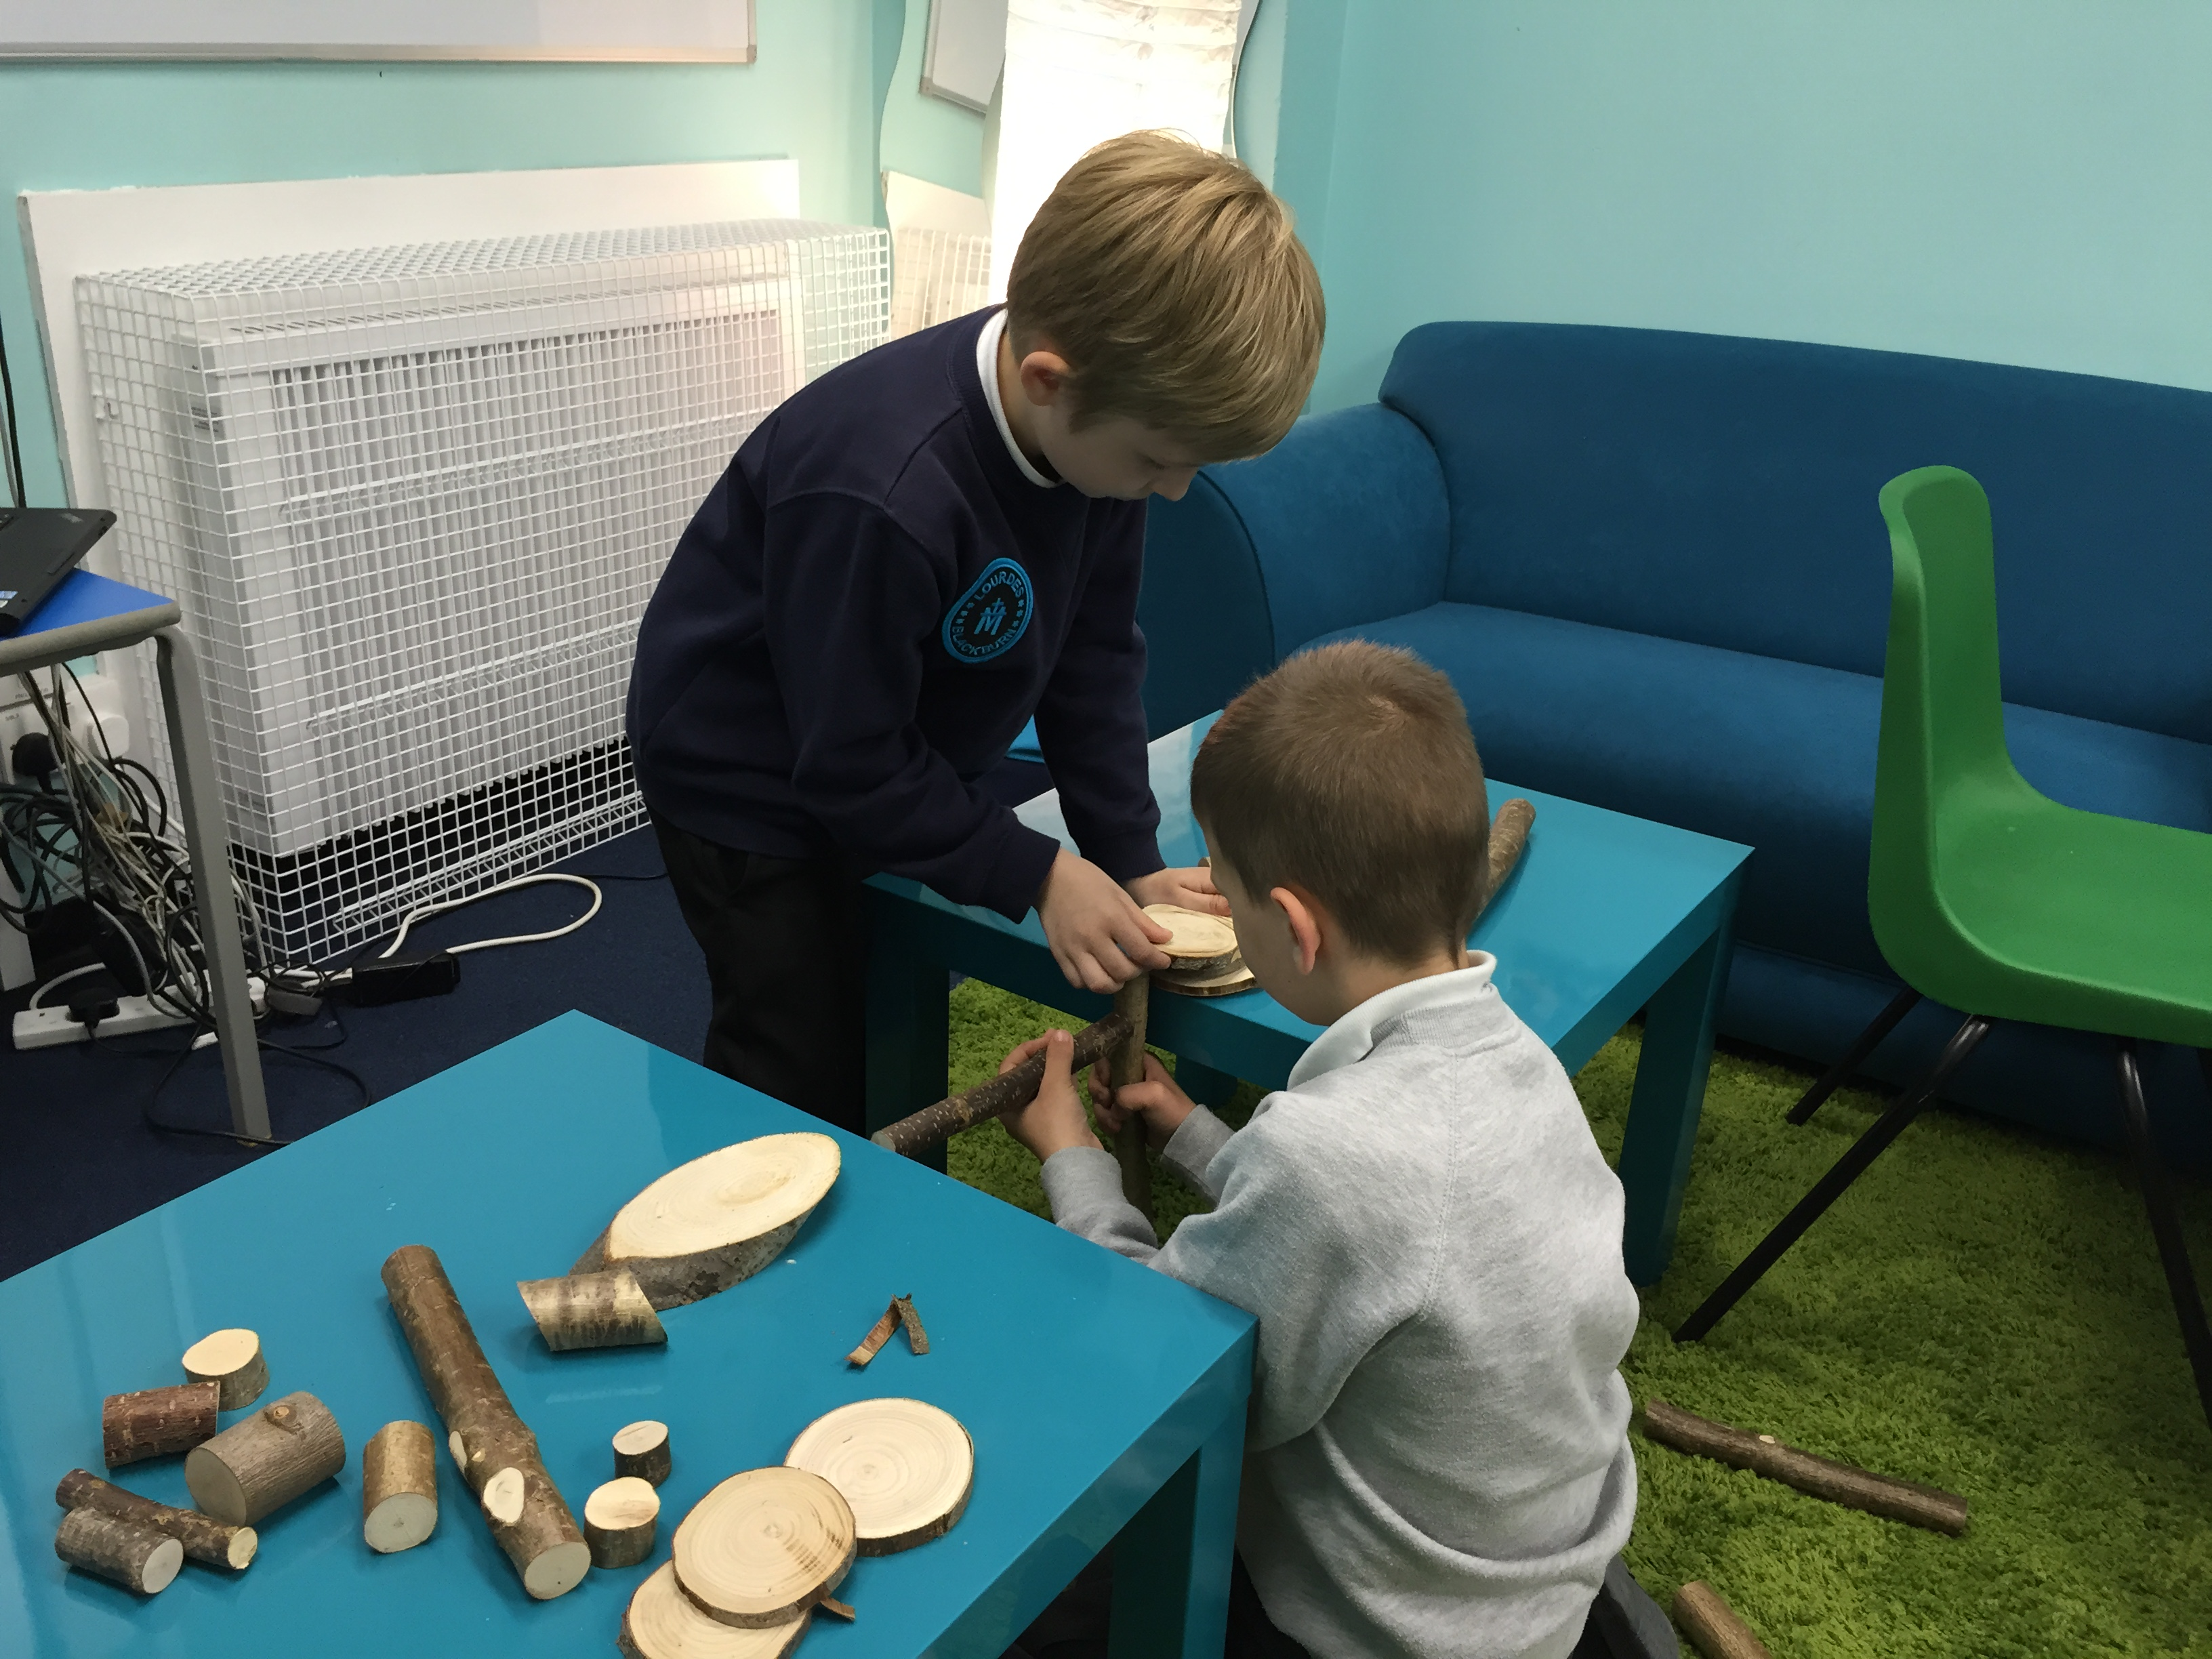
The Stars extended their bridge building skills, using larger pieces of wood to build in the garden.
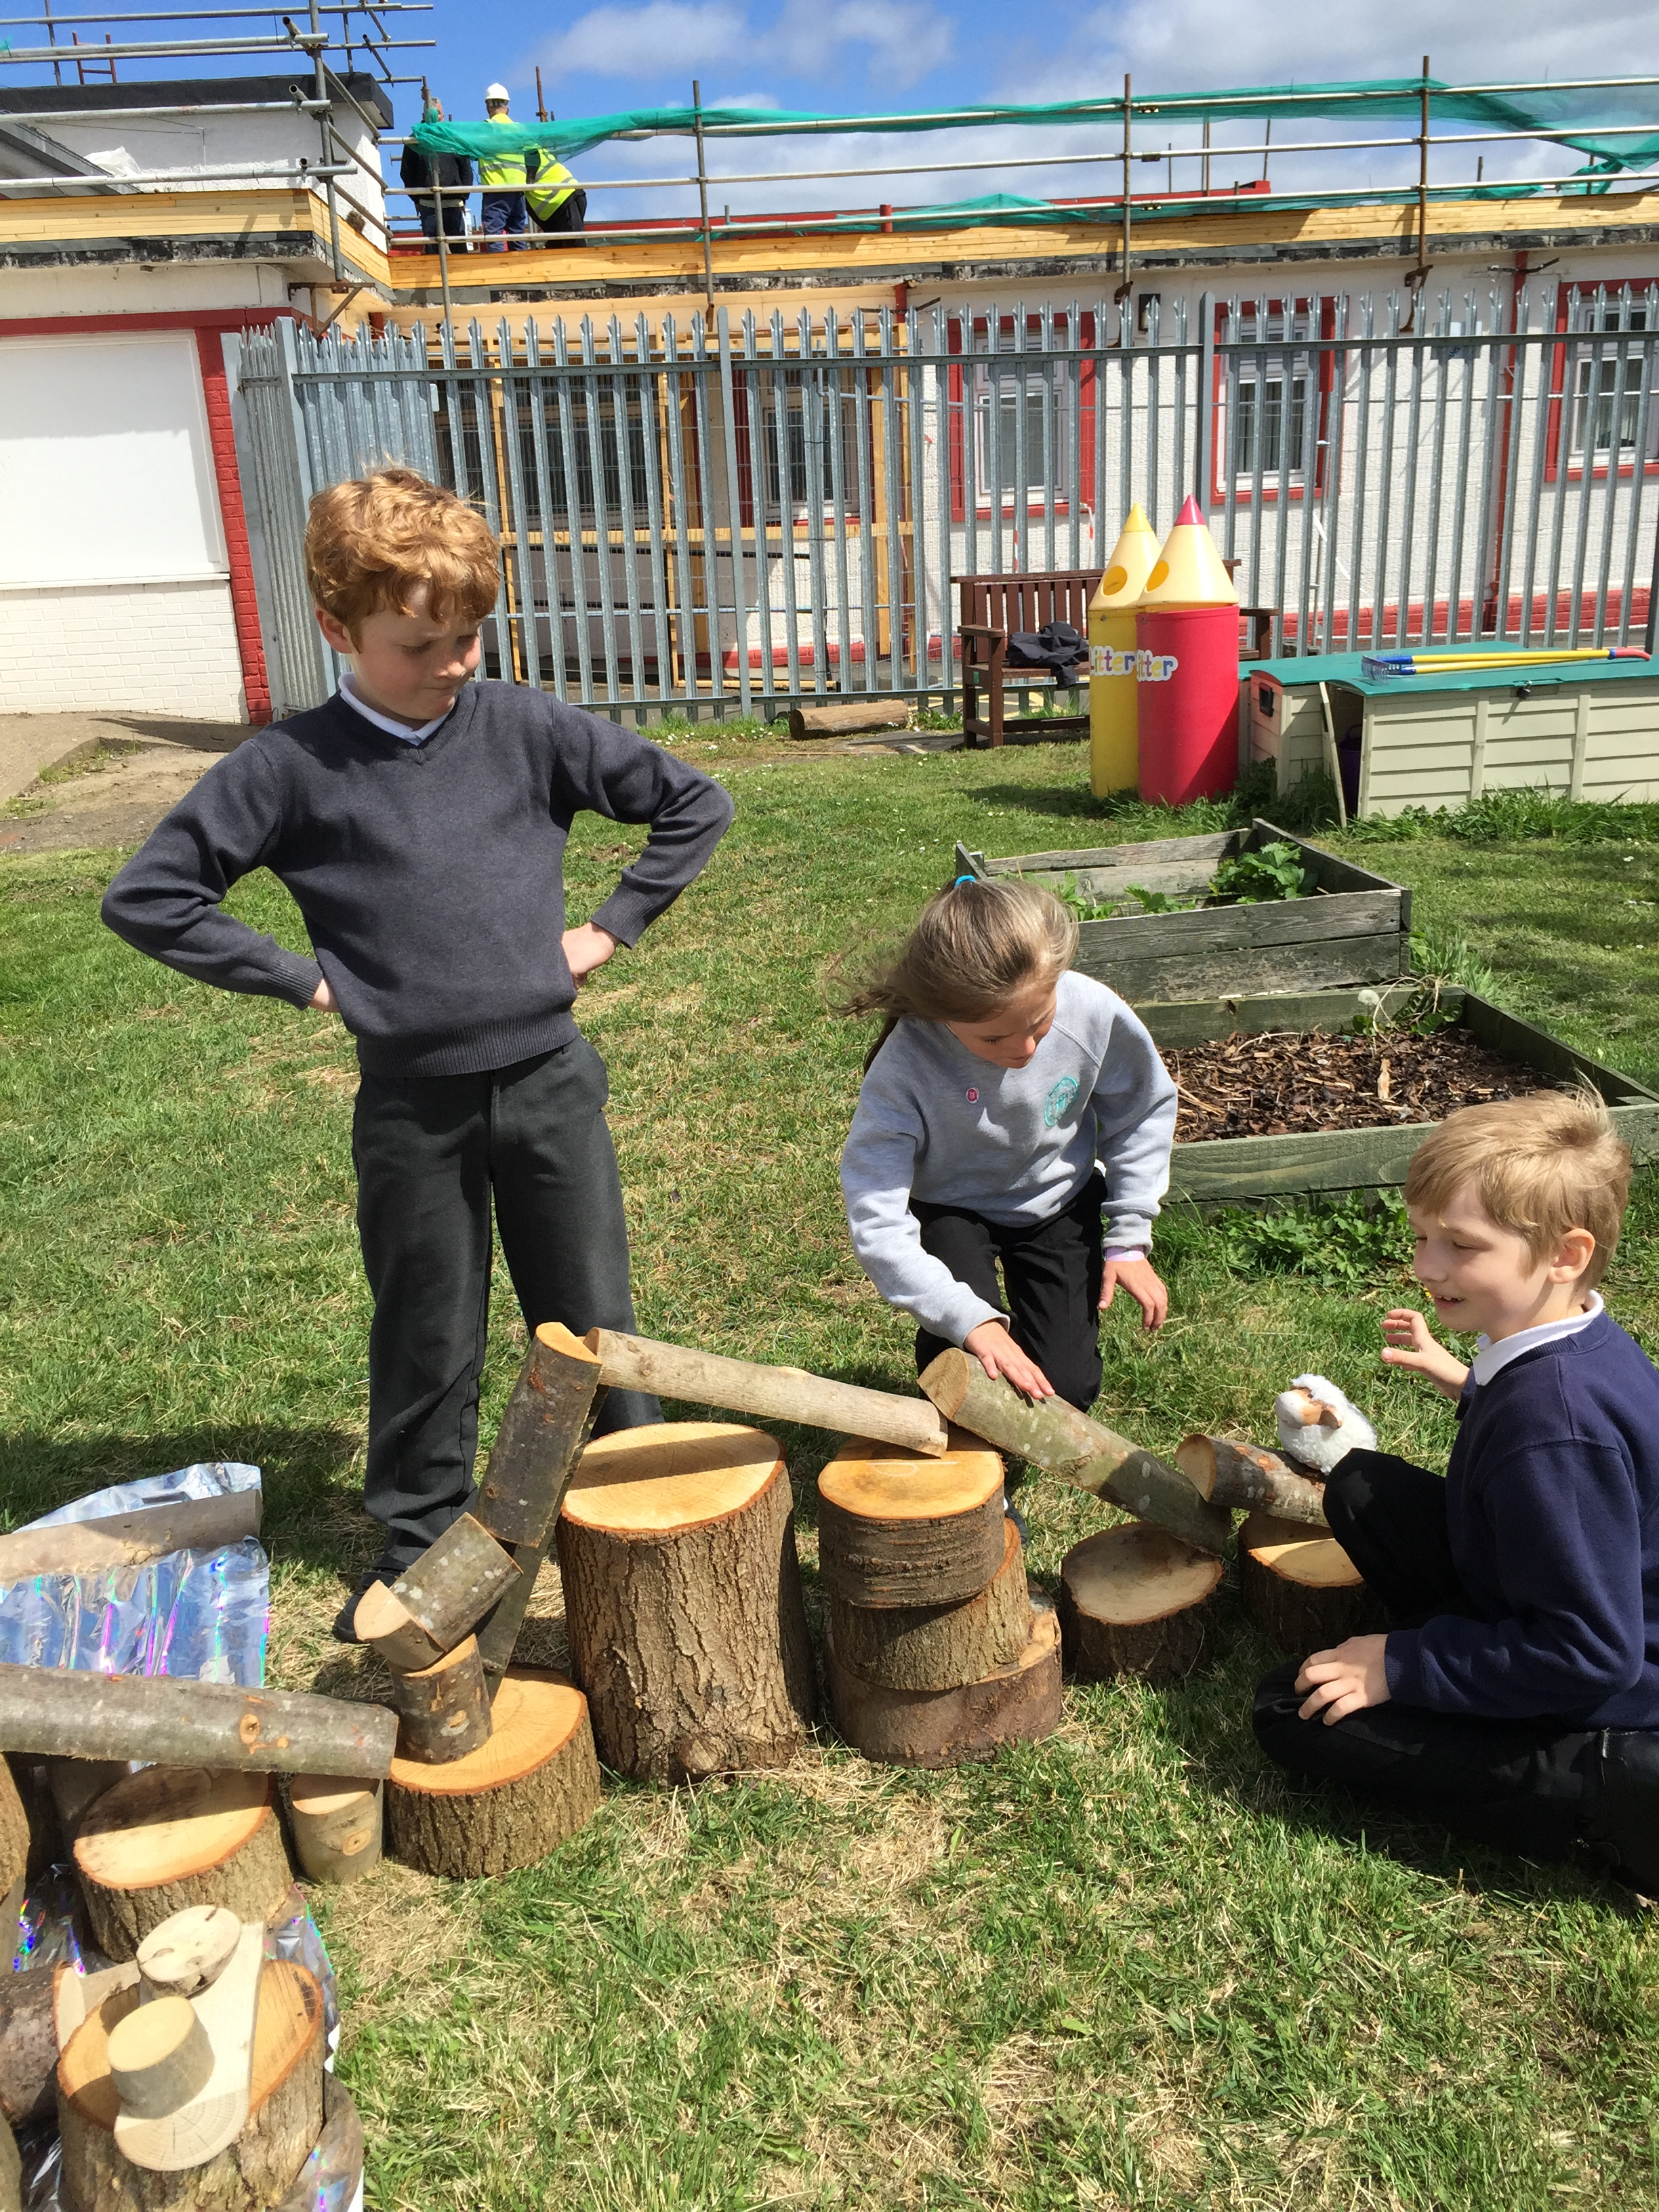
Igor - It was super fun, we learned how to make a bridge
The ability to research well is an important skill and the SHIELD group were set a video challenge of discovering if it was safe to eat insects. The groups did this brilliantly, making videos of their responses. We all learned lots of interesting facts, and even though lots of insects are safe to eat we decided not to try them!
Lewis – I liked finding out if you can eat a bug!
Assessment this term has shown how successful this type of intervention is, all of the children have made so much progress over the last few terms and are all so much more confident. I will be sad at the end of term to say goodbye to Hollie, John-Paul, Lewis, Adam and Fiona as they head off to high school and wish them all the best as they leave.

