Snow Day Activities for Penguins and Giraffes
Indoor Activities
Paint the Snow
Take some paints outside and see how creative you can be painting in the snow. If it’s not safe to go outside, why not bring a tray of snow inside!
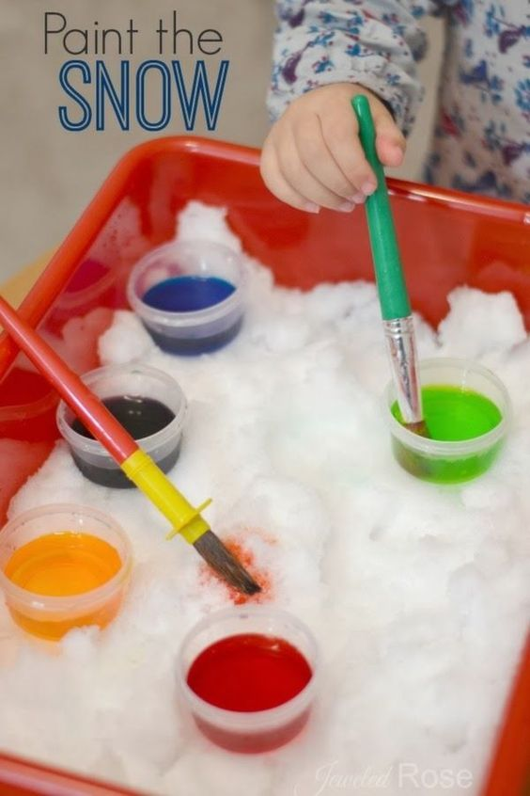
Build a Fort
If it’s too cold outside, try building a cosy fort in the living room or bedroom using pillows and blankets.
Toilet Paper Snowman
Grab a roll of toilet paper and have a snowman building contest. Work in pairs as one person stands still like a statue and the other wraps the toilet paper round and round. Use a scarf and hat to create the final snowman look.
Family Time
Spend some time with your family doing the things you love whether it’s reading a book, doing a puzzle, playing a game or watching a movie.

Singing and Dancing
Sing some of your child’s favourite songs or nursery rhymes at home with a winter twist, for example, Five Little Monkey’s Playing in the Snow. If you would like to burn some energy with your child go onto YouTube and search for Patty Shukla to find some of your child’s favourite songs to dance to.
Experiment with Hot and Cold
Bring in a big basin of snow and think of different ways to melt the snow. Talk to your child about hot and cold and think of different ways you could experiement with this, for example make some flavoured ice cubes using a little bit of diluting juice and water, make ice lollies or make ice slushies.

Outdoor Activities
Snow Angel
Can you lie down in the snow and make snow angels? Make sure to wrap up warm!
Making patterns
Go and find some sticks and stones and make your own patterns in the snow or use the sticks to make marks in the snow.
Build a Snowman
Help an adult or a friend build a snowman. Can you make him taller than you? What do you need to make a face?
Snowball Fight
Make lots of snowballs and try to throw them at a target on a wall or tree.
Snow Prints
Using cardboard, cut out some large footprints and attach them to your shoes. Walk in the snow and create some bit snow prints.
