Winter Activities

Here are some ideas for you to do at home when the snow is too deep for children to get into school.

- Get creative with some paint and make some snowflake handprints which you can hang in your house or classroom.
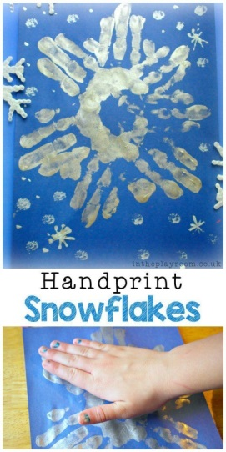
- Make some indoor snowmen or wrap up warm and build a snowman. Take a photo of it and email it to school to share with your friends in class.
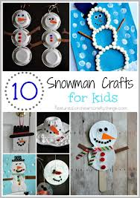

- If it gets to icy or cold bring some snow indoors and paint it with paint or food colouring.
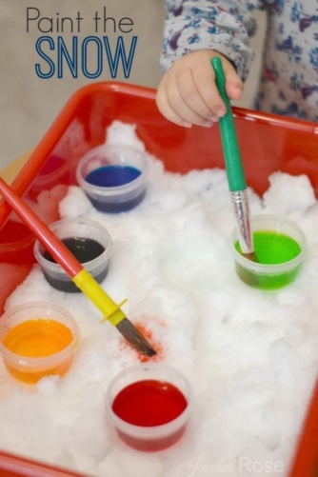
- Why not wrap up warm and go outside for a walk in the snow. Look to see who has the biggest footprints. You can jump in the snow and see how deep it is. Can you see any other prints in the snow?
