SNOW DOUGH 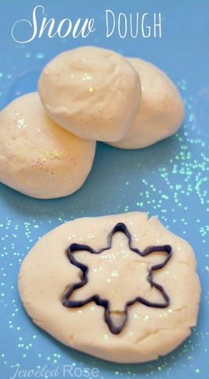

Snow Dough Recipe

1 cup of cornflour
1 cup of baby lotion (any oil/lotion would do)
Silver/white glitter and peppermint essence are optional extras
(To make your snow dough extra cold pop the cornflour in the freezer for a few hours before making this recipe. You can also refrigerate the lotion.)
Method:
- In a bowl combine roughly equal parts of cornflour and lotion.
- If desired you can mix in a few drops of peppermint essence to add a winter scent. You can also add glitter.
- Continue to mix the ingredients until a dough is formed.
- Once you have mould-able dough, remove it from the bowl and finish kneading it with clean, dry hands.
- If the dough is too sticky, add some more cornflour and knead it in.
- After a bit of mixing and kneading you will have icy-cold Snow Dough!

Snow Dough Play

This snow looks and feels so real! It is soft and powdery and icy-cold. It creates the most fantastic snowballs. The possibilities for play are endless….
Here are a few ideas…
- Add dough cutters, scoopers and other kitchen utensils.
- Add cars and trucks.
- Try using your finger to practice letter formation.
- Make and embelish icy-cold snowmen. 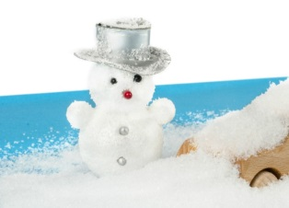 Let us know what you did with your Snow Dough!

Bird Feeder – Cut the top off an organge and scoop out the segments. When you have finished eating this healthy snack fill the orange with seeds and hang them outside for the birds to eat. Try positioning your bird feeder so that you can see it from a window, then keep an eye out to spot any birds.
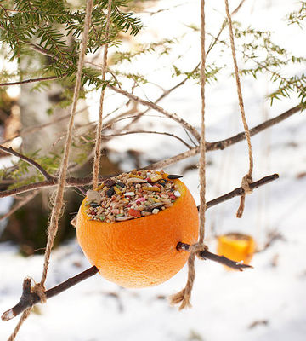

Outdoor Snow Play
- Try spinning a hula hoop around your waist and count how many rotations you make without falling over.
- Fill spray bottle with water and food colouring and have fun spray painting the snow.
- Take your paints and brush out-side and see how creative you can be.
- See what happens when you take your bubbles out-side……… if you don’t have any bubbles make your own mix with washing-up liquid or bubble bath, add to water and use a straw.
- Make some coloured ice cubes by adding food colouring to the water before filling the ice-cube trays, when frozen, remove and use them to build coloured outdoor sculptures or hide them and get your friends to find them.

Indoor Snow Play

When it’s not safe to be out in the snow, you could get an adult to bring a large basin of snow into the house.
- You could use kitchen utensils to help you create a small snowman then decorate it with whatever you have around the house.
- Try replacing the potato in your Mr Potato Head set with a large snowball and use the extras to create your own Mr Snow Head!
- You can paint snow using a paint set or carefully adding food colouring.
- Add your cars, trucks and little people to a huge heep of snow and play.
- If you have penguins and polar bears add them to the snow along with different shaped pieces of ice from the freezer or from outside.
- Experiment with melting snow, find out where in the house your snow melts the quickest.

