Dear Parents, Carers & Partners
Welcome to the final newsletter of 2016-2017.
We are coming to the end of a very busy term and a very eventful and productive year for the school. We have been spoiled with lots of sunny days in the last couple of weeks and can only hope the wet weather this week has been good for our grass and flowers and the sun will return for the summer holidays.
During this term the children have been involved in a wide range of activities, horse riding, astro gym, Kurling at Cedarbank, Swimming and football. All children have also had fun on their summer outing.
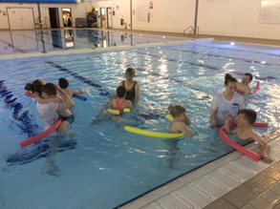
This term we have enjoyed our first summer singalong ‘sunhats and sunglasses’, many thanks to our talented music Teacher Alison Sharp for organising this event that was enjoyed by all staff, children, parents and carers.
Sports day this year was an excellent success. Thank you very much to all the parent/carers that made the day very special for the children and to those that took part in our fun Hungry Hippo parent/carers race. (Start practising for next year, it will be even more competitive) Our Parent Council raised over £100 for school funds from their raffle and delicious scones. Thank you to all parent/carers and staff for your contribution.
The children had their photographs taken this term and behaved beautifully for the Tempest photographer and I am sure you will agree they were lovely.
This week the children have moved to their new classrooms and for some children they have a new class teacher. They have all settled very well and are making new friends.
We are saying goodbye to two Primary 7 children who will be moving onto Secondary school, an exciting time and we wish them all the best in their first year at Secondary school.
A very warm welcome goes to our new Primary 1 children and their parents and carers, we look forward to seeing your little ones grow and flourish.
We also look forward to working alongside our new parents and carers. We have appointed a new temporary class teacher Ms Tracey Hider to our team to cover Mrs Murphy as she takes a break to have her baby in August. We extend a warm welcome to Ms Hider and wish Mrs Murphy well and agree her baby will be in very good hands, she will make an excellent mummy.
This has again been a very quick year for me; I can honestly say I have never enjoyed working in a school as much as I have enjoyed working in Ogilvie. It is a privilege to work with such enthusiastic, skilled and hard-working staff; I can’t thank them enough for all their hard work, care and understanding throughout the year. I would personally like to thank the Parent Council, parent’s, carers and partners for your continuing support, you can be justifiably proud of all your hard work.
It goes without saying though that our real stars are the children, who make Ogilvie a wonderful place to work, thank you for being you.
Liz Speirs

Class 1
The Robins Class have been extremely busy this term and have enjoyed lots of special trips. As part of their bird topic the children went to the Scottish Owl Centre at Polkemmet County Park in Whitburn. All of the children really enjoyed the trip and did brilliantly during the flight show. Some of the owls were really big! It was a really wet day but we all still enjoyed a woodland walk.
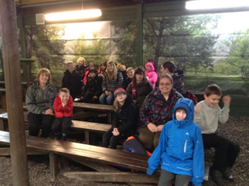
We have also had some swimming sessions where the children all had a great time learning to swim with noodles. Everyone listened to the swimming instructors and played safely.
It has been a great year with the Robins class; we are so proud of you! We all hope you have a great summer holiday and look forward to welcoming you all back in August!
Mrs Murphy, Mrs Strachan, Mrs McGrane, Miss Todd & Mrs Hedges

Class 2
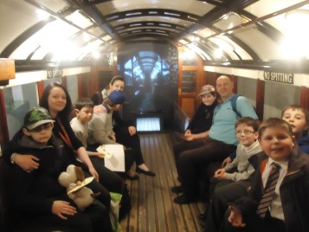
We have had a really busy final term. Our topic has been Transport. We have learned to identify different types of transport, design our own cars, cross the road safely, and create a fabulous wall display using natural materials and a range of art techniques. We were lucky enough to visit the Transport Museum where we saw transport old and new, sat on a subway carriage, ‘scrubbed the deck’ of a ship and saw an entire wall full of motorbikes!
In Maths we have been using a resource called ‘Numicon’ to practise working with numbers. We have been using it to make patterns, count, match colours, add and calculate the two times table. We have also been learning to programme miniature robots called ‘BeeBots’ to move forward, backwards, left and right. Some children have been able to programme quite complex journeys that require long successions of instructions. In Literacy we have been using computer technology to make up stories. Our favourite is the app ‘Sock Puppets’ which we use to record a dialogue between two puppet characters. We can even make the puppets move and put on silly voices, which makes our stories very entertaining! We have been progressing through the Colourful Consonants programme to learn and reinforce our sounds. We have been learning to read common sight words through games on the Smartboard and ‘fishing’ for words with a magnetic fishing rod.
Thank you for supporting us through this exciting year; we look forward to working with you in August!
Miss Hastie, Mr Blyth, Miss Cunningham & Miss McLeary

Class 3
Hello everyone,
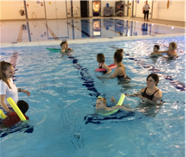
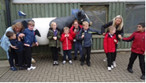
Wow! Hasn’t this come around quickly! The Meercat class has had a very busy summer term. We have enjoyed swimming sessions, walks to the park, shopping for ingredients to cook with in connection with our farm topic. We learned about the story of milk; how the farmer collects the milk and the products that can be made from it. We all found the process of making our own butter very interesting, tasting it afterwards. It was delicious! The Meercats enjoyed planting vegetables and herbs that would be found on the farm and watching them grow. Our trip to the farm was lots of fun and some of us were brave enough to pet some of the animals there. We set up a shop in class to sell farm produce which was lots of fun especially when we changed it to an ice-cream shop – Mmmm lots of happy smiles! We also had fun with taster sessions of Judo and dance as well as trips out to use bikes.
We are shortly due to break up for the summer so we would like to take the opportunity to say Thank You to all our parents and carers for their help and interest in our learning and wish you all a very happy summer.
Mrs Richardson, Miss Wylie, Miss McKenzie & Mrs Auchie

Class 4
The Lions have had a busy term. We have been hard at work doing lots of gardening and planting bean sprout, sunflowers and lettuce. We have enjoyed watching our plants change and seeing how tall our bean sprouts are growing. We have also had lots of fun at Astro Gymnastics and swimming this term. We love getting out and about and these activities are some of our favourites. We have also been welcoming some new children to our class or visiting our new classes towards the end of the term and have enjoyed making some new friends.
Miss Millar, Mrs Stirrit, Mrs Welch & Mrs Hunter

Class 5
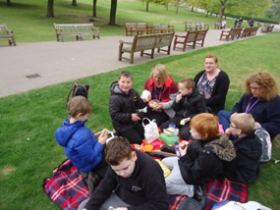
The Penguins have had another busy half term!
We had a great time learning about different types of transport when we visited the Transport museum at the start of term and our train ride to Edinburgh was really exciting, we had our photos taken with some police officers and tried on their hats!
In maths we have been looking at measure, long and short and heavy and light.
In literacy we have continued to work with our letter sounds, blending our letter sounds to make words and joining in with the actions from our jolly phonics songs is fun!
We have been working with Neil at the Community Garden, planting seeds and helping him to look after some new trees. We have really enjoyed learning our songs for the summer show and taking part in our sports day event this term .
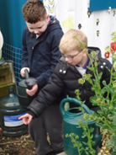
We have all continued to work hard on our individual targets and we have enjoyed using lots of new and interesting resources to help us achieve them.
The penguins have worked so hard this term; we look forward to next session where the fun and adventures will continue!
Mrs Beestone, Mrs Craig, Mrs Charles & Mrs Platt

Class 6
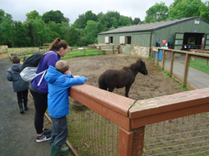
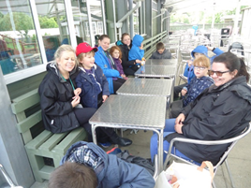
The children in the Giraffe class have been learning all about farming this term. We have been looking at where food comes from and the animals we will find on the farm. We all thoroughly enjoyed our trip to Mill Farm and enjoying meeting the animals, having our picnic and having a good bounce on the trampolines. Huge congratulations to Emily and Ethan who came first in the curling competition, great job! Scott, Christopher and Emily have been lucky enough to go to horse riding and had a fab time, while Reece, Kai and Kali have been to gymnastics. All of the class have been exploring the new water wall outside and this is a big hit, especially with Kai. We also had a lovely party during the last week to celebrate our time in the Giraffe class. Best of luck in your new classes and have a great holiday.
Miss Priestley, Mrs McGowan, Miss Cairney & Miss West

Class 7
Hello Parents and Carers!
We have had s super busy last term in the Hippo class! We began growing some flowers in our school garden and have been watering them regularly. We have made lots of lovely flowery pictures for our wall display. We have also been busy doing lots of wider activities like swimming, horse riding, bikes and astro-gymnastics. We even went on a class trip to Deep Sea World which we all absolutely loved!
Well done for such a fab year Hippos – have a lovely Summer .
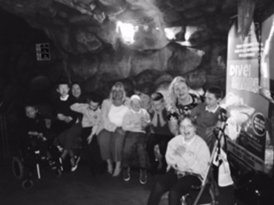
Ms Borthwick, Miss Mackenzie, Mrs Bremner & Miss Buist

Class 8
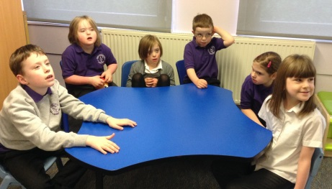
Term 4 in the Kangaroo class has been predictably busy! As well as completing our ‘Growing’ topic by nurturing our beans and sunflowers in the garden, we have taken an interest in developing parts of our outdoor space for playtimes. Along with our friends in the Lion class we revamped our out-door Music Wall by choosing ‘instruments’ from around the school. (Don’t throw out any old pots, pans or kitchen utensils – send them into school – we’ll use them to create great music!) We also started to develop our Mud Kitchen, a great place to make mud pies, dandelion buns, petal cupcakes and daisy soup, increasing fine motor skills by mixing and using utensils, maths skills by sorting and counting and social skills by sharing and role-play. It can be very messy but we are always well protected in our waterproofs – another learning opportunity to develop our independent dressing skills!
As a reward for all our hard work throughout the year we will celebrate our last day with a trip to Jump Station where we will jump, bounce, sing, dance, laugh and eat together to celebrate a very hardworking year. Well Done Kangaroos!
Miss Nicoll, Mrs Duncan, Miss Gemmill & Mrs Gilani

Class 9
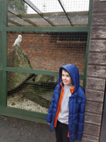
Term four has been a very busy term for the Huggy Bears. As our topic has been looking at birds and the garden we have got to experience lots of fun outdoor learning. On our adventure across the playground we used binoculars to locate and discover birds, and collected data through the use of tally marks to tell our friends how many birds we found. We then used our knowledge of birds on our trip to Linlithgow Loch where we identified swans and seagulls – followed by a trip to the park! At the end of term we joined up with our friends from the Robin class and went on an exciting journey to the Scottish Owl Centre where we got to watch a flight show and take part in an owl tour with our teachers.
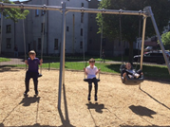
Having come to the end of the term, we now prepare to say a heartfelt farewell to two of our classmates, Robert and Natalie, who are moving on to high school after the summer! We wish them all the very best and hope to see them again soon to hear all about their new school.
Miss McClure, Mrs De & Miss Morton

Dates for the Diary
Last Day of Term-Friday 30th June
Staff resume-Monday 21st August
Pupils resume-Tuesday 22nd August
Holiday-Monday18th September
In-Service Day-Tuesday 20th September
Last Day of Term-Friday 13th October

School Blog
https://blogs.glowscotland.org.uk/wl/ogilvieschoolcampuslivingston

