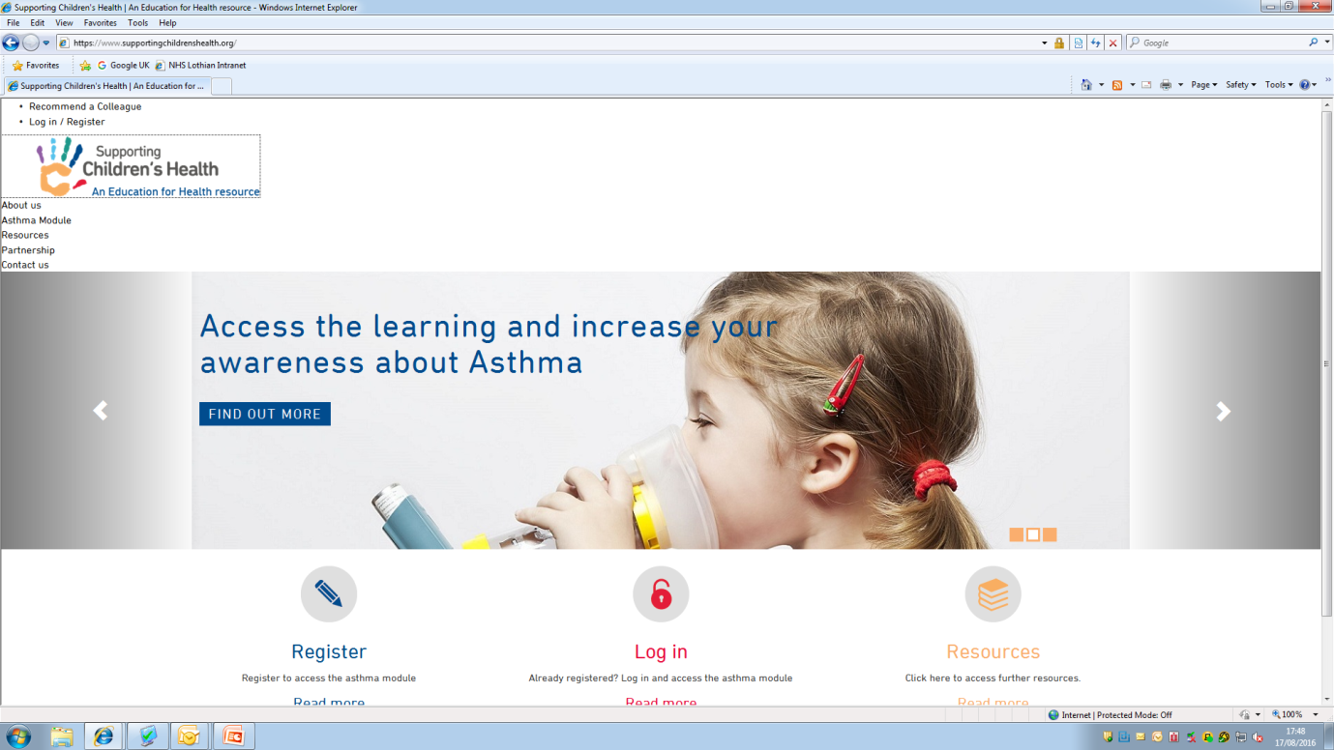

http://www.supportingchildrenshealth.org/
- Free learning module that takes around an hour to complete with certificate on completion.

