Dear Parents, Carers & Partners
Welcome to our first newsletter of 2017-2018 session.
How quickly we have come to the end of a very busy and enjoyable first term.
I am pleased to say all children have settled into their new classrooms with their new friends and staff members. My highlight of the day is visiting the children and staff in their classes who are all busy working and having fun. What a lovely atmosphere.
It was great to see so many parents at our ‘meet the team’ afternoon and we hope you enjoyed the opportunity to meet the whole class team that look after your children so well and meet the other parents as well as watching your little ones at work.
We have said goodbye this term to Advanced Pupil Support Workers; Laurie McKenzie, Jodie Buist and Kerry-Ann Craig who have left Ogilvie to take up new career promotion opportunities outwith West Lothian. Class Teacher Anna Borthwick is leaving to take up a new career opportunity as an Outreach Teacher in Edinburgh. Also our School Nurse Marie McIntosh has left to take up a career promotion outwith West Lothian. They will all be sadly missed; we wish them well for the future.
We would like to welcome the following new Advanced Pupil Support Workers to Ogilvie; Michelle Cunningham, Liza Wolfe, Lucy Colbrun and Gillian McQuade. By the time you read this newsletter we will have recruited a replacement Teacher for Anna.
Our school Blog is growing and we hope you have had the chance to have a look at it. We added two more sites last year that we would really appreciate your contribution to;
‘Child-friendly places to visit’. We would like you to share places with other parents that you have visited with your children which are appropriate, safe and fun. This may be cafes, libraries, parks, swimming pools or cinema outings.
The other site we would like you to contribute to is ‘parent activity ideas’. We realise that as parents you have a wealth of experience and ideas for activities either to do or make to keep our children active and engaged. This would be wonderful to share with all parents.
Please support our Blog by sending us your suggestions.
We have had our first Parent Council of the session; the minutes have been placed on the Ogilvie Blog. We appreciate it is hard for you to attend but welcome any questions/suggestions you would like discussed. Our Parent Council will be contacting you all soon with details of the next Parent Council meeting and asking for your agenda items. Can I warmly remind you that you are all considered to be part of your child’s Parent Council and your views and support is welcomed?
It has been lovely to see some of you in school at our newly formed PEEP group and attending the Adapted PPP group and coffee mornings, we hope you have found these groups informative, supportive and enjoyable. Please check the Blog for future training/support workshops as requested by yourselves. I would like to take this opportunity to thank our Partners for delivering these sessions.
You will be aware by now that HMIe are due to visit Ogilvie on the 24th October. You should have received a group call providing you with a link to express your views about your child’s experience and progress in school. We have made significant progress over the past few years and welcome this inspection as an opportunity to showcase the fabulous collaboration between staff, parents and partners to improve the educational experience for your child. HMI will also advise and support the school on specific aspects that we can continue to develop further.
Next term will be a very busy and festive time for all in Ogilvie. Please take note of the dates for your diary especially our Christmas singalong that was a huge success last year.
I hope you all have a safe and relaxing October break and I look forward to seeing you in Ogilvie next term.
Liz Speirs

Class 1
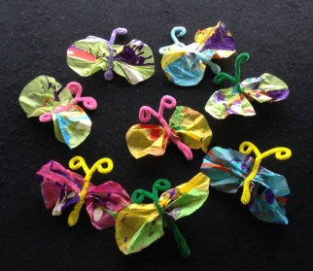
A great big friendly ‘HELLO!’ from the new Primary One children in the Squirrel Class. We have spent the first few weeks of term getting to know each other and exploring some of the new things Ogilvie School has to offer.
So far we have been learning to come together for short class activities including: Good Morning Group which entails greeting our friends, identifying emotions, learning about the weather and the days of the week; Bubble Group where we learn to anticipate and take our turns before popping the bubbles with our index fingers; Breakfast and Snack where we all use different forms of communication to request what we want and try out new foods; Sticky Kids where we learn to listen and respond to different songs and copy simple dance routines and Singing Group where we choose then join in with favourite songs.
We also work hard individually and in smaller groups to develop our literacy and numeracy skills.
Below is a photograph of the unique Butterflies we have created to join the School display in reception. The next time you are in school have a good look to see if you can find us. Parents and carers it would be great if you made one too, we would be delighted to display it.
For photographs of us at work, please log onto our School Blog.
Miss Nicoll, Miss Wylie, Mrs McGowan & Mrs Duncan

Class 2
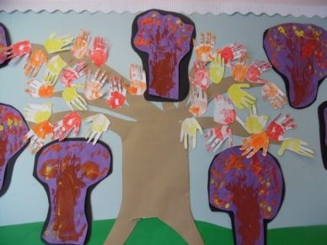
Hello everyone, we hope you all had a fabulous summer whatever you were doing. Since returning to school we have all been very busy. We started off with fun games with our friends then learned all about George Seurat. He was a painter who painted scenes using dots of colour, of course we had lots of fun with finger painting shapes, butterflies and beach scenes. We have also been learning about the Ocean through The Rainbow Fish story. We have had fun visits to the fishmonger, Dobbies aquarium section and cooking/tasting fish. We have created Ocean scenes and learned new words to write. We have had fun with floating and sinking shells, fish and crabs. The primary 4 Meercats have also been attending horse riding lessons with the RDA at Abercorn. Lots of fun and games so far.
We are almost at the October break so we would like to take the opportunity to wish you all a happy and hopefully mild break.
Mrs Richardson, Mrs Auchie, Mrs Strachan & Mrs Scholan

Class 3
The Hippos have loved being back in school after the summer holidays. We have been busy enjoying our big new classroom which we love running around in. We have been doing a topic about autumn which has involved us going on some autumn walks to look at all the crunchy leaves. We have done some lovely autumn paintings which decorate one of our walls in our classroom. The Hippos also had an open afternoon where our parents and carers were invited in to play some games with us. We are all working hard in our workbaskets where we do some literacy, numeracy and fine motor activities. We have also painted in lots of different Artists styles including Kandinsky and Pollock. We have just started swimming lessons again which we are really enjoying and as always doing lots and lots of messy play!
Miss Borthwick, Mrs Hunter, Mrs Todd & Mrs Cunningham

Class 4
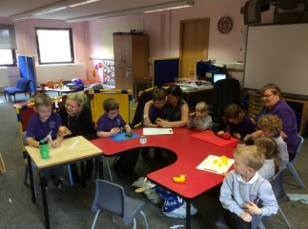
The Lion class have had a fantastic start to the new school year. We have been very busy getting to know all of our new friends in the class and working together in our groups. We have been working hard in literacy and maths, we are all very good at moving around the 3 stations of activities and learning lots while we play there. We have enjoyed our ‘All About Me’ topic this term and have been busy teaching all of the ladies in the class what we like and don’t like and have been making brilliant self-portraits of ourselves. We are having great fun using all of the special rooms in the school like the sensory room, soft play and creation station. We have also been out and about in the community visiting the shops and buying food in for our cooking time in class. This term we have made some very yummy food including mini pizzas and vegetable soup.
Miss Millar is very proud of how well we have all settled in and says she is having a brilliant time with us all.
Miss Millar, Mrs Stirrat, Miss McKenzie & Miss Gemmill

Class 5
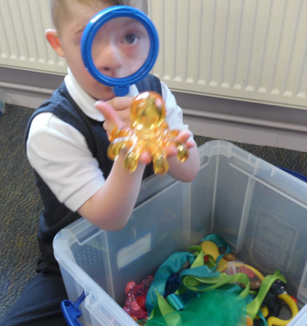
The Giraffes class have had a busy term. We have been enjoying getting to know our new classmates and developing new friendships. We have been looking at what makes a good friend through the story of The Rainbow Fish who shared her shiny scales and we have been developing our own sharing skills. We have enjoyed exploring other aspects of the story through our underwater theme and have been identifying various sea creatures. We made some amazing underwater sensory bottles, enjoyed bubble painting and made a fishing game by decorating our own rainbow fish. We have enjoyed experimenting with objects that float and sink in the water tray and recording our results with pictures. Everyone has had the experience of visiting the fish counter at the local supermarket and choosing some fish. We have developed independence skills in the kitchen by helping prepare and try new ways of eating fish and have enjoyed fish in breadcrumbs, pasta and sandwiches.
Well done Giraffes, we hope you all have a great holiday!
Mrs Hider, Mrs Gourlay, Miss Todd, Miss West & Mrs Cairney

Class 6
This half term the Penguins were involved in a whole school topic looking at famous artists. The children explored the art work of Kandinsky and created some fabulous pieces of art. We also looked at sculpture in different parts of the world and designed our own using Junk modelling, creative and Eco friendly!
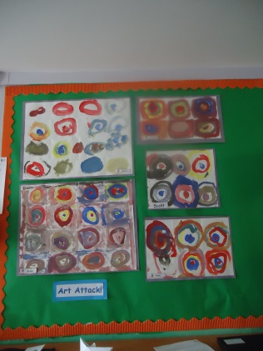
In addition, we have been looking at farms and where our food has come from and how it is ends up in the supermarkets for us to buy.
The boys have been involved in football training at Broxburn Football Club; they have really enjoyed their experiences of learning new skills and getting to know the coach Aiden. We have also had our swimming sessions this term where we were gaining confidence in the water not using swim aids whilst we were playing and collecting objects from the bottom of the pool.
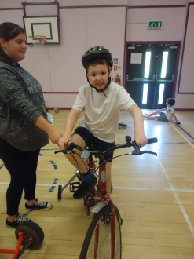
In maths we have continued to explore measure, long and short and heavy and light, and our own individual targets. In literacy we have continued to work with our letter sounds, blending our letter sounds to make words and joining in with the actions from our jolly phonics songs is fun!
We have continued to work with Neil at the Community Garden, digging up vegetables we helped to plant and look after last term. We have all continued to work hard on our individual targets and we have enjoyed using lots of new and interesting resources to help us achieve them.
The penguins have worked so hard this term; we look forward to next session where the fun and adventures will continue!
Mrs Beestone, Mrs Hedges, Miss McPhee

Class 7
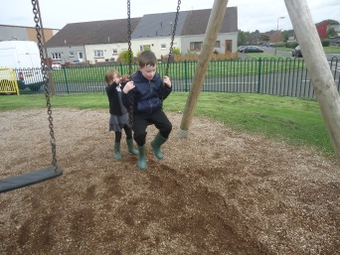
The Kangaroo class have been enjoying the nice weather by all visiting the park. We have all been exploring the different park equipment and it is lovely to see several of the children working on their swing skills, Logan has been very kind giving her friend Mark a push, please see photo. We have also started our swimming block, most enjoying a good splash.
We have almost come to the end of our Rainbow Fish topic, which has been fun. The children have taken part in fishing water play, making a sea painting, made tuna sandwiches and had fish and mushy peas in food and nutrition.
In P.E all of the children have been participating in dressing themselves with growing independence. We have been working on our bike skills this term, everyone has now had a go, which is lovely is lovely to see, Jack even had the confidence to have a go in the adult bike. Keep up the great work Kangaroos!
Miss Priestley, Miss Morton, Mrs Lindsay & Mrs Gilani

Class 8
The Hedgehog pupils’ have been transformed into Super-Secret Agents following the mystery of our missing class mascot, Robin the bear!
We have been developing our outdoor skills and coordination in order to be fast and strong like Jack Stalwart – the secret agent in our class novel.
All the pupils have engaged very well in our literacy ‘spy’ topic and are determined to become the best spies in the world. We have designed gadget bags, fingerprint profiles, identification badges and written letter to the ‘Global Protection Force’ spy agency to tell them what makes us special and why we would make great agents.
We have also had a lot of fun with the beginning of autumn arriving. We have collected leaves and used them for art work, role play, cooking and maths!
Hopefully we discover the whereabouts of Robin the bear soon! Keep up the great work Secret Agents!
Miss McClure, Mrs Charles, Mrs De, Mrs McGrane

Class 9
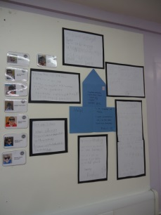
We have settled in really well to our Senior School classrooms and have been very busy so far this term.
In Maths we are learning about Measure, Time and Number Processes (addition, subtraction, etc.) This has involved lots of practical activities such as measuring the height of our classroom furniture and finding out whose teddy is the heaviest! In Literacy, we are revising our sounds and continuing to read our personal reading books. We are also using interactive story-telling technology to create our own adventures.
We also had a very exciting time during Maths week. We took part in a workshop where we played with lots of different Maths-related activities. We also made soup and sandwiches to sell at our food stall, meaning we could practise our measuring skills and money-handling skills.
Our topic this term is about being a spy. As a class, we are reading a book about Jack Stalwart who is a spy and has to investigate the theft of the Mona Lisa. The boys have been given their own Special Agent identities and will be investigating our own ‘crime’ (the disappearance of Robin, the cuddly toy mascot from the Hedgehogs class). We hope to try out gathering fingerprints, conducting interviews and comparing footprint patterns.
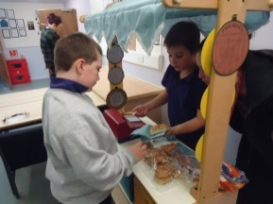
We had a wonderful time at our most recent swimming sessions. We will be given more lessons in the near future; we will communicate when they are via home diaries.
Thank you for your continued support!
Miss Hastie, Mr Blyth, Mrs Bremner & Miss McLeary

Dates for the Diary
October Holiday-All break-Friday 13.10.17 12.25pm
Staff resume-Monday 23.10.17
Pupils resume-Tuesday 24.10.17
IEP Fortnight-06-16.11.17
Christmas Singalong-14.12.17 Times TBC
Last Day of Term-Friday 22.12.17
Staff resume-Monday 08.01.18
Pupils resume-Tuesday 09.01.18

School Blog
https://blogs.glowscotland.org.uk/wl/ogilvieschoolcampuslivingston

