Dear Parents and Carers & Partners
Welcome to our Autumn newsletter!
How quickly we have come to the end of a very busy and enjoyable first term.
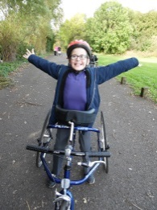
I am pleased to say that all children have settled into their new classrooms with their new friends and staff members. Whenever I get the opportunity to visit the classes I find the children and staff all busy working, having fun and there is such a lovely atmosphere.
It was lovely to see so many parents/carers at our ‘meet the team’ afternoon. We hope you enjoyed the opportunity to spend time with the staff who look after your children so well and to meet other parents in addition to watching your little ones at play.
Our school Blog is growing and we hope you have had the chance to have a look at it. Two more sites have been added which would benefit from your contribution;
‘Child friendly places to visit’ please share with other parents places you have visited with your children that are appropriate, safe and fun. This may be cafes, libraries, parks, swimming pools or cinema outings.
The other site we would like you to contribute to is ‘parent activity ideas’. We realise that, as parents, you have a wealth of experience and ideas for activities either to do or make to keep our children active and engaged. This would be wonderful to share with all parents.
Please support our Blog by sending us your suggestions.
Can I say a big thank you to our Parent Council for organising our first fund raising evening, over £1200 was raised (await final count). The night was a huge success and enjoyed by all who attended. Our Parent Council will be contacting you all soon with details of the next meeting and asking for your agenda items. Can I warmly remind you that all our Parents/Carers are considered to be part of the Parent Council and your views and support are welcomed?
We have just held our first information sharing session on our Behaviour Policy and Learning tracks. We feel it is important to share what we are doing in Ogilvie, what our school priorities are and we value your opinions and suggestions to help support all improvements.
Next term looks like it will be a very busy and festive time for all in Ogilvie. Please take note of the dates for your diary especially our Christmas singalong that was a huge success last year and I hope to see you all again this year.
In the meantime, I wish you a safe and relaxing October break.
Liz Speirs

Class 1
The Robins class have settled well into their new classroom and have enjoyed their first term back at school. We have been working hard on our topic; ‘we’re going on a bear hunt’ and enjoyed lots of sensory play, baking and expressive arts activities.
We have been very busy taking part in swimming lessons at the local pool, where the children have shown increased confidence in the water and good swimming skills with flotation aids. We have also taken part in cycling sessions with all-ability bikes where the children have had the opportunity to try different bikes and cycling techniques. They have had a great time!
Well done from everyone in the Robins; we hope you all have a great October holiday!
Mrs Murphy, Mrs Strachan, Mrs McGrane, Miss Todd & Mrs Platt

Class 2
Hello everyone,
The Koalas class have been very busy this term getting to know our new friends in class and the new staff who help us. We have been working on our community skills visiting local shops, a garden centre, finding out about churches in our area, the library and local walks. When we were in the library the librarian allowed us to scan the books in and out which we loved. We have also been learning about using money through shopping and role play as well as computer games based on money. We have enjoyed cooking, making healthy meals especially the vegetable soup. We made so much we had to freeze some for later! We all thought it was yummy. We have also been swimming and some of us have enjoyed horse-riding and cycle training at Broxburn. We have also had lots of fun with our new P.E. teacher Mr McKay. We are really looking forward to the October holiday so we can be rested for more fun learning afterwards.
We hope you have a super holiday and enjoy reading about what we have been doing.
Mrs Richardson, Mr Blyth, Miss McKenzie & Miss West

Class 3
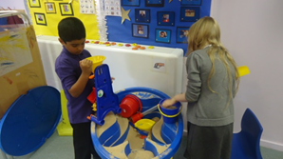
We cannot believe it is October already! Time certainly does fly when you are having fun!
Our little Meercats have all settled very well into their new class and have already enjoyed some exciting trips and activities!
We have been working very hard in class with our daily literacy and numeracy activities! We have enjoyed a variety of different activities such as the spelling snake game, rainbow writing and using shaving foam to form letters- this one is our favourite as it is very messy!
Our topic this term has been Dinosaurs, we have loved reading dinosaur books, creating dinosaur eggs and masks during topic time in class!
We have also been very busy with Astro Gymnastics, swimming and shopping! We have loved these weekly experiences and have certainly been learning a lot from them!
Miss McCullagh, Miss Wylie, Miss McKenzie & Miss West

Class 4
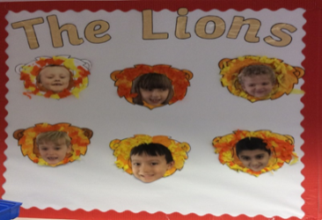
The Lions Primary 1 class have settled in beautifully for their first term at Ogilvie School Campus. The children in the class have loved getting to know each other and their new routine here at Ogilvie. Our topic this term has been ‘The Owl Who Was Afraid of the Dark’ and the children have enjoyed learning about the story and making lots of fun, messy art activities about the story. This term, The Lions have also loved attending Astro Gymnastics once a week and had so much fun there. We have also been busy going shopping each week to buy lots of lovely food for our food and nutrition activities each week.
Miss Millar, Mrs Ross, Mrs Welch & Mrs Hunter
Class 5
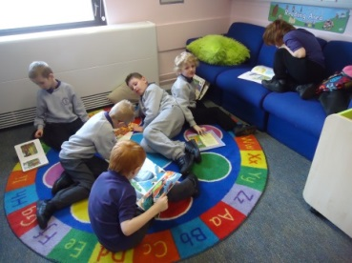
It has been a very busy term so far in the penguin class with lots of adventures and fun in and out of the classroom. This half term we have been learning about our local community, the children have visited the library regularly and are learning how to check out and return their books using the machines. We have been shopping in Morrison’s, we are using the isles to help us find the food we are looking for. Some of us have had a great time exploring the equipment at Astro- Gymnastics, some of us have been horse- riding and swimming has been another weekly treat!
In maths we have been learning about our days of the week and the calendar as well as our numbers, simple addition and counting back.
We are all working hard on our individual targets and we have enjoyed learning the letter sounds of Phase one Jolly Phonics and exploring books.
The class team are very proud of what the children in the Penguin class have achieved this half term, well done!
Mrs Beestone, Mrs Craig, Mrs Charles & Miss Montgomery

Class 6
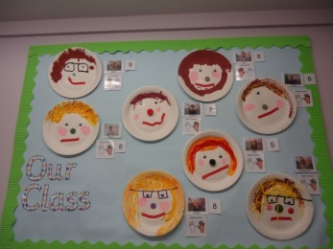
The children have welcomed Scott, Mrs Auchie and Miss McGowan into the Giraffe class and we have settled well and enjoyed getting to know each other. The children enjoyed making their faces using paint and different materials to stick. We have also been exploring about dinosaurs and been reading lots of dinosaur stories, playing with the dinosaurs, dinosaur messy play and dinosaur art. In food and nutrition we are promoting independence and I was very impressed with the children’s sandwich making skills. In food tasting we are continuing to experience different soups, tomato soup was our favourite. Please send in any cardboard boxes (cereal, sweet boxes) kitchen roll inserts and milk bottle lids up until the end of the holidays, as we are going to be making dinosaur models.
Miss Priestley, Mrs McGowan, Miss Cairney & Mrs Auchie

Class 7
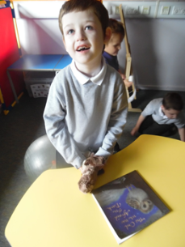
Plop the owl might be afraid of the dark but in the Hippo Class we certainly aren’t! We have been practicing good listening and good sitting when listening to “The Owl who was Afraid of the Dark”. We enjoyed a special sensory version of the story, particularly as it involved drinking hot chocolate and watching fireworks! We love exploring light and dark using torches, and have been practising cutting skills to make shadow puppets.
We have been working very hard during work basket time to develop our literacy and numeracy skills and have enjoyed visiting the library, sensory room and soft play. Those of us in primary 1-3 have really enjoyed Astro Gymnastics…the inflatable track is still our favourite! We have also visited Sainsbury’s to buy food for our snack. What a busy term so far!
Mrs Thompson, Mr Stewart, Miss Mackenzie, Mrs Bremner & Miss Buist

Class 8
We’re the Kangaroos and we have had a very busy start to this year. Some children have already attended horse-riding, gymnastics and cycling. We’ve been visiting shops, library and local parks as well as participating in West Lothian Walking Week and the school sponsored cycle to Rio. Very soon we will be starting swimming.
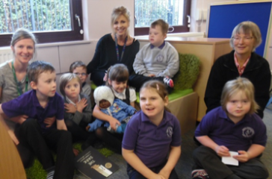
Our topic this term has been about Day and Night and was inspired by ‘The Owl Who was Afraid of the Dark’. We have learned that you can see stars and the moon in a dark sky at night and hopefully the sun in a blue sky during the day. Some children have been learning to categorise the different activities we do by night and day.
We look forward to participating in lots more exciting learning opportunities in the coming terms.
Miss Nicoll, Mrs Duncan, Mrs Hedges & Miss Gemmill

Class 9
Hi everyone!
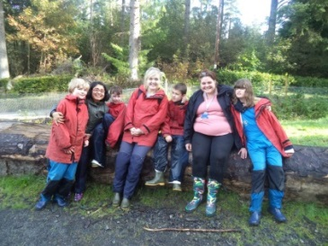
We have had a busy term so far getting to know lots of new staff throughout the school. We have all loved our block of swimming we participated in on Fridays. We have been learning about lots of different autumn animals and we have made a lovely display with lots of craft animals on it. On our weekly walk we used crayons to make bark rubbings and have been discussing the changes in the trees. Each week we have been going food shopping to buy ingredients to cook with. Last week we made cupcakes for our taxi drivers to enjoy! We have also been on an action packed outdoor adventure trip to Low Port. We walked up burns and went over and under trees in our way.
Miss Borthwick, Mrs De & Miss Morton

New Staff
Jodie Buist, Rebecca McLeary, Kirsty West, Michelle Hunter, Madeleine Auchie, Natalie Gemmill-Advanced Pupil Support Workers, Anna Borthwick, David Stewart, Class Teachers & Andrew McKay, PE Teacher.

Eco Committee
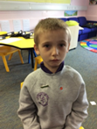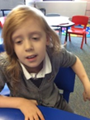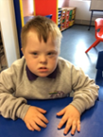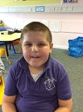

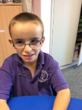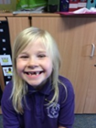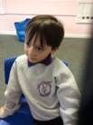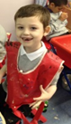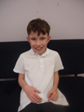
To help our school look after our local community we have an Eco- committee, here are our members for session 2016-2017
We had our first meeting on Friday 9th September to meet our new members and revisit our goals for the coming session. We will be focusing on litter picking in the local community, recycling our paper weekly, reusing our water waste in the garden and sending our uneaten food to the recycling centre.

School Nurse
Date to Remember
On Friday 28th October, the vaccination team will be in school to administer the nasal flu.
I will be in school that day to assist the team and make sure that everything possible is done to ensure the children receive the vaccine.
This can be a distressing time for a lot of our children, but school are working hard to prepare them.
If you have any concerns or questions regarding the vaccine, please let me know.
If you have not completed the consent form please can you do so as soon as possible as we need to know how much vaccine to order prior to that date.
Marie McIntosh

Dates for the Diary
14.10.16 End of term-12.25pm
24.10.16 Staff resume
25.10.16 Pupils resume
03.11.16 Parent Council Meeting – 9.30-11.00am & 6.30-8.00pm
18.11.16 Children in Need fund raising event
15.12.16 Christmas singalong

School Blog
https://blogs.glowscotland.org.uk/wl/ogilvieschoolcampuslivingston

