Dear Parents, Carers & Partners
Welcome to our Spring newsletter of 2016-2017.
We are coming to the end of a very busy term, the long dark nights are almost over and all the staff and pupils have a definite spring in their step as they celebrate a very productive and eventful term. We were spoiled with some sunny days last weekend and look forward to plenty more this Spring/Summer. We are especially hopeful of some warm sunny days so we can enjoy our new outside toys, our water wall that all staff, children and yourselves voted for and our wonderful animal seats. Our Garden is starting to look very tidy thanks to Mr Kilgallon, parent and Miss McKenzie’s brother and also some of our staff who have put many extra hours in after work at night to paint and tidy up our mud kitchen area.
You will hopefully be keeping up to date with how your children are doing with our Blog. We hope we are responding to your requests and improving the Blog greatly. We have made it more accessible by using the ’QR scan code’ and more recently we have set up a Twitter account where you can now follow Ogilvie School Campus (@ogilvieschool1). You will automatically receive an alert to let you know we have posted more information/photographs on the Blog.
We have added some more Tabs;
‘Transition songs’ – a selection of songsignifiers and transition songs that hopefully will help you at home.
‘Child friendly places to visit’. We are appealing for you to let us know of any places you have visited that make you and your children feel welcome. Hopefully this will help you during the weekends and holidays when you are looking for places to visit and things to entertain your children. We will then present this place with a certificate specially made by our Ogilvie children to say ‘thank you’.
It has been so lovely to welcome so many of you into the school this term for the variety of Parental engagement events; Stay and Play , Parents Evenings and our final event this term our Share the Learning. We hope these events provide you with very different opportunities to see your child at work and play and not only meet your child class team but have an opportunity to meet other parents and carers.
The parental workshops have been well attended this term and that is thanks to you for suggesting the type

of workshops you would like. Thank you to all our contributors for organising these workshops. From our recent survey you completed we now have a very good idea about the workshops we will deliver next session.
Fund raising- On behalf of everyone at Ogilvie can I say a huge thank you to Alan McIntosh (parent) for raising a grand total of £1,900. A vote will take place next term from all children, staff and you on an item that will enhance the children’s learning in a fun and engaging way.
The Parent Council has agreed to jointly fund a new mini bus for the school; this will be very welcome as our current bus is on its last legs.
You have helped to evaluate our School Improvement Priorities by sharing your views through surveys on both Communication and our new IEP format. We will always respond to your views to let you know the appropriate actions we plan to put in place to address your points. Please continue to share your views on how we can improve Ogilvie.
Can I please take this opportunity to wish you all a very happy holiday and looking forward to seeing you in Ogilvie next term.
Liz Speirs

Class 1
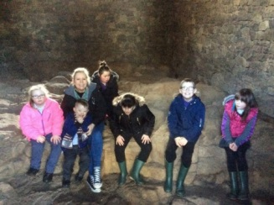
The Robins class have been very busy during the last term learning about our body and how to look after it, celebrating Burns night, Chinese New Year and going on a fantastic trip to Jupiter Artland.
We have been learning about healthy foods and have had the opportunity to try a selection of fruit and vegetables. We have also made our own healthy fruity frozen yogurt ice cream which we all enjoyed!
Our trip to Jupiter Artland was a great adventure where we went on a hunt for statues in the forest and even found a crystal cave.
We all hope you have a great break and have a Happy Easter!
Mrs Murphy, Mrs Strachan, Mrs McGrane, Miss Todd & Mrs Hedges

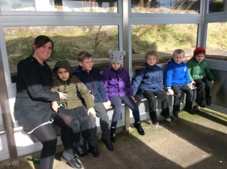
Class 2
Hello everyone!
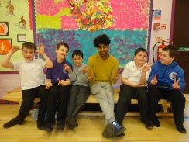
The Koalas have been extremely busy this term. In Literacy we have been learning/revising our sounds and using these to help us read. The boys have been writing some great stories that have a beginning, middle and end; we have some wonderful imaginations in our class! In Numeracy we have been learning about money and applying our knowledge to our weekly shopping trips. We are currently learning about the calendar and naming the days/months/seasons. We have been lucky enough to enjoy some trips and visits this term, including a wonderful Street Dance workshop that the boys absolutely loved! Primary 5 pupils had a great time at Jupiter Artland, where they explored the woods and took part in fun art activities. Well done Koalas!
Miss Hastie, Mr Blyth, Miss Cunningham & Miss McLeary

Class 3
Hello everyone,
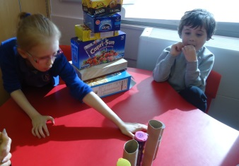
The Meercat class have been busy this term learning about our senses. We have been smelling lovely and not so nice smells. Our favourite was of baking Gingerbread men. We have listened for sounds we recognise in the environment and experimented with touching to find out what we do/don’t like. We have worked hard on mark making and enjoyed going out in the bus to the library to find out more about Senses and Spring. We have been looking for 3D shapes in our environment and used every day 3D objects to sort and build with. We worked on O’clock time and enjoyed making our own. We enjoyed the Gingerbread Man story, using puppets to retell it to others.
We are looking forward to our Easter Egg hunt next week and wish everyone a wonderful Easter break.
From the Meercat class.
Mrs Richardson, Miss Wylie, Miss McKenzie & Mrs Auchie

Class 4
The Lion Class have been so busy this term learning about People Who Help Us and The World of Work. We have had lots of fun outings and visitors including a visit from Allan the Mobile Mechanic, a trip out on the train to Edinburgh Princes Street Gardens, a trip out on a Horsburgh bus, a visit from two Police Officers and a very fun visit to the Fire Station. We have had so much fun and have learned lots about different types of jobs and how all of these people can help us in our lives. We have loved getting dressed up in different types of uniforms and playing with toys relating to People Who Help Us.
Miss Millar, Mrs Stirrit, Mrs Welch & Mrs Hunter

Class 5
The Penguins have had another busy half term!
We have worked hard on our planters in the school garden to prepare them for our growing topic-so far we have planted sunflowers, carrots and runner beans; we hope the late frost doesn’t kill them off!
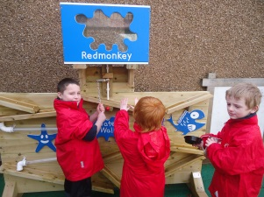
In maths we have been looking at patterns, coins and position and movement.
In literacy we have been working hard on our letter sounds, joining in with the actions from our jolly phonics songs is fun!
We have enjoyed some great outdoor learning experiences, filling treasure boxes, I- spy games, our new water wheel and exploring our outdoor play equipment in the play grounds.
In cookery some of us have made different meals following recipes as best we can by ourselves, whilst others are trying out new foods.
We are all working hard on our individual targets and we have enjoyed using lots of new and interesting resources to help us achieve them.
The penguins have worked so hard this term, keep up the good work!
Mrs Beestone, Mrs Craig, Mrs Charles & Mrs Platt

Class 6
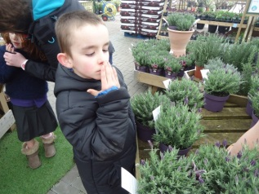
This term the Giraffe class have been learning about ‘Our Senses’ we have enjoyed smelling and tasting different fruits and vegetables and we had fun exploring the smells and touch of the different flowers in the sensory garden and at Dobbies Garden Centre as you can see in the photo below of Christopher smelling the lavender. The children have been doing well with their independence skills in food and nutrition all having a go at chopping vegetables using butter knives, I was very impressed. The children and the adults all loved our first visit to the construction room in school; we ended up with some wonderful structures, lots of fun had by all! In the next fortnight we will be planting our own vegetables and flowers and watching them grow.
Miss Priestley, Mrs McGowan, Miss Cairney & Miss West

Class 7
Hello Parents and Carers!
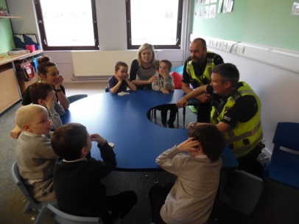
We have had a super busy term in the Hippo class! We have all been continuing to work hard in our workbaskets. Our topic this term has been ‘People Who Help Us’ which has been super practical! We have posted paintings home using a post box and we even had the Police come in and went on a bus trip. Alan the mechanic came in and let us play with tools as well as letting us have a go in his recovery truck!!
As always we have been continuing having lots of messy fun in our class All our messy play recipes are now on the BLOG and we have loved trying out some new ideas!
Ms Borthwick, Miss Mackenzie, Mrs Bremner & Miss Buist

Class 8
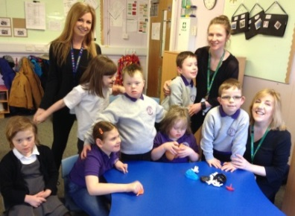
At the start of the term the children in the Kangaroo Class were busy learning about Burn’s Day and The Chinese New Year – they were both brilliant celebrations!
Our topic this term has been all about The World of Work and we have had a few visitors and a few visits out to find out all about: hairdressers, postal workers, shop assistants, librarians, nurses, bus drivers, mechanics, dentists, police officers and fire-fighters.
At present we are learning about Growing as part of our whole school topic. We have cleared our garden area and started to grow seeds. We are enjoying stories such as Jack and the Beanstalk and are learning the mathematical language associated with it.
We recently said ‘Goodbye’ to our friend Loghan King who has moved away. He will be missed but we wish him well.
Check out our school blog page to see some fabulous photos and find out more about what we have been learning this term.
Miss Nicoll, Mrs Duncan, Mrs Hedges & Miss Gemmill

Class 9
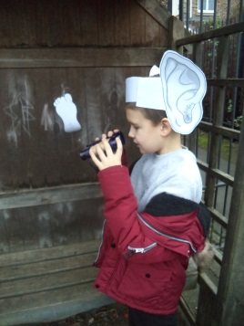
This term the Huggy Bears have had lots of fun learning all about our changing bodies and how to look after ourselves! We have taken part in lots of interesting activities and even had a visit from our school nurse.
We have really enjoyed reading The BFG novel and using our listening ears to hear sounds and our binoculars to find interesting things in our playground. We have also made some wonderful dream jars and dream catchers!
For the last two weeks the Huggy Bears have ran their very own Fairtrade Café! The café was a fantastic success and all the children were able to use their skills to contribute in some way. Thank you to all who donated.
Miss McClure, Mrs De & Miss Morton

Pupil Council
Our newly formed pupil council met for this first time this week, to decide which event the children would like to celebrate Easter and the end of term. After much deliberation we all voted and agreed on an Easter Egg Hunt to take place on Thursday 30th.
We are already looking forward to our next meeting and making choices about what happens in our school!
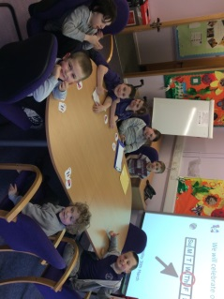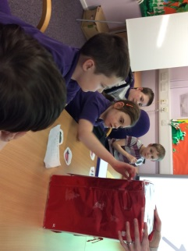

Eco Committee
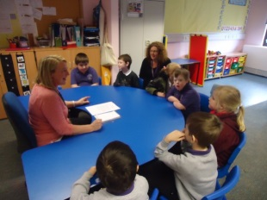
The Eco Committee met this term to discuss how we can continue to support the environment in our school.
Each class is following a weekly rota to ensure that our blue recycling bins are emptied. We also go litter picking in our local community to help keep our streets litter free.
Each lunch time we are collecting all the water waste to use in our gardens for watering our plants and to help fill the water play resources outside.
This half term we have begun to prepare the planters in the gardens – placing all the weeds in our composter, ready to plant some flowers and vegetables for our whole school topic ‘Growing’.

Dates for the Diary
Last Day of Term-Friday 31st March
All resume-Tuesday 18th April
Dress Down Day-Friday 28th April
May Holiday-Monday 1st May
All resume-Tuesday 2nd May
In-service day-Thursday 4th May
Pupils resume-Friday 5th May
Unique Week-8-12th May (we will celebrate all the special needs our children have)
Parent Council AGM & Ogilvie Film Show-Thursday 18th May-all welcome
Victoria Day Holiday-Monday 22nd May
End of Term Show (TBC) Morning & Afternoon-Monday 1st June
Sports Day-Thursday 15th June
Dress Down Day & Last day of term-
Friday 30th June
School Blog
https://blogs.glowscotland.org.uk/wl/ogilvieschoolcampuslivingston

