Dear Parents, Carers & Partners
Welcome to our Winter Newsletter!
Of all the seasons this is the most magical time to be working in Ogilvie School Campus.
The children were very busy making wonderful crafts for you to buy and practising their songs and actions for this Year’s Singalong ‘Humph the Camel’, which I am sure you fully enjoyed and appreciated last Thursday.
The staff and children have had a busy term and have enjoyed taking part and being spotty for Children in Need where we raised £430.00 and the ParentCouncil raised £465! We enjoyed taking part in ‘spotacular’ sports, spotty art activities and wearing spots for the day.
We had an Assembly where the ‘Riding for the Disabled’ presented our children with certificates to acknowledge their artwork that had been submitted to a national contest. Ogilvie children also presented our first Children’s Certificate to the ‘Riding for the Disabled’ to say a huge thank you for all their support over the years. You can see this presentation on our Blog.
Our Primary 3 children have had a lovely visit to the cinema to see the new Disney film, ‘Moana’. The Vue organised a special cinema showing for our children where the volume was not so loud and we had the whole screening room to ourselves!
We have set up our new role-play room to support play therapy. This room has been set up this term as a shop to celebrate West Lothian Money week, a Surgery to prepare the children for their flu Inoculations and a Dentist to prepare the children for their annual teeth check-up. The room is proving to be a valuable and enjoyable place to enhance the learning for our children. It is currently being transformed into Santa’s Grotto where the children can play with themed toys and meet Santa.
We have received donations to the school from Charlie Irvin (Inkwell tattooist) and Mrs McIntosh is currently raising money for Ogilvie in the Volunteer Arms in Uphall. Livingston Ladies have been very supportive and arranged to pick up our children’s Santa letters and ensure Santa replies to every child.
Thank you to the parents that attended our Parents workshops, I hope you found them supportive. This term the focus was on ‘What is a learning Disability’ and a special Christmas Singalong. Please let us know what workshop you would like us to organise for you in the future.
This term we have said goodbye to Mrs Henderson (she will be back next October) and Miss McCullagh and we welcome Miss Hastie and Miss McClure to our team, they are settling in very well.
Finally I would like to thank you on behalf of myself and all at Ogilvie for your continued support and wish you all a very Merry Christmas and a Happy New Year.
Liz Speirs

Class 1
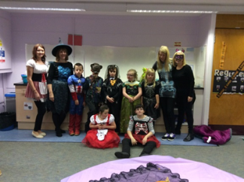
The Robins class have been extremely busy this term. We have enjoyed celebrating lots of different events such as Halloween, Bonfire night and several birthdays within the class.
Of course the children have also been working very hard! We have been learning about Noah’s Ark and done lots of beautiful Christmas art work. We have also been working hard on our Christmas Crafts to sell at the Christmas Signalong.
We have been practicing lots for our Christmas Signalong and we cannot wait for you all to see it!
We all hope you have a great Christmas! Remember to be good girls and boys, Santa and his elves are watching!
Mrs Murphy, Mrs Strachan, Mrs McGrane, Miss Todd & Mrs Platt

Class 2
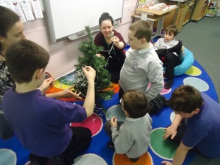
This term the Koalas welcomed there new teacher, Miss Hastie. We celebrated St. Andrews day by making our own tartan, recreating the Scotland flag using tissue paper and baking delicious shortbread. We have been enjoying the run up to Christmas. Here we are decorating our class Christmas tree with baubles we bought at Dobbies garden centre. While we were there, we were lucky enough to meet Santa and one of his elves! We have also been busy decorating our products for the Christmas fayre. We have been working really hard to practice for the Christmas sing along - we are sure you are going to love it!
Miss Hastie, Mr Blyth, Miss McKenzie & Miss West

Class 3
Hello everyone,
WOW! Hasn’t this been a fast term! Everyone in the Meerkat class has been working so hard to fit all the extra Christmas activities into our normal routine. We have been busy learning new songs and signing for our Signalong show, we have learned new stories connected to our topic of Celebrations and of course signing and rhymes connected to Christmas. We have enjoyed going Out and About, shopping for ingredients for our cooking (especially making cakes to sell on behalf of Pudsey). We have been working hard on our sounds, making words and reading them to each other.
We now have a new teacher and have been learning her name; Mrs Richardson, who joined us in our trip to the cinema which was great fun.
Everyone in class hopes that you have a very happy and peaceful Christmas.
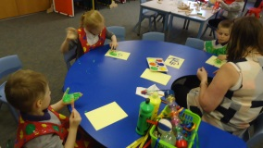
Mrs Richardson, Miss Wylie, Miss McKenzie & Miss West

Class 4
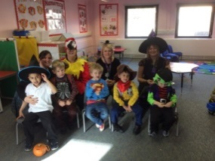
The Lions Primary 1 class have had a super term. We have loved going along to Inveralmond Community High School for our swimming lessons, we were all very confident in the water and Miss Millar was very impressed. We have also been out and about to the shops lots to buy in our ingredients for food and nutrition. We have been working on our spreading skills and are getting very good at it. We had a great time at Halloween where we all dressed up and went guising around the school; we even got some special treats. It will be our Christmas Singalong show very soon and we have all been working so hard at practising the songs to sing and sign to you on the day. We hope to see you all there, Merry Christmas!
Miss Millar, Mrs Ross, Mrs Welch & Mrs Hunter

Class 5
The Penguins have had another busy half term!
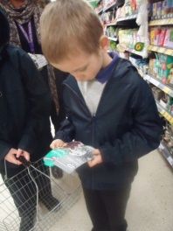
We have had a great time learning our sing along songs in music and practicing them in class ready for sing along performance, we hope you enjoy the show!
We have continued to work in the community, visiting the community garden and litter picking. We have also been visiting the library; we can use the machines really well and always manage to find some fantastic books which we share with our friends at story time. We are also continuing to shop at Morrison’s and are getting very good finding the food we are looking for using our visual shopping lists.
We are all working hard on our individual targets and we have enjoyed using lots of new and interesting resources to help us achieve them.
In maths we have been looking at 3d shapes, counting back and our numbers.
In cookery we have made different soups to help us try out new vegetables. We have been very careful with our chopping skills and using a blender to help make our soups smooth.
The class team are very proud of what the children in the Penguins have achieved this half term, well done!
Mrs Beestone, Mrs Craig, Mrs Charles & Miss Montgomery

Class 6
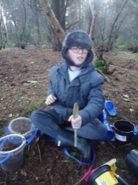
This term the children in the Giraffe class have been enjoying learning about the ‘Celebrations and Traditions’. We have covered Bonfire Night, Diwali, Remembrance Day and are currently having lots of fun learning about Christmas. We have taken part in lots of Christmas crafts, been learning the Christmas Story, learning the songs for the sing-along and visiting the local church. The children have also been exploring the local woodland and have lots of fun while making mud pies and discovering lots of natural materials. Here in the photo, you can see Ethan having lots of fun. The children have been continuing their independence in dressing by hanging up their coats and continuing to pack our bags. I am pleased to say all the children are now carrying their own lunch tray to the table. This is lovely to see!
Keep up the good work Giraffes.
Miss Priestley, Mrs McGowan, Miss Cairney & Mrs Auchie

Class 7
Hello again everyone!
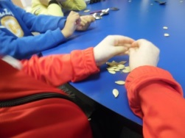
The Hippos have been very busy over the last month learning lots of new things and having messy fun!
The fun began when we made a pumpkin lantern for Halloween. We took turns to scoop out the flesh and all the stringy bits from the centre of our pumpkin and used this for our messy play! As part of our festivals and moral stories topic we learned about the celebration of Diwali – the festival of light. We got to make firework pictures and learned about the story of Rama and Sita. We watched a shadow puppet video of the story and also a clip of school children performing it. We made clay Diya lamps from scratch!
Ms Borthwick, Miss Mackenzie, Mrs Bremner & Miss Buist

Class 8
The Children in the Kangaroo class have been learning about Festivals and Moral stories this term. We started off by looking at Diwali and created some beautiful lamps.
We then went on to create some fire-work pictures and learned about keeping safe during Guy Fawkes Celebrations.
Investigating moral stories such as The Magic Porridge Pot, The Enormous Turnip and The Loaves and Fishes enabled us to learn more about helping each other and sharing.
We celebrated Children in Need by preparing a ‘spotty snack’, creating a tactile spot for display in the school and participated in some ‘Spotacular Sports’. The fact that we also dressed up in spotty clothes made it even more fun!
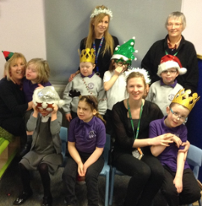
At present we are making Christmas cards for family and friends, creating crafts to sell at our Christmas Sing-a-long and are looking forward to a Christmas Party and hopefully a visit from Santa.
If you would like to find out more and see photographs of our learning please have a look at the School Blog where we appear regularly.
For now, the children and staff in The Kangaroo Class wish you all a Happy Christmas!
Miss Nicoll, Mrs Duncan, Mrs Hedges & Miss Gemmill

Class 9
Hi everyone!
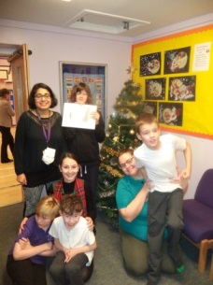
We have had lots to do this term! We made some fantastic Halloween pumpkins which the whole school loved. We also made some great Halloween crafts which included skeletons made out of cotton buds. We have been focussing on position and movement in maths which we have all been great at doing! Our topic has been Noahs Ark and learning all about water. We made a brilliant Noahs Ark for our wall display with lots of different animals! We are also enjoying getting to know our new teacher Miss McClure. We are beginning to do all our Christmas crafts and learning our songs for our Christmas Sing Along. We hope to see you all there to hear our fab singing voices!
Miss McClure, Mrs De & Miss Morton

New Staff
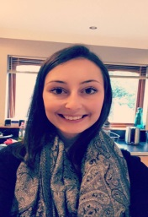
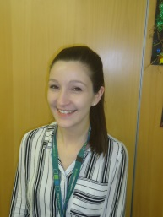

Miss Hastie Miss McClure

Dates for the Diary
Wednesday 21st December-Last Day of Term
Wednesday 4th January-All resume
Thursday 5th January-Parent Group
Friday 20th January-Parent Group
Thursday 2nd February-Parent Group
Thursday 9th February-All break
Wednesday 15th February-All resume

School Blog
https://blogs.glowscotland.org.uk/wl/ogilvieschoolcampuslivingston

