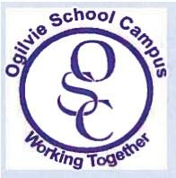

Parent Council Meeting
6 March 2017 @ 9.30pm
Agenda
  - 'Scottish Attainment , pupil equity funding – Liz Speirs
  - Minibus Update – Liz Speirs
  - Finance Update – PC Balance Sheet
  - Fundraising Ideas for year ahead
  - AGM in May and drive for interest in joining Parent Council
  - Additional points of discussion from the floor

