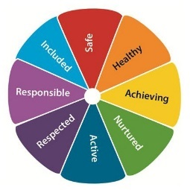
Murrayfield Parent Council Newsletter
June 2019

This is a wee update from your parent council. If you are new to the school or parent council, welcome! The parent council is an informal group of parents who are working together to enhance our children's education. We do this through fundraising, supporting each other and assisting with some school decisions.

Please join in :)
There are many ways to get involved, one is to come to our meetings, there are 7 each year, each on a Wednesday, 6:15-7:30pm. Each time we check in on our plans for events and fundraising and discuss other school issues, centered on an update from Ms Macrae.

Next year’s meetings will be:
04/09/19, 02/10/19, 13/11/19, 15/01/20, 26/02/20, 29/04/20, 03/06/20

If you can’t come to the meetings that’s fine too, just use form below and we’ll work out how to loop you in, we mostly use letters sent home, GroupCall, Twitter and the school blog to keep everyone informed, let us know what works for you.

Fundraising Update
We’ve raised a fair bit this year, so we’ll need your help to go one better next year. Most recent was the Family Race Night. This raised a whopping £700. Congratulations to Penny, Eileen, and the rest of the team.

Proposed Plans for next year
We’ve got a plan for next year. Please put these in your calendar as we wouldn't want you to miss out.
02/09/19 - Film Night - P1-3
16/09/19 - Film Night - P4-7
30/10/19 - Halloween Party
04/12/19 - Christmas Fair
Late Feb - Family Evening Event
(Race Night, Ceilidh help us decide!)
8/5/2020 - School hours sponsored event (bouncathon, bikeathon, wait and see!)

Get Involved
We’re always looking for raffle and tombola prizes so if you have anything suitable, wine, gift sets, toys or could offer a service to give away please let us know.

Your Name
Childs name
Phone, email
I’d like to be involved in…  Please circle | A Film Night  The Halloween Party  The Christmas Fair  The Family Evening Event (Race Night, Ceilidh)  The School hours sponsored event  Anything else, let us know here...

Please hand into school or fill out online here http://tiny.cc/mpcgetin

