

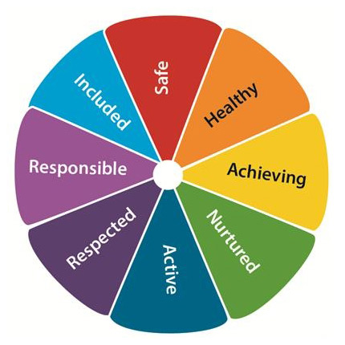



LOWEST PRIORITY

HIGHEST PRIORITY

Murrayfield Values

Place the statements in order of priority.

Help us create strong values for all our stakeholders – pupils, parents/carers, staff, community and partners.

Please return to school by **Friday 23rd March.**