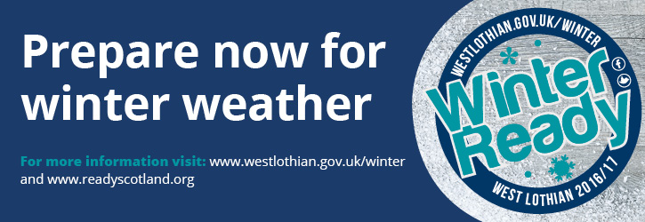
West Lothian Council has launched its public information campaign Winter Ready West Lothian 2016/17.
The campaign highlights the council's preparations for possible severe weather and encourages local people to prepare now. Severe winter weather can include snow, frost and low temperatures, high winds and flooding.
More information is available at www.westlothian.gov.uk/winter
As with previous years the council has:
- Maintained salt stocks.
- Set up contracts with local suppliers for severe weather support.
- Provided an email alert service so that regular information can be sent direct to your inbox.
- Delivered refresher training to staff on all severe weather equipment.
- Published a Winter Ready supplement in the winter issue of Bulletin, the council newspaper. This is also available online at www.westlothian.gov.uk/bulletin
The council is also asking residents and local businesses to help:
- Park sensibly – abandoned vehicles can cause serious issues.
- Share information with friends and neighbours, and spare a moment for vulnerable neighbours.
- Stay informed. Sign up for the email alert on the council’s website at www.westlothian.gov.uk/email, like the council Facebook page at www.facebook.com/westlothiancouncil or follow us on Twitter at www.twitter.com/lovewestlothian for updates.
- If you are able, clear the path and pavement in front of your home.
- Prepare your car and home ahead of the winter.
- Keep the winter issue of Bulletin handy.
- Parents and carers should also ensure that their child’s school has up to date contact information.
- Should severe weather hit, Groupcall is the way that schools will inform parents and carers about closures.

