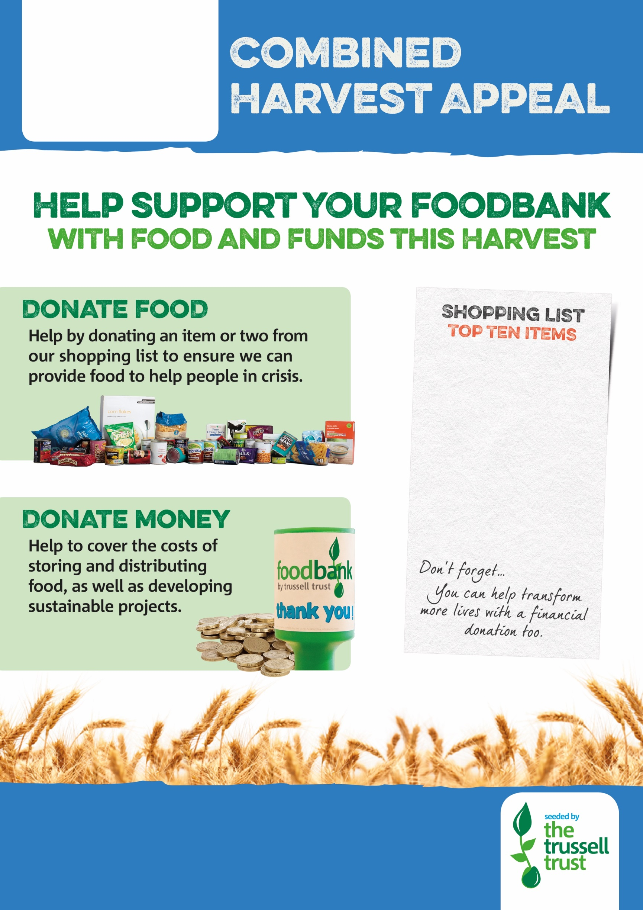

Registered Charity in Scotland (SC 008274)

westlothian.foodbank.org.uk

**Tinned potatoes**

**Instant potatoes**

**Cartons UHT milk**

**Tuna**

**Biscuits**

**Fruit juice/diluting juice(1L)**

**Jam and other spreads**

**Toothpaste & tooth brushes**

**Washing powder**

**Sweets**

