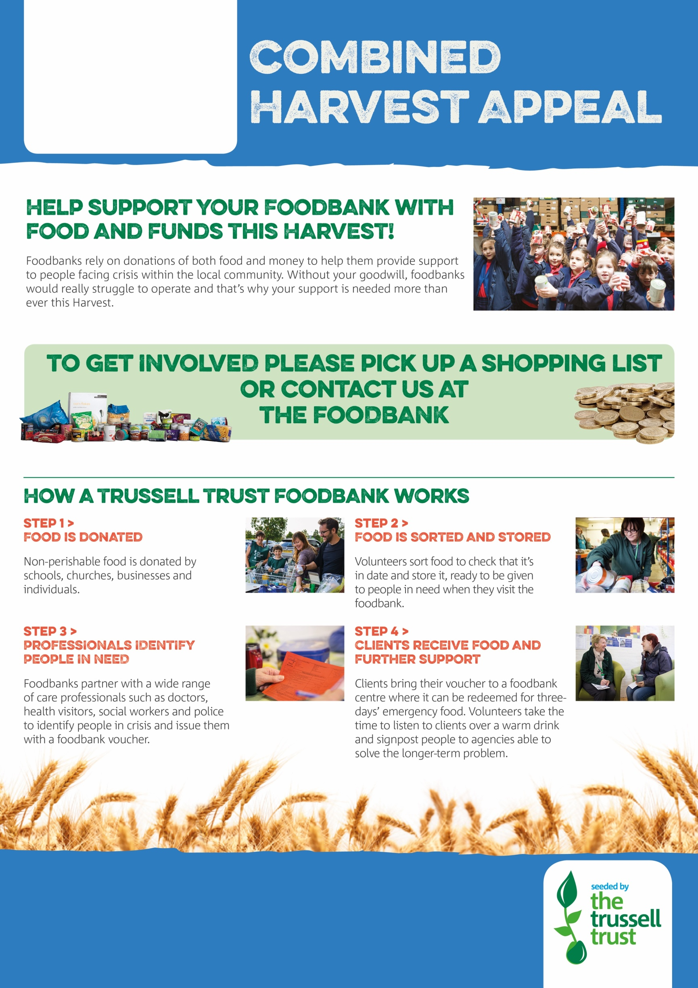

westlothian.foodbank.org.uk

Registered Charity in Scotland (SC 008274)

