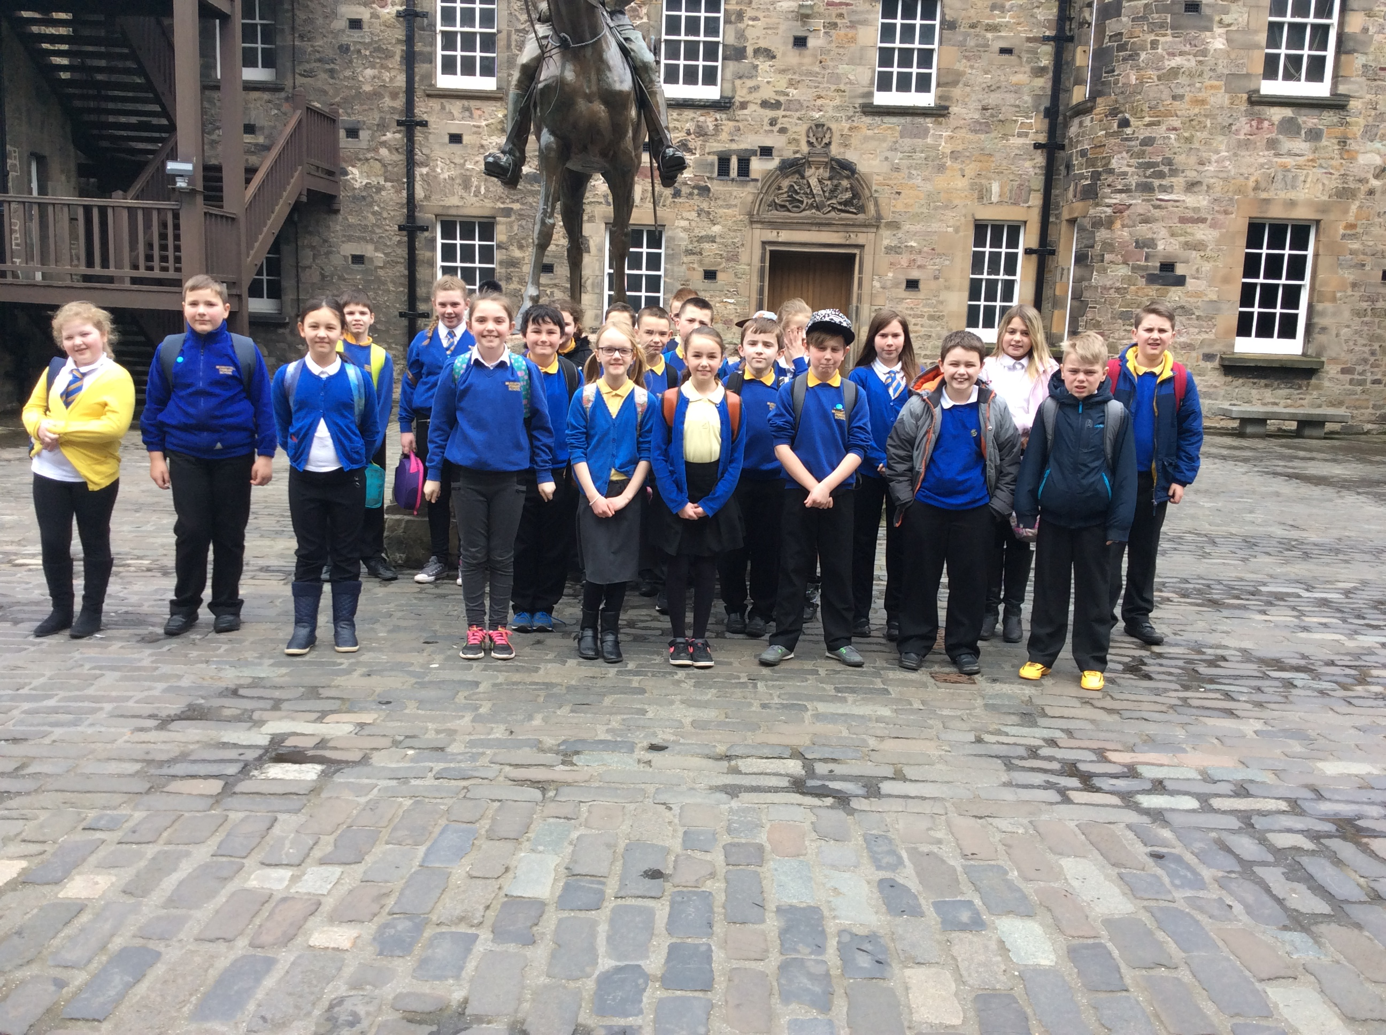
p6 class Newsletter
Dear Parents and Carer’s,
I hope everyone had a fantastic Easter Holiday! It was a shame that the weather wasn’t great but it looks like Spring has finally arrived ☺
P6 really enjoyed their WW2 topic last term. Not only did they go on a fantastic trip to the Edinburgh castle, but they also had 2 visitors in the school. Tom Gordon from Edinburgh Castle came with a selection of fantastic WW2 resources for the children to touch and even try on. They also had another visitor who gave a talk about life during WW2 and showed the children how much chocolate and jam was rationed during this time. The children were shocked! (and so was Miss Moir).
This term the children will focussing on The Human Body for their new topic. This will be a Science based topic which will also link in with their HWB topic of Sex Education.

Again I would like to thank you for an excellent turn out of homework this year. I have started a reward system with the children where if I am particularly impressed with homework then someone in the class will receive a giant star in their jotter. This will give them 100 points for their house in school and a sticker for their sticker chart in class. Well done to those of you who have already received one ☺
Homework will still be given as follows:
Monday-Spelling which is for a Thursday
Tuesday-Reading to be completed for Thursday
Thursday- Reading and Numeracy to be completed for a Tuesday.
I will also be giving out some topic homework this term. This will be in the form of creating a model, drawing a picture or completing a worksheet.
Please remember that P.E is on aTuesday for P6 as well as them taking part in Outdoor P.E throughout the week. Please make sure your child has suitable p>e kits for this.

Reminder:
P.E for p6 will still be on a Tuesday so please make sure your child has a suitable P.E kit. Children will also take part in some outdoor activities throughout the week so please make sure your child has suitable clothing for outdoors.

Newsletter Date April 2016

Spring has finally Arrived!

HOmework!!
Dates for your Diary:
Monday 2nd May-Holiday
Tuesday 3rd May-In Service
Thursday 5th May-Voting day-school closed
Thursday 12th May-Cross Country
Monday 23rd May-Holiday
Tuesday 7th June-Sports Afternoon (1)
Thursday 9th June-Sports Afternoon (2)
Wednesday 22nd June-Meet the Teacher
Thursday 23rd June-Voting Day-School Closed
Wednesday 29th June-P6 Leavers assembly
Wednesday 29th June-Last Day of Term
Class Topic-The Human Body!

