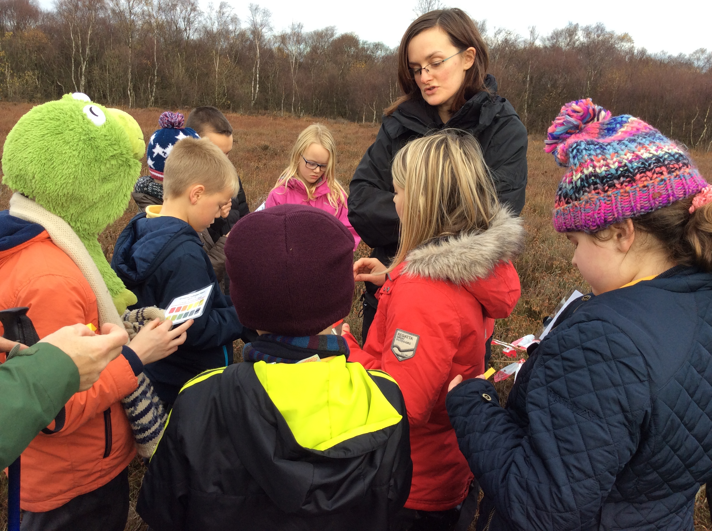
p6 class Newsletter
Dear Parents and Carer’s,
A Happy New Year to everyone and I hope you had a wonderful Christmas and a well deserved break.
The children of p6 have settled well into class routine and are very much looking forward to starting their new topic of WW2. We will continue our Europe topic until the February weekend which will tie in nicely with the start of WW2. The children have already discussed what they would like to learn through the areas of the curriculum and have come up with some excellent ideas.
This term we will also be focusing on a little project through heart start with first aid training for the whole class. We have already completed the first lesson which was helping a conscious casualty. The children used their knowledge of keeping safe to give excellent answers and are inquisitive about the rest of the course. This is an excellent skill to have and will prepare them for their future.
Thank you very much for an excellent turn out of homework so far. It has been of a very good standard with some children really excelling in some tasks. If you do not have coloured pencils at home, your child can borrow some from myself providing they return them to school.
Homework will still be given as follows:
Monday-Spelling which is for a Thursday
Tuesday-Reading to be completed for Thursday
Thursday- Reading and Numeracy to be completed for a Tuesday.

Reminder:
P.E for p6 will be on a Tuesday so please make sure your child has a suitable P.E kit. Children will also take part in some outdoor activities throughout the week so please make sure your child has suitable clothing for outdoors.
GYM SHOES
Please make sure your child has a change of shoes for school and that they are preferable black gym shoes.

Newsletter Date January 2016

Happy New year

HOmework!!
Dates for your Diary
- Friday 12th February-Dress Down Day-Wear Red
- Thursday 28th Jan-Dress in Tartan
- February Holiday- Monday 15th and Tuesday 16th
- Friday 19th February-Open Morning-Mild, Spicy and Hot Showcase
- Thursday 17th March-Parents Night
- Friday 18th March-p6 and P7 Assembly
- Wednesday 23rd March-Quiz Night
- Friday 25th March-Easter Holidays Begin
Europe and WW2

