Primary 5 Class Newsletter
Settling in after the summer holidays.
Dear Parents,
After a rather wet but seemingly fun filled summer, the boys and girls of p5 have returned to school to a new class and a new teacher.
The pupils have settled in well and have been enjoying working together in groups and pairs to complete a variety of tasks. We had great fun creating a cube “all about me” The children have worked in groups to discuss six key questions to a happy, stimulating learning environment and we have used their answers to draw up a class pledge which they all have agreed to and signed. P4’s and P5’s in Blackburn have been invited to participate in a competition designing a knot garden for Blackburn house. We have done some research on Blackburn house and knot gardens and have started designing our gardens.
diary:
Dates for your diary
2nd September – Parent Council Meeting
18th September – Fundraising Dress Down Day
21st & 22nd September – Holiday
25th September – Movie Afternoon
1st October – Parental Consultations
7th October – Parent Council Meeting
19th – 26th October – October Holidays
9th November – Parent Council Meeting
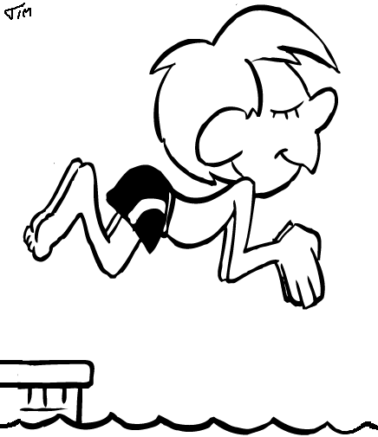
Health and Well being
P5’s will be going to swimming on Mondays. Please remember all your swimming gear.
We are working together to walk/ run a mile everyday (weather dependent), we have all already noticed a change in our fitness.
PE will be on Wednesdays (outdoors) and Thursdays with our PE specialist Mrs Logan
2nd December – Christmas Fair
Homework
The boys and girls of p5 will be given homework on a Monday and asked to return this on a Thursday. The homework will be Reading, Spelling, Maths

Topics:
This session we will be looking at Woodlands, Wallace and Bruce, Scotland and My body. I am looking forward to many great adventures with the children this year.
In Numeracy this term we will be looking at addition, symmetry and shape.
During Literacy we will be exploring some functional writing.

