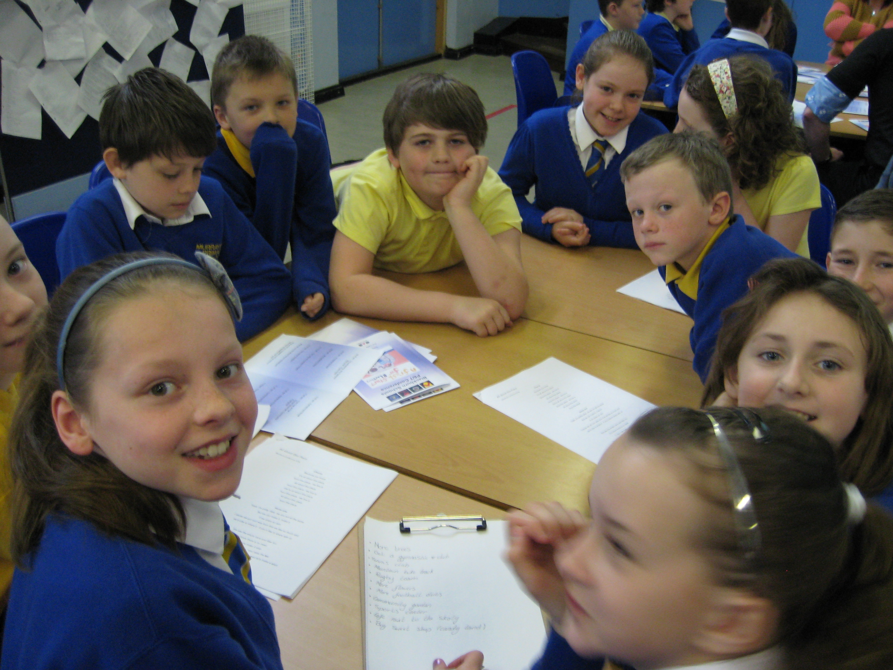
p6 class Newsletter
Dear Parents and Carers,
Summer is soon approaching and p6 are looking forward to the challenges ahead in p7.
The class has started the buddy programme this term and has been visiting the nursery children to play games, sing songs and make the nursery children feel welcome to Murrayfield. The children are also enjoying the memories of the nursery (but don’t tell them I said that☺).
The boys and girls have nearly finished their Europe topic but still have a few things to complete which they will do after THE SCHOOL SHOW!!...which the children are just as excited about as I am. The theme for this year’s show is a musical theme with a radio twist…very fun indeed. The children have chosen their songs and preparing themselves for the all the rehearsals ahead of them. It will be very hard work but it will all be worth it in the end.
I would also like to mention 2 pupils is this newsletter this term…Emma Parker and Abbie Heaney. Both girls have been working hard outside of school and I wanted to personally congratulate them for all their hard work. Emma has achieved her personal best for her swimming while Abbie entered a writing competition and had her story made into a short story book. I am so proud of these girls and I have no doubt they will keep up the good work ☺

Homework:
Over last term homework was completed to a good standard in p6. Most children handed their homework in on time as well but it would be nice to up this from good to excellent this term.
Spelling homework will be handed out every Monday and must be handed in on a Thursday. Reading homework will be heard on a Tuesday and should also be completed for a Thursday. Children must complete a chosen reading and spelling task and must complete this to an achievable standard.
Numeracy homework will be handed out on a Tuesday to be completed for Thursday
Reminder:
P.E for p6 will be on a Tuesday and Wednesday this term so please make sure your child has a suitable P.E kit.

Newsletter Date May 2015
Dates for your Diary
- Monday 18th May-Holiday
- Tuesday 16th June-Sports Day 1
- Thursday 18th June- Sports Day 2 (weather depends on day of sports day)
- Wednesday 24th June-p7 Leavers Assembly
- Thursday 25th June-p7 Disco
- Friday 26th June-Last Day of Term and Church Assembly-P6 Assembly

