Primary 3/2 Newsletter

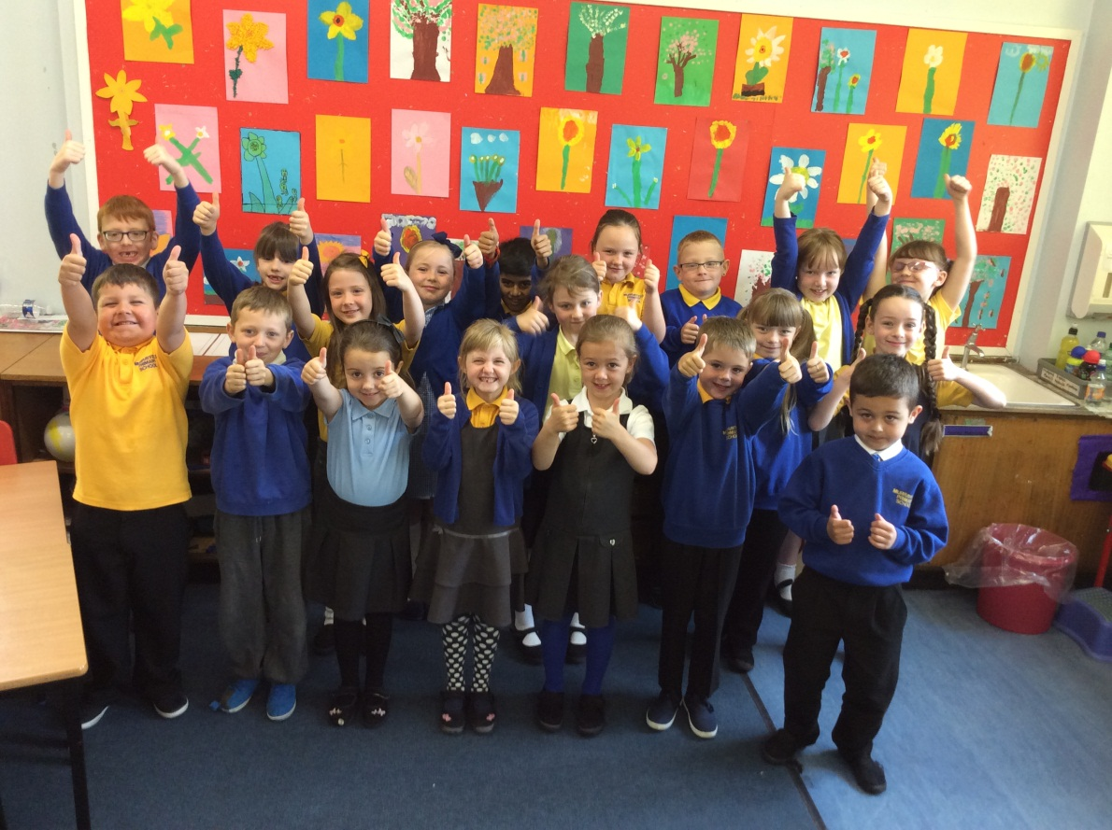

Welcome to our newsletter!

We have a busy couple of months ahead of us as we move into term 4. We will be studying two mini-topics this term. Our first is a social studies topic, linking in with the French language and comparisons between two similar towns and their cultures. In our second mini-topic we will be looking at substance abuse. This will be done at a level appropriate for our age group. If you have any questions or concerns regarding this please do not hesitate to contact Miss Preston. In numeracy we will be concentrating on a variety of subject areas dependent upon each child’s stage. We will also be looking at measurement. Our literacy focus for term 4 is functional/informative writing. Keep your eyes open for our brochures promoting Blackburn!

The new school wide behaviour policy starts this month, I have every confidence that only positive news will be fed back to all parents and carers of P3/2 pupils. ☺

We have our whole class assembly on Friday 29th May. We hope you can come along to see what we have been learning this year.

Thank you for your ongoing support at home with your child’s learning.

*Miss Preston, Mrs Anderson and P3/2*